
COMMUNITY

NEWS

October
2012 - 1
This community newsletter is sent out usually twice each month on behalf of tawalink.com, Tawa’s community website since 2002. The newsletter is supported by the Tawa Progressive & Ratepayers’ Association.

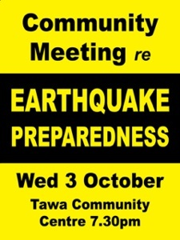
BE PREPARED FOR AN EARTHQUAKE
The Wellington City Council is running a number of meetings around the region providing advice on how to be better prepared for an earthquake. The session in Tawa is this coming Wednesday, 3 October, at the Tawa Community Centre at 7.30pm.
Regardless of how many times we hear this stuff, most of us aren’t as prepared as we need to be. Perhaps some of us are. When the earthquakes hit in Christchurch, there probably weren’t too many who felt, after the event(s), that they couldn’t have been better prepared in one way or another.
Mayor Celia Wade-Brown says she is pleased that so many people have taken the time to attend a session. “The briefings highlight the work the Council and other organisations have done to improve our city’s resilience. They also help people know what they can do practically in their communities and in their homes to make sure they are ready to get through an earthquake, and help their neighbours. This is critical information for every city resident and I encourage Wellingtonians to come along to a session.”
The Tawa meeting is being supported by the Tawa Community Board and the Tawa Community Centre. See www.wellington.govt.nz/services/earthquake/resilience/briefings.html. The ideal is to register in advance. Whether you do or not, come on Wednesday evening.

TAWA UNION YOUTH GROUP CLAIMS FIRST PRIZE
This year Tawa Union Church hosted JYMC’s Annual Film Festival. This is an event which has taken place for more than 10 years where Presbyterian, Methodist and Uniting Parishes from around the wider Wellington region enter 5-minute short films into the competition. They are then judged and shown for everyone to see.
On this occasion 230 people packed out Tawa Union Church eager to see this year’s entries and hear the winning results.
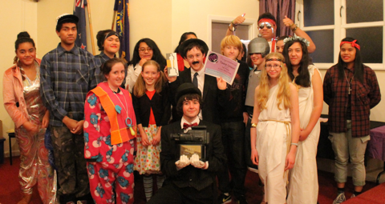
Tawa Union’s Youth Group not only hosted the event but also took out the top prize, taking home with them the Film Fest trophy. Thrive Youth from St John’s in the City came second and Ignition Youth from Porirua PIPC were third. 12 youth groups entered the competition, with 13 groups involved on the night.
The theme for the night was ‘historical’, hence the costumes and outfits. The photo shows Tawa Union Church Youth Group celebrating with 1st prize. “After receiving 2nd prize in both the 2010 and 2011 competitions it was fantastic to finally get top spot, and on home turf too (almost like hosting and winning the world cup!).”

TAWA BASKETBALL CLUB NOTICE
Tawa Basketball Club will be running a Social League at the Tawa Recreation Centre starting 4 October. Games will be on Thursday nights and will run for 10 weeks. Welcome to all. Registrations are now taking place this month. If you are interested in entering a team or playing in the League, contact Duncan Moore on 027 325 0638 or email tawabasketball@gmail.com. More information can be found at www.tawabasketball.co.nz.

REVOLVE FITNESS GRAND (RE)OPENING
Formerly known as “Body Shape Fitness Studio”, Revolve Fitness has taken on some very exciting changes. As well as the great new and fresh branding, they have another co-owner to the business, Lucy Newrick. Lucy started Revolve over 18 months ago and has now partnered with Alastair Leslie to expand the business. Alastair, who is also a top coach for athletes in middle to long distance running, has owned the business for over 16 years and now has the Rio Olympics set in mind for his athletes.
Revolve Fitness is a private personal training studio with fantastic trainers who target each session to the individual’s needs. It operates slightly differently to the standard commerical gym, so each time you come in you are with a trainer, never left on your own to fend for yourself!
Revolve is having its grand re-opening/launch party and would love the community to come along! Local businesses, current gym members and anyone who may be interested in learning more and meeting the team must come! Spot prizes will be given away on the night and you must be there to claim your prize!
Where: Shop 7, 210 Main Road, Tawa (in the plaza)
When: Friday 12 October
Time: 6-7pm

Please contact Lucy Newrick to find out more on

027 665 9541 or lucynewrick@hotmail.com.

EVENING TAI CHI CLASS?
The request has been made for a Tai Chi class to be started in Tawa in the evening. A class could be commenced if there’s enough interest. Contact us on info@tawalink.com if you might wish to join such a class.

OPENING OF SUPERMARKET
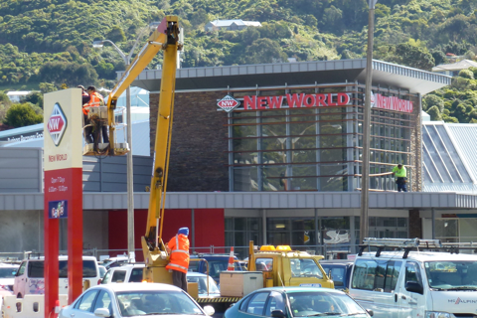
It’s official. New World Tawa will be open for
business from 9am on Tuesday 9 October.

VOLUNTEERS REQUIRED FOR STREET COLLECTIONS IN TAWA
Pink Ribbon Appeal - Friday 12 & Saturday 13 October
To volunteer, see www.onlineregistration.co.nz/pinkribbon or free phone 0508 105 105.
NZ Foundation for the Blind - Friday 26 October
To volunteer, see www.blindweek@rnzfb.org.nz or free phone 0800 120 250
Both these collections are being co-ordinated by the Tawa Lions Club.

Enquiries to communityactivities@xtra.co.nz or phone Alastair on 232 7936.

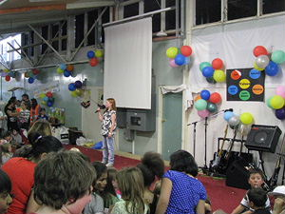
TAWA COMMUNITY LIGHT PARTY
A safe alternative to Halloween.
This is a fun night of entertainment, food, face painting and talent quest for children aged 5-12.
When: Wednesday 31 October 6pm–8pm (starting with a sausage sizzle for tea).
Where: Tawa New Life Church, 236 Main Road, Tawa.
This is a free event – sponsored by Wellington City Council, Tawa Community Board, and many local businesses, but tickets are essential to gain entry and can be picked up from 9 October onwards at:
Baptist Church Office (corner Main Road and Victory Cres) 9-12 Tues-Friday
New Life Church Office (next to Pink Pineapple) 12-5 Tues–Friday or 10-1pm on Sat 27 October
or contact Michele McDonald, Light Party coordinator, on 232 4924.

ESSENTIAL TREMOR SUPPORT GROUP
Informal meetings for people in the Johnsonville to Porirua districts interested in getting together, forming our own support group and making contact with the National Support Group.
Essential Tremor is a condition which is hereditary and varies greatly from person to person. The severity of the tremor, which is seen mainly in hands and head, may be only just noticeable in one person, but can greatly restrict another’s activities. It is not restricted to any one age group and can affect both young and old.
No real cause for the tremor has yet been identified although there is ongoing research. Medication is sometimes used as a means of control, but no medication specific to an essential tremor yet exists.
If you would like to get together with others who have this condition or are interested in finding out more about it, come and meet in the Tawa Community Centre for tea, coffee and a sandwich for lunch on Tuesday 9 October, 23 October, 6 November at 12.15pm, or if you cannot come at lunchtime, please feel free to telephone Maureen on 232 4555. Leave your name and contact number and she will return your call.

FAMILY FUN AFTERNOON IN TAWA
The Tawa Services Bowling Club is organising a “Have A Go At Bowls” afternoon on Sunday 14 October from 2pm - 4pm. Participation is free and bowls are supplied – flat-soled shoes are required.
There will be a sausage sizzle and free tea and coffee will be supplied. People of all ages are very welcome. The green is situated at 89 Oxford Street in Tawa. There is plenty of parking available in the area.
Any cancellation will be broadcast on Newstalk ZB on the Sunday morning. For all enquiries phone John on 232 8257.

TE KOHANGA REO O NGAHAURANGA MARKET FUN DAY
Te Kohanga Reo o Ngahauranga are having a Market Fun Day on Saturday 27 October from 9.30am onwards at Linden School. Plenty of goodies, fun and entertainment to be had. So come along and join the fun in helping us celebrate the milestone of Kohanga Reo being around in the community for over 30 years.
• Venue: Linden School, 58 Ranui Terrace, Tawa
• Time: 9.30am onwards
• Date: Saturday, 27th October 2012

Enquiries to Frankie on 232 8424 or email Whanau@k09c043.kohanga.ac.nz

Adios

Malcolm Sparrow

On behalf of TawaLink.com
(loosely under the umbrella of the Tawa Progressive & Ratepayers’ Association)
info@tawalink.com www.tawalink.com
232 5030 or 027 232 2320

“Don't lose your real self in the search for acceptance by others.”
“Shot my first turkey today. Scared everyone in the frozen food section. It was awesome. Getting old is so much fun …”
Whether in families or in politics, a good observation: “One can disagree without being disagreeable.”
– Barry Goldwater

This newsletter is emailed to around 1200 Tawa households, businesses, schools, churches and clubs/groups (anyone who has an interest in the community of Tawa) usually in the first and the third weeks of each month. If there’s anything you'd like to include in the next newsletter, please let us know. If you do not wish to receive the newsletter, please send us an email requesting that your name be deleted from our list.

WRITING IT PROPER
They say that the language evolves (or changes) over time. That may well be the case, but I suspect that a certain amount of that is due to certain “incorrect useage” gradually becoming the norm – and that’s not really a good thing!
There’s a page on the TawaLink website entitled “Writing it Proper” which I have replicated below. It sets out a few examples which I think are all too common. One that is a little frustrating is the number of times (not the amount of times) people put an apostrophe before the ‘s’ in the plural form of a word when there’s no need to. Surely that’s a simple one to get right!
The webpage reads as follows:

I don’t profess to be an expert on the English language, but I do make an effort to “get it right” and avoid certain common mistakes like placing an apostrophe in the word its at the wrong time! As far as this website is concerned, my aim is to keep each of the following “pledges”:

- I will spell correctly on these web pages. If you ever see a word spelt incorrectly, please let me know. My spelling will be English English however, not American English, so we’ll have a ‘u’ in the word colour and an ‘s’ in the word organise, etc.
- I will never put an apostrophe in the possessive word its. It’s with an apostrophe is short for “it is” (or “it has”), otherwise it has NO apostrophe.
- I will not use an apostrophe simply because a word is in its plural form. “Lots of trees” is okay – “lot’s of tree’s” clearly isn’t!
- I will not use the word amount when I really mean number. By that I mean I will not talk about “the amount of pages” on this site any more than I will talk about “the number of rain we had yesterday”.
- When abbreviated, the words “you are” become “you’re”. I will never say “Your looking good today” when what I’m meaning is “You’re not looking so good today”.
- I will not say “a nonsense” or “a fantasy” when, as I understand it, it is not necessary to use the word ‘a’ in those instances. Is that nonsense or merely fantasy?
- I will not “reverse back” when to reverse means to go backwards anyway! Nor will I “return again” - unless I am going there a third time. “Re” in many instances means it’s happening a second time, so there’s no need to use the word “again”! Do I need to repeat that again, or revert back to what I said earlier?
- I will not use the word rung when I really mean rang (or replace sang with sung, etc). By that I mean I will not tell you “I rung her today” any more than I will ask “have you rang her yet?”

Here are a couple more that I need to add to the above page:

- I will not say “should of” instead of “should have”. I’ve heard highly educated people say that. They should of got it right!
- Another one that has become commonplace is to say “me and Fred” will do whatever, instead of “Fred and I”. I’ve also heard a teacher come out with “Myself and Mike went to Auckland”. Does every young person today say “Me and X”, rather than “X and I”? I suspect so. Maybe that one’s already a lost cause!

I freely admit I get it wrong occasionally – hopefully not too often. I put together a publication in the 1990s with a particular category heading spelt “Accomodation”. I’ve never forgotten that and have never mis-spelt it since (I hope).

On two occasions in these newsletters I’ve talked about my dog chewing through a chord. It had nothing to do with music. The word in question shouldn’t of had an ‘h’. I’ll be doing my best to ensure I don’t get that one wrong again! Let me know when I do err. It’s helpful to know (I think).

