Invitation
Florio Terrace Barbecue
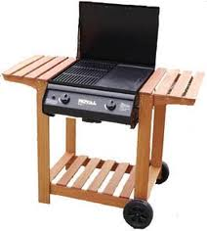

Sunday 25th March at 5pm
An Opportunity to meet Others
& Celebrate our Neighbourhood

Where? Midway in Florio Terrace where you


see the balloons. (If wet, in the rumpus room at No … Florio)

Please bring your own food, drink, cutlery, plates & something to sit on.
Hope you can join us. “Everybody needs good neighbours!”
Any queries to ………. 232…….
……………….. 232……

