
This newsletter is sent out every 3 weeks or so on behalf of TawaLink.com
(Tawa’s community website).

29 January 2010

Happy New Year to you (as it’s still January I’m sure it’s still okay to be expressing such sentiments!)

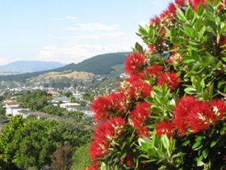
It’s nice to have experienced some reasonable summer weather over the past week or two right here in Tawa, and it’s great to have seen the pohutukawa trees in full bloom around the place in recent days. Their “blaze of red” does make a very picturesque sight!

It’s only a matter of days before schools start again, Tawa College on Monday and all the other schools in Tawa (as far as I’m aware) on Tuesday.

Have a great 2010. We’ll keep on sending you this email newsletter every 3 weeks or so.
Of course, if you don’t wish to be kept informed of what’s going on in our wonderful little community (well, not that little really), you’re fully entitled to opt out.

WHAT’S HAPPENING OVER THE NEXT FEW WEEKS?
You tell me (please). If you’re organising or know of an event coming up in the next month or two, PLEASE let us know - email info@tawalink.com. We need to update our list of what’s happening in Tawa on the “Coming Events” page of the TawaLink community website: <http://www.tawalink.com/coming_events.html>.

REDWOOD STATION CLOSING FOR AROUND FOUR MONTHS
Like the heading says, Redwood Station will be closing for up to four months - effective from Monday 8 February. Tranz Metro advises: “We’re getting Redwood Station ready for the arrival of the new ‘Matangi’ trains later this year. To do this, the station has to be closed from 8 February for up to 4 months.
While Redwood Station is closed, the adjacent Takapu Road and Tawa Stations can be used instead. Additional temporary carparking will be available at Tawa Station at the northern end of the current carpark on the western side of the station. This additional carparking will be available for use from Monday 1 February.”

PARKING AT THE MAIN ROAD SHOPS

The signs indicate that the time limit on parking outside the shops in central Tawa is 60 minutes. What the signs don’t say is that this time restriction doesn’t apply after 6pm Monday to Thursday, and after 8pm on Fridays. Nor does it apply on Sundays. That’s the official ruling the Tawa Community Board has in writing (well, email) from the powers-that-be. You might know this already. The less-well-informed amongst us, like
the writer, didn’t know the specifics until now.

Parking wardens do visit Tawa from time to time, probably when you least expect them. They have a job to do, and some of us don’t have a great deal of sympathy for those who simply choose to ignore the rules. A certain individual has never forgotten the time he parked for a mere two to three minutes on yellow lines in Christchurch some
25 years ago and got hit with a rather hefty fine! He’s kept clear of yellow lines ever since. And, as per an earlier email to do with parking, never ever so much as idle in a ‘mobility’ parking space if you’re not disabled. That too can be very costly!

NEW COORDINATOR AT COMMUNITY CENTRE
Official word hasn’t come through yet, but you may have seen in last week’s CityLife Porirua News that a new coordinator has been appointed at the Tawa Community Centre. She is Lynette Te Paa, a very pleasant individual who was formerly coordinator at the Newlands Community Centre and, before that, a librarian at the Mervyn Kemp Library (Tawa).

TAWA IN THE DOMPOST
Earlier this month when many of us were out of town enjoying summer holidays, there was an article in The Dominion Post entitled “Story of a suburb: Tawa”. Richard Herbert was good enough to inform me of this and email the web link. The article stars Allan Todd (Tawa’s ‘elder statesman’) - see <http://www.tawalink.com/allan_todd.html>

It’s a very good writeup. Here are a few extracts from it: “Tawa spreads through the valley, snug on the edge of Wellington’s boundary. The shopping centre, the train station and Tawa College are at the heart of this tight-knit community.”
And quoting Allan Todd: “Community is the heart of Tawa ... Tawa is a village, and everyone gets along - but it is not suited to people who do not want to get involved ... It’s a place in which people are motivated
to get involved ... For people moving to the area, if you do not get involved you will find yourself on the outside. But if you do, it’s a great place to live ... They’re friendly and they’re my type of people. That’s what it amounts to.” Well done, Allan. My thoughts exactly!
Read the full article here: <http://www.stuff.co.nz/dominion-post/local/3205078/Story-of-a-suburb-Tawa>

TAKAPU ISLAND
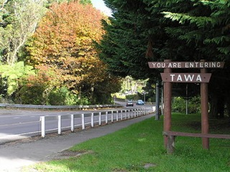
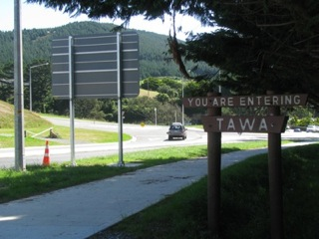
Very little news on this one, except that after years of work on the site (and the removal
of lots of attractive trees), we’re now back to square one and the Takapu Island site is available for a would-be buyer. Anyone interested? Details about the proposed Mitre 10 Megastore which is no longer being proposed can be found here: <http://www.stuff.co.nz/business/industries/3244261/Tawa-Mitre-10-development-falls-through>.
April 2006 January 2009
The Tawa Community Board has been advised that NZTA (NZ Transport Agency) is still working with the roading contractors to improve safety in the vicinity of the roundabouts.
It has been decided that the roundabout closest to the motorway will be turned into a ‘complete roundabout’. At present the easternmost part of the roundabout is blocked off.
It will be unblocked so that, in theory, one can drive round and round in circles forever. Sounds a bit like Takapu Island itself!

COMING UP IN TAWA:
Monday 1st February: Start of school year at Tawa College
Tuesday 2nd February: Start of school year at other schools in Tawa
Thursday 4th February: Welcome for Tawa Union Church’s new minister
Saturday 6th February: Waitangi Day (no day off unfortunately)
Monday 8th February: Temporary closure of Redwood Station
Saturday 14th February: Enrolment for Tawa Music Centre

Full details of the above are available at <http://www.tawalink.com/coming_events.html>

Adios

Malcolm Sparrow
On behalf of TawaLink.com
<info@tawalink.com>
<http://www.tawalink.com>
232 5030 A/H or 027 232 2320 or 02 232 232 00

“Life is like a mirror, we get the best results when we smile at it.”

“Sometimes I wonder whether the world is being run by smart people who are putting us on or by imbeciles who really mean it.” - Mark Twain

“I shall pass through this life but once. Any good therefore that I can do, let me do it now. Let me not defer or neglect it. For I shall never pass this way again.” - Etienne de Grellet

This community newsletter is emailed to around 700 Tawa households, businesses, schools, churches and clubs/groups (anyone who has an interest in the community of Tawa) every 3 weeks or so. If you do not already receive it and would like to, please send an email to info@tawalink.com requesting that your name is added to our list.

