
This newsletter is sent out every 3 weeks or so on behalf of TawaLink.com
(Tawa’s community website).

19 February 2010

Hello again

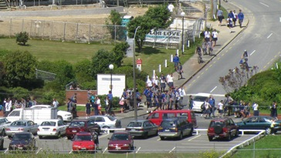
School is well under way at all 10* schools in Tawa. In case you’re interested, the total number of kids attending schools in this valley exceeds 3250 (which includes a certain number from out-of-zone). The roll at Tawa College currently stands at 1428, Tawa Intermediate has 485 pupils, and approximately 1340 attend the 6 primary schools. No
wonder there’s congestion at the schoolgate from 3pm each weekday!
* Greenacres, Hampton Hill, He Huarahi Tamariki, Linden, Montessori, Redwood, St Francis Xavier, Tawa, Tawa College, Tawa Intermediate.

We currently don’t have details of too many events coming up in the life of Tawa. Please keep us informed of anything you know that’s happening in the weeks ahead. Thanks.

CLEARING UP ANY CONFUSION …
Lynette Te Paa is now the coordinator at the Tawa Community Centre. Malcolm Sparrow
has gone from there and is instead an elected member of the Tawa Community Board which is a totally separate entity. This involves around 4-8 hours a week. The role of the community board is to “… represent the interests of the Tawa community” and to “… help Wellington City Council understand and meet the [Tawa] community’s needs.”
Any community centre matters (such as bookings or displaying posters) should be directed to Lynette in person or by calling 232 1682.
This email newsletter is independent of both the community centre and the community board. It has been sent out as a community service since 2005, before the community centre came into being. My intention is to continue it into the future. It’s really an ‘offshoot’ of tawalink.com, Tawa’s community website.
Community board ‘issues’ of interest to the community will usually be included in this newsletter. This is additional to the board distributing its own printed newsletter to most Tawa households approximately three times a year.
Are you any more informed now than you were 60 seconds ago (or 90 seconds if you’re a slow reader)? Hopefully so!

COMMUNITY EDUCATION CLASSES AT TAWA COLLEGE
In case you weren’t aware of it, Community Education (evening) classes are still going strong at Tawa College, despite no other schools between here and and north of Kapiti continuing with them.
Four new classes which have started this term are:
- astronomy
- raranga (flax weaving for beginners)
- Maori for beginners
- gluten-free cooking
Check it all out at http://www.tawacomed.nz

WHERE WILL YOU HOST YOUR WEBSITE IN THE FUTURE?
If your community group currently has a website which is hosted by the Wellington Community Net service, you’ll probably know by now that the WCC will not be funding this beyond 30 June 2010. You’ll need to host your site elsewhere.
We’re not sure how many community groups in Tawa will be affected by this. I know of at least three. If your group will be affected, please get in contact with us. It would be good to get together and discuss where we go from here.


REDWOOD STATION CLOSED TEMPORARILY
Redwood Station is currently closed to enable improvements to be made “… for the arrival of the new ‘Matangi’ trains later this year.”
Shots of Redwood Station can be seen here:
<http://www.tawalink.com/pic_week_2010-05.html>

ARE YOU AFRAID OF PUBLIC SPEAKING?
This meeting is for you! Toastmasters Night at the Tawa
Community Centre at 7.30pm. Celebrity guest speaker and a delicious supper.
Enquiries to Alan on 232 8487.

MUSIC LEARNING CENTRE
The Music Learning Centre in Tawa (not to be confused with the Tawa Music Centre) is accepting enrolments for individual and group tuition in violin, viola, cello, flute, guitar, drums, music theory and composition. Also sign up now for orchestra, choir and chamber music. Email info@musiclearning.co.nz for more information or call 232 1231.

BELLY DANCING SUPPER CLUB
Informal belly dancing club for all ages and experience levels. Tuition available. No experience necessary, though experienced dancers are most welcome. Meets every second Thursday, 7.30-9.30pm, at Beanstalk Kindergarten, Duncan Street, Tawa. Contact Jude Hutton on 232 7812 or email toroa@paradise.net.nz.

STREET COLLECTORS NEEDED
Show you care. Street collectors are needed by Porirua Victim Support. Victim Support’s street appeal takes place in March 2010. Please contact Paula@victimsupport.org.nz.

COMING UP IN TAWA:
Details of various events are available at <http://www.tawalink.com/coming_events.html>.
If your school/church/club or group has an event coming up that should be included on
our list, please let us know.

Adios

Malcolm Sparrow
On behalf of TawaLink.com
<info@tawalink.com>
<http://www.tawalink.com>
232 5030 A/H or 027 232 2320 or 02 232 232 00

P.S. One of the cheerful folks at Tawa’s ‘Take Note’ store told me that the first she’d heard of Redwood Station’s (temporary) closure was in this newsletter. As a result, she was able to pass on the word to customers.

Good to receive useful feedback like that!

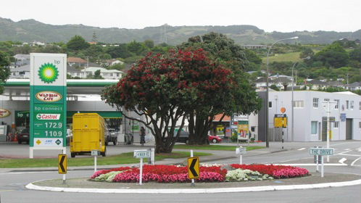

“Humans are the only creatures on earth that allow their children to come back home.”
- Bill Cosby

“A dog is the only thing on earth that loves you more than you love yourself.” – Josh Billings

“Whether one believes in a religion or not, and whether one believes in rebirth or not, there isn’t anyone who doesn’t appreciate kindness and compassion.” – Dalai Lama

This community newsletter is emailed to more than 700 Tawa households, businesses, schools, churches and clubs/groups (anyone who has an interest in the community of Tawa) every 3 weeks or so. If you do not already receive it and would like to, please send an email to info@tawalink.com requesting that your name is added to our list. If there’s anything you’d like to include in the next newsletter, please let us know.

