≠
COMMUNITY

NEWS
May 2010

Tawa

This community newsletter is compiled every month or so on behalf of tawalink.com, Tawa’s community website since 2002.

TAWA COMMUNITY CIVIC AWARDS
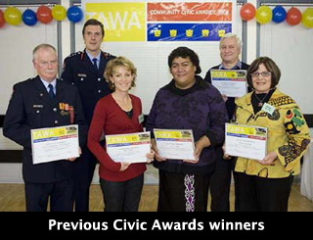
We all know that Tawa’s a great place to live. And we stack up pretty well in terms of the number of volunteers who contribute in numerous ways to the life of this community. So every two years the Tawa Community Board organises the “Tawa Community Civic Awards” as a way of publicly thanking all those people who put time and effort into local clubs & groups, schools & churches, etc, in a voluntary capacity.
Various individuals (and groups) will be ‘recognised’ one-by-one at a ceremony to be held at the Tawa Community Centre in June. All those actually nominated by you and me will receive a specific vote of thanks - from the Deputy Mayor of Wellington, as it happens. It really is a special occasion! We need you to take a few minutes to bring to mind the name of someone you think is worthy of such recognition. Then all you have to do is fill in a few details on the official form, send it in by Friday 21 May, and your job is done!
Nomination forms have already been delivered to every household in Tawa, all 4500+. More are available at the local library or online at this page:
<http://www.wellington.govt.nz/haveyoursay/meetings/comgroup/Tawa_Community_Board/profile.html>
GIRLS’ CRICKET SUCCESS
Tawa Intermediate School Girls’ cricket team is once again competing in the Milo Shield Competition. Defending their 2009 National title, the Tawa Intermediate team defeated Samuel Marsden School and Plimmerton School in pool play and met Sts Peter and Paul in the Wellington Regional Final.
Tawa batted first, making 157 runs off 25 overs. Jess Kerr top batted, making 71 runs with the lower order batters running aggressively between the wickets to score 42 valuable runs off the final 5 overs. Tight bowling from Phoenix Williams, Jess Kerr and Kadi-Eve Leggett restricted Sts Peter and Paul to 140 runs.
With this win, the Tawa Intermediate team retains their Wellington Regional Winners trophy. Their next game is due to be played in term 4 against the winner of the Central Districts competition, with the winning team going to the National Milo Cricket Series finals.
REDWOOD STATION OPEN AGAIN
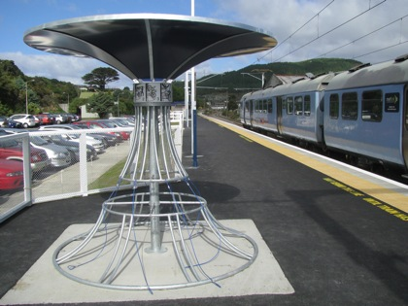
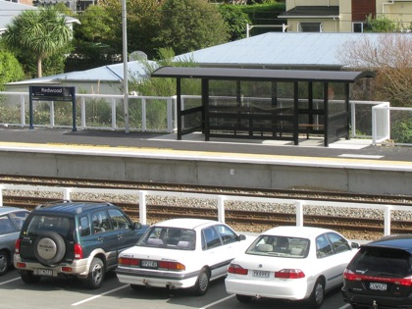
Redwood Station opened for business again last Monday. Improvements have been made to the platforms “… for the arrival of the new ‘Matangi’ trains later this year.” The new structure on the southern platform is a bicycle stand. At this stage it’s not being used to quite its full potential, as per the first photo. A shiny new shelter has been constructed on the northern platform (see other photo).

As the seasons change and the year rolls onwards we have been meeting more and more of the personalities who call Tawa home.
Foremost in our minds is how to assist folk to celebrate life’s milestones. Their experiences are sometimes quite profound and moving. Your feedback is most welcome and valuable in developing our shop to better meet individual requirements. Please visit www.villagegifts.co.nz and requests via info@villagegifts.co.nz. Sometimes we simply don’t have an item to match the customer’s requirements in store. We offer a no obligation search facility with email responses including photos and prices, or come on down to your retail centre and enjoy what other communities do not have.
Kind regards
Chris

QUESTION FOR YOU
The following question was in the Dominion Post’s Five-Minute Quiz the other day: “Who or what are Balliol, Brasenose and Magdalen?” Local residents will know, of course, that they’re the names of streets in Tawa - Redwood, to be precise. But from whence do the names originate? In plain English, where are they from originally? Answer below.
TAWA ORCHESTRA CONCERT - “STORMY WEATHER!”
2pm on Sunday 16 May in the Tawa College Hall. Come - rain or shine - all welcome. Entry by gold coin donation. We have a new conductor for this concert, Robert Lynch; our leader is Maria Sydor. Our guest artist will be soprano Imogen Thirlwall, a third year Bachelor of Music Performance student at Victoria University who will join the orchestra in Peer Gynt's Solvejg's Song and then perform with piano accompanist Isaac Stone (an ex-Tawa College student).
ALPHA DINNER
Tawa Churches invite you to an “Alpha Dinner” on Sunday 16 May at 6.30pm in the Emmaus Centre (behind St Christopher's Church), cnr Main Road & Lyndhurst Road. No charge. It would help us with catering if you let us know you are coming. Please phone 232 5611 (Michael) or 232 4852 (Christine).
EXTENSIONS TO TAWA COLLEGE MUSIC DEPARTMENT
Tawa College’s Music Department is undergoing a major redevelopment. When completed, the new suite will have substantially more space, providing two classrooms, a large performance room, a recording studio, and three instrumental and vocal teaching spaces. The cost of these new facilities is $1.6 million. The Board regretfully does not have the resources to provide all that is needed in terms of equipment for these greatly improved teaching and performing spaces.
For the Department to be up and running for its opening at the start of July, a considerable amount of expensive equipment needs to be purchased. Funding for items such as classroom furniture is covered in the allocated funds. We are also grateful to Mana Community Grants and Tawa Music Centre for giving grants for equipment. However a large shortfall remains which the Department itself must raise in order to get the block functioning fully. We are looking to the community to help raise $120,000 towards this shortfall. Maybe you can help!
For more details, see: <http://www.tawacol.school.nz/forms/music_fundraising_letter.pdf>
TAKAPU ISLAND - CALTEX STATION - STREAM WALKWAY
Nothing further to report on any of these at this stage. We do expect to have more information about the Takapu Island roundabouts in our next exciting instalment. Stay tuned!
ANSWER FOR YOU
Balliol, Brasenose and Magdalen, all various streets in Redwood, Tawa, derive their names from colleges at Oxford University. You may be fascinated to know that a total of 14 Redwood streets (including the three already mentioned) derive their names from that particular source.
PET-FRIENDLY SHOPS
Tawa is known as a family-friendly community (that’s our considered opinion!), but did you know that a number of the shops are very accommodating when it comes to pets? The shopkeepers’ own pets, that is.
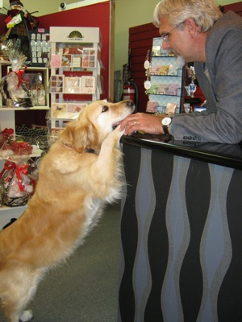
The writer of this newsletter came across the following critters residing in (or out the back of) certain Main Road central shops. By the way, thanks to all those shopowners who were happy to display in their front window a poster advertising the upcoming Tawa Community Civic Awards.
The pets, from


left to right, were located as follows:
Darroch’s
Hardware
Regency
Jewellery
Village Gifts

COMING UP IN TAWA:
Thursday 13th May: Tawa Community Board meeting
Thursday 13th May: Tawa College PTA AGM
Saturday 15th May: Tawa-Linden Plunket sale
Sunday 16th May: Tawa Orchestra Concert
Sunday 16th May: Alpha Dinner
Friday 21st May: Last day for Tawa Community Civic Awards nominations
Saturday 22nd May: Greenacres School garage sale
Saturday 22nd May: Tawa-Linden Playcentre 60th anniversary
Full details of the above are available at <http://www.tawalink.com/coming_events.html>
THE CURRENT HOUSING MARKET
[The following comments are merely the opinions of the writer of this newsletter, with some material derived from other sources.]
A recent report in the Dominion Post reads: “House buyers and sellers are sitting on their hands ahead of the Budget - keeping the already subdued property market at bay … There is little urgency and many people are waiting to see the exact nature of the changes in the May Budget before deciding their next move.”
People are still buying and selling houses, but not in the numbers we’ve seen in the past. Selling prices have come back a little over the last while as owners (well, some anyway) have come to realise that asking more than a realistic amount for their property means that it simply won’t sell in a hurry.
It’s a good time to buy right now. As a buyer you’re likely to have a reasonable amount of clout, particularly if you’re a cash buyer, and without the kind of competition there sometimes is, i.e. other people vying for the same property.
If you’re looking to sell, it may take longer than you’d like. However you enhance your chances of an early sale if your property is well-presented and ‘priced right’ from the outset. Once you’ve sold, the world’s your oyster, so to speak! To discuss any of the above or to get an idea of what your house might be worth in today’s market, please feel free to call the writer.

Adios

Malcolm Sparrow
On behalf of TawaLink.com
<info@tawalink.com>
<http://www.tawalink.com>
232 5030 A/H or 027 232 2320

“If you put a small value on yourself, rest assured that the world will not raise your price.”

“Life is not measured by the number of breaths we take, but by the moments that take our breath away.”

“A bird doesn't sing because it has an answer, it sings because it has a song.” - Maya Angelou

This community newsletter is emailed to more than 700 Tawa households, businesses, schools, churches and clubs/groups (anyone who has an interest in the community of Tawa) every month or so. If there's anything you'd like to include in the next newsletter, please let us know. If you do not wish to receive the newsletter, please send us an email requesting that your name be deleted from our list.

Newsletter sponsored by:

