≠
COMMUNITY

NEWS
June 2010

Tawa

This community newsletter is compiled every month or so on behalf of tawalink.com, Tawa’s community website since 2002.

TAWA COMMUNITY CIVIC AWARDS
At a well-attended ceremony (120+ people) run by the Tawa Community Board earlier in June, the Deputy Mayor of Wellington, Ian McKinnon, presented certificates to those nominated for a Tawa Community Civic Award. MPs, city councillors, nominators and friends and family of nominees were at the Tawa Community Centre to lend their support.
“We received more than 40 nominations for individuals and groups that members of the community considered worthy of receiving an award,” says Malcolm Sparrow, joint organiser of the awards.
The purpose of the civic awards is to publicly thank the many people in the community who are involved in a wide range of voluntary activities. “There is no doubt the commitment and dedication of these people make our community a better place in which to live.”
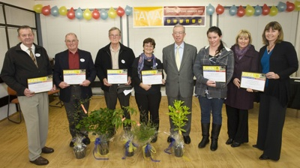
Winners of each of the six categories, including the newly-added Youth category, received a framed certificate and native tree from the Deputy Mayor.
The winners shown in the photo are:
David Allo (Health & Wellbeing), Tom Humphries (Art & Culture), Norm Robertson (Heritage & Environment), Clare Smith (Education & Child/Youth Development), Deputy Mayor Ian McKinnon, Annelise Havill (Youth), Tawa Swimming Club represented by Kathryn Gillum & Catherine Barnes (Sport & Leisure).
EMERGENCY TEXT ALERTS FROM WEMO
Be the first to hear about Wellington emergencies, e.g. tsunami warnings.
Sign up to receive Emergency Text Alerts from WEMO (Wellington Emergency Management Office, the “Civil Defence” people).
- The service is FREE, but signing up costs four texts under your normal price plan.
- We will send you two test messages per year. Any other message will be a genuine alert.
- Does not currently work on 2degrees.
Sign up to WEMO Emergency Alerts
(If your cell phone number is already registered on Twitter, go to step 4).
- Text the word “start” to 8987 (wait for a reply after each send)
- Text “signup” to 8987
- Text username to 8987 * (if rejected or password requested, try again)
- Text “follow WemoNZ” to 8987.
That’s it - you’re now on the Alert List. There’s nothing more to do.
* You won’t need to remember your username. Try using the first five letters of your street name plus birthday, e.g. Woodm020671.
SUNDAY ROAST AT TAWA’S COMMUNITY CLUB
Tawa residents and their friends/families (including children) are invited to Tawa’s Community Club, aka the RSA, at 89 Oxford Street for:
Sunday Roast Lunch on 4 July 2010.
Club rooms open at 12 noon, with roast lunch served from 1pm. Only $12.00 per head for roast lamb with all the trimming. The bar will be open. Our prices are very competitive (only $3.20 for a glass of wine).
If you’d like to come to the Sunday lunch please ring 232 5788 and advise how many will be attending. Leave a message if the phone is not answered.
TAWA SCHOOLS’ & COMMUNITY FESTIVAL 2010
‘Tawa Goes to Town’ is again the theme for this year’s Tawa Schools’ and Community (Music) Festival which takes place in the Michael Fowler Centre on Thursday 16 September at 7.30pm. This vibrant multi-media show will feature several hundred singers from Tawa’s six Primary Schools, Tawa Intermediate, and Tawa College’s Dawn Chorus, as well as an adult choir from the Tawa community and beyond.
The programme features a variety of songs, some as choral numbers, whilst others are accompanied by dances, choralography, props and special effects. There will be solo, group and instrumental interludes between brackets of songs.
Tawa College musicians Murray Cameron and Shona Murray will team up as Producer and Musical Director, whilst well-known choreographer, Sara Scott, who choreographed Tawa College’s successful production ‘Standing Ovation’ last year, will oversee the dance and theatrical numbers. Martin Burdan has been the ‘piano man’ since the festival was first held in the Michael Fowler Centre in 1982. The musical backing is provided by a combination of experienced instrumentalists and young and talented music students from Tawa College. The Convenor of the Festival is Pieter Braun, Principal at Redwood School.
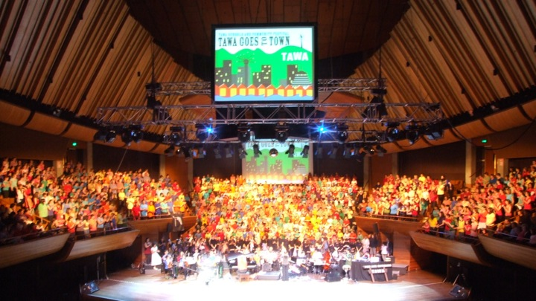
Rehearsals with singers, dancers and instrumentalists have begun this month and will culminate in the dress rehearsal for the show on Sunday 12 September which will be the first time the combined forces will come together.
Adults rehearsals began two Sundays ago at 4.00pm in the Tawa College Hall. The cost for the festival music book and a CD is $15. Any adults or ex Tawa College students may still be able to join the backing choir.
Contact information:
Shona Murray - Musical Director
‘Tawa Goes to Town’
shonamurray@e3.net.nz
NEW PRINCIPAL COMING TO HAMPTON HILL
Alison Cowan retired as principal of Hampton Hill School at the end of May, having spent “20 enjoyable years” at the school. She has since moved to Mount Maunganui. Jenny Pearl, a Year 5 & 6 teacher at Hampton Hill, is acting principal until a new principal is appointed.
THE ROUNDABOUT AT THE SOUTHERN ENTRANCE TO TAWA
You may have noticed that the easternmost of the two roundabouts (the one closer to the motorway) at the southern entrance to Tawa has now been fully ‘opened’. This means that you can now complete a full circuit of this roundabout if you so wish. The concrete island which previously stopped you going around completely has now gone. This ‘island’ was originally put in place with the option of being removed if it seemed like a good idea to do so. It was.
Meanwhile it appears that further lowering of the ground to the right of the off-ramp (from Wellington) has not yet been completed. We’ll let you know when that has taken place.

NUNSENSE
Tawa Community Theatre’s upcoming production ‘Nunsense’ runs from 1-10 July at the Linden Social Centre, Linden Ave. Book now on 232 3711.
BEATBOPPERS FOR PRESCHOOL CHILDREN
A new singing, dancing, movement and music class for preschool children in Tawa starts on 22 July at the RSA hall in Oxford Street, Tawa. Classes will be held at 10am on Thursdays for 0-2 year olds and 10.40am for 3-4 year olds. Contact Wendy (Dip ECE) on 027 637 5805 or email beatboppers@hotmail.com. $5 per child.
16-WEEK TAI CHI PROGRAMME
An ACC Modified Tai Chi programme is being provided at the Tawa Community Centre on Wednesdays at 1pm starting 30 June.
For people to receive the ACC funding they need to live in their own home, have either had a fall in the past year or are at risk of falling, and are 65 yrs+ or 55 yrs+ for Maori and Pacific Islanders.
This is a once a week for sixteen week programme (block course).
The focus of the programme is to reduce the risk of falls within this group of people. Enliven Positive Ageing Services focuses on the health benefits of the programme. The benefits include improved lower body strength and balance, postural and coordination.
Enquiries to 439 4967 or 027 276 9503 or anthony.busch@psc.org.nz.
MASSIVE BOOK FAIR
The Rotary Club of Tawa will be holding its 9th “Massive Book Fair” at Tawa Junction on Saturday 24 July and Saturday 31 July. Once again the Fair will be in support of The Life Education Trust whose mobile classroom and teaching programme are well known to local children and parents.
The Club would like to receive any clean and cared for books, CDs and DVDs that you no longer need and are willing to donate to the Book Fair.
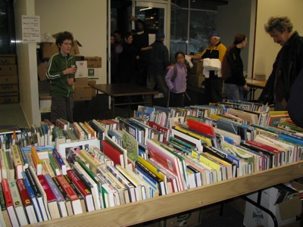
The fair provides an opportunity for local residents to clear their shelves of books they no longer need and put them towards some good causes, as ALL profits go to The Life Education Trust and other charities. There will be tens of thousands to choose from, covering a wide range of topics and authors. These include lots of children’s books priced at only 50 cents each. Most other books are only $2 or $3 each.
If you are able to assist this Rotary project, please take books, etc, to Mexted Motors, Harcourts Tawa or Drummonds Pharmacy, all of which are on Main Road, Tawa.
If you have too many to deliver yourself, please contact Ann on 232 8827, Brian on 232 5893 or Doug on 232 7894. They will arrange for someone to visit your home.
Look out for a household flyer in your mail box and keep it as a reminder to donate some surplus books or to go along to the Book Fair for a bargain.
SPRING INTO TAWA MARKET DAY
This year’s “Spring into Tawa Market Day” will take place on Saturday 11 September at the Main Road shops. Stalls can be booked from Tuesday 29 June at the Tawa Community Centre on 232 1682 or tawacc@wcc.govt.nz. They will be allocated on the basis of previous patronage, and then first come, first served. Full details including the proposed layout are now available on www.tawalink.com/springintotawa2010.html.
AGNES HARKINS TURNS 107
You might have seen an article in Saturday’s Dominion Post about Agnes Harkins, reputed to be the oldest woman in Wellington. “A Tawa rest home resident ….. she is still going strong on the eve of birthday no. 107.”
In the October 2007 edition of this newsletter we asked a question as to who was Tawa’s oldest resident. This is what we ran the following month (November 2007):
“After my question last month relating to the oldest person in Tawa, I was informed that a member of the Tawa Union parish turned 104 on 27 June this year [2007]. She is Agnes Harkins and she moved into Longview earlier this year, having previously resided in Linden. Reliable sources tell me she does get out and about! I’d be surprised to hear of anyone senior to her!”

An amazing age indeed!
DID YOU KNOW?
The “Bucket Tree”, world famous in Tawa, is registered as a notable tree. It is thought to have been first pruned into shape by Frederick Westbury, who worked for landowner William Earp, in the 1880s. It is actually a group of about five macrocarpas.

Adios

Malcolm Sparrow
On behalf of TawaLink.com
<info@tawalink.com>
<http://www.tawalink.com>
232 5030 A/H or 027 232 2320

“The most important work you and I will ever do will be within the walls of our own homes.”
- Harold B Lee
“You must give some time to your fellow men. Even if it's a little thing, do something for others, something for which you get no pay but the privilege of doing it.” - Albert Schweitzer
“We never really grow up. We just learn how to act in public.”

This community newsletter is emailed to around 800 Tawa households, businesses, schools, churches and clubs/groups (anyone who has an interest in the community of Tawa) every month or so. If there's anything you'd like to include in the next newsletter, please let us know. If you do not wish to receive the newsletter, please send us an email requesting that your name be deleted from our list.

THINKING OF SELLING? FOR A NO-OBLIGATION ASSESSMENT OF WHAT YOUR HOUSE MIGHT BE WORTH IN TODAY’S MARKET, CALL …

