
3
COMMUNITY

NEWS

Tawa

Christmas 2010

This community newsletter is compiled every month or so on behalf of tawalink.com, Tawa’s community website since 2002.

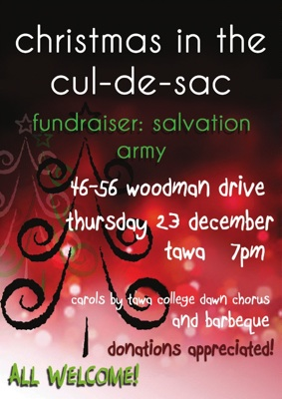
CHRISTMAS IN THE CUL-DE-SAC
Surrounded by the wonderful backdrop of the Woodman Drive Christmas lights, come and support the Salvation Army and give back to the community in this time of giving.
Members of the Tawa College Dawn Chorus will be performing an arrangement of Christmas carols from 8pm accompanied by a band. There will be a sausage sizzle, food and drink for sale prior to that.
Thanks to kind donations from local businesses, there will be two Christmas gift baskets to be raffled. So come along to 46-56 Woodman Drive from 7pm on Thursday 23 December, bring the family and celebrate the festive season. All proceeds go to the Salvation Army. Postponement date 24 December.

TAWA COMMUNITY GRANTS
If your club or group, school or church, is considering applying for a grant from the Tawa Community Board which has $15,000 to be made available to worthy local causes, you’ll need to forward your completed application to the Wellington City Council by 31 January 2011. Here’s the link: http://www.wellington.govt.nz/services/grants/index.html

NORFOLK PINE AND MAIN ROAD LIGHTS
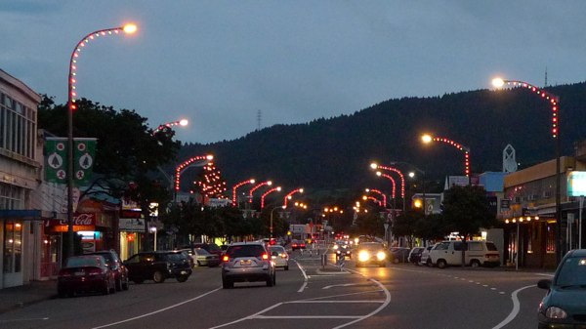
If you’ve driven along the Main Road in the middle of Tawa after dark lately, you’ll have seen how good the Christmas lights on the lamp posts look, in addition to the splendid sight that is the lit-up Norfolk pine outside the library. I was driving along Duncan St the other night and noticed from there how impressive the Norfolk pine appeared.
The Community Board passed an official vote of thanks on behalf of all of us to those responsible for putting these lights into our lives (so to speak). They’re a joy to behold!

NEW POLICE CONSTABLE IN TAWA
We have a new community constable who will be starting on the beat at the end of January. Her name is Sarah Riddering and apparently she’s previously been in the military. We’re looking forward to having her on board.

NEW COORDINATOR AT THE COMMUNITY CENTRE
The Wellington City Council is in the process of appointing a new coordinator for the Tawa Community Centre. Despite the name of the centre, the community of Tawa has no input in this. The intention is for the new coordinator to commence at the centre on or soon after its re-opening date of Monday, 17 January 2011.
Lynette Te Paa left the centre at the end of November after eleven months in the role. She was highly respected. It’s just sad that treatment of coordinators at the centre (by “the powers- that-be”) is such that they are driven away from the place sooner than they would like to be.

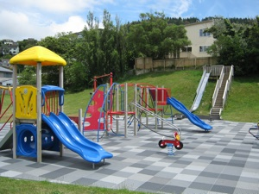
TWO GREAT PARKS
Tawa got a mention on the “Our Wellington” pages of last Tuesday’s Dominion Post. It happens occasionally! The first article, entitled “Free, fun and fantastic!”, listed ten of their favourite free playgrounds in Wellington. It stated: “Tawa boasts two great parks, Willowbank Park, which has a play area for younger kids, large green spaces, a stream and a number of picnic spots, and Duncan Park, at the northern end of Tawa, where the large play area includes a huge metal slide.”
See the photo of Duncan Park (off Linden Ave) at right, and Willowbank at the bottom of this newsletter.

HOWARD YOUNG - GREENACRES SCHOOL TEACHER
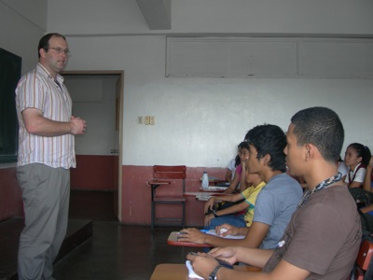
In July I, Howard Young, was lucky enough to receive an Asia NZ / AFS scholarship to visit the Philippines. On my return to New Zealand my class of Year 2 and 3 students and I embarked on a three month adventure using the Drucker Project to send over 60 books to the schools I had visited.

While in the Philippines I identified that schools experience difficulty funding items such as books for the library. My class then used the template for the Drucker in High Schools project to assist them in this area. After making some changes to make it more age-appropriate we set about collecting books. Things started out slowly, but in next to no time the community had swung into action and 108 books were donated. After sorting through these books we made a donation to the Mary Potter Hospice shop of 44 books, keeping the rest to send to three schools in the Philippines.
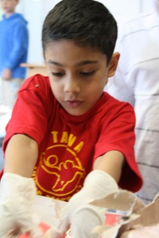
Next we had to raise some money and this was done by holding an ice cream day at school. Lots of ice cream was sold and we were proud that we raised $300 towards our project. Finally after much hard work it was time to say goodbye to the books as they were sent off to the University of Batangas, Hope Christian School and Claret School of Quezon City.
The success of this project is owed to many people: AFS New Zealand, Save the Children, Asia NZ Foundation and the local community who supported us. But the group most important in assuring this project was a huge success is my class, Room 4, Greenacres School!
The photos show:
- Howard Young teaching at the University of Batangas
- Greenacres School and the books they collected
- Preparing ice cream for sale

CHARLOTTE MURRAY’S AWARD
Congratulations are due to Charlotte Murray, well-known in local music circles, on having just been awarded the BHS (Barbershop Harmony Society) Master Director designation. She is one of only nine people in the world to have had this award bestowed upon them, and the first outside the USA.
Charlotte has coached the world-renowned Musical Island Boys (barbershop quartet), and spends many hours directing Focal FX (NZ Champion Barbershop Chorus), as well as being involved with Tawa College music.
She will be presented with a plaque at the BHS International Convention in Kansas City in July 2011. Well done, Charlotte! Another Tawa celebrity.

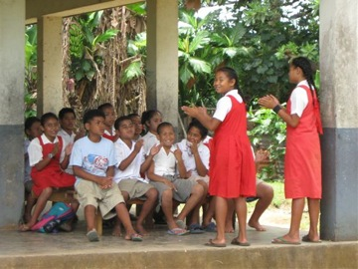
TOYS 4 TONGA
Toys 4 Tonga is a Rotary project with the aim of filling a container with quality new and used toys, children’s books and stationery for needy children in Tonga. Children there lack the basic pens, pencils and paper which our children take for granted. Already a number of schools in Tawa have collected items for the container which will be sent off in February/ March 2011.
Toys, books and stationery can be left in the Toys 4 Tonga collection box at the Tawa Community Centre in Cambridge St or Toy World in Porirua.

BABYSTAR IN TAWA
Babystar was born in Wellington in 2001. It was conceived out of the need to find high quality products in one place for all of baby’s needs. Babystar offers a strong sense of commitment to its customers, and makes every effort to match up customer needs with the right purchases.
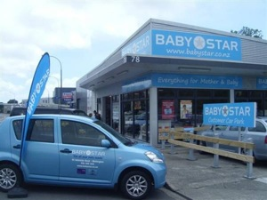
Babystar stocks a huge range of baby products, maternity clothing, nursery furniture, baby and toddler clothing, car seats, highchairs, buggies, toys and gifts.
We have a loyalty scheme, gift vouchers available, babyshower and gift registry scheme. Car seat, buggy, highchair and portacot short-term rentals are also available.
Now open in Tawa every day, and late night Thursday. Visit us at the Tawa Business Park, 78 Main Road, tel 232 1549. Or shop online and earn Flybuys at www.babystar.co.nz.

CONGRATULATIONS TO THE GIRLS’ CRICKET TEAM
You may have read in recent editions of The Wellingtonian and Kapi-Mana News that Tawa Intermediate Girls’ Cricket team has won the national primary school cricket title for the second time in a row!
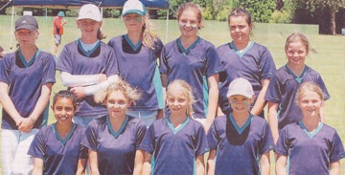
The girls successfully defended the Milo Shield title they won last year, beating Christchurch’s Heaton Normal Intermediate in the final, the same team they beat in the 2009 semi-final. In this year’s semi-final they scored 42-2 to beat Waimea (Nelson) who had managed only 40 runs. In the regional final they had beaten Havelock North. What a team!
Further details can be found in those local newspapers.

TAWA COMMUNITY BOARD SNIPPETS
COMMUNITY BOARD MEETING LAST THURSDAY 9.12.10
- John Spence, Area Commander for the Kapiti-Mana Police District, gave a report on “policing in Tawa” in which he advised that criminal activity in this area appears to be minimal at present. Long may it stay that way! He also provided details of the new community constable as mentioned earlier in this newsletter.
- Jack Marshall, a year 11 student at Tawa College, provided a brief report on his role as a Wellington City Council Youth Council member. He goes to meetings in town twice a month and helps put across a young person’s point-of-view.
- Graeme Hansen was elected deputy chair of the Tawa Community Board.
- Members were appointed to the Tawa Community Grants Subcommittee and to the Tawa Borough Scholarship Trust. The latter is responsible for a scholarship awarded to a Tawa College student each year. In November 2010 that recipient was Patrick Barnes.
- Various other reports were given and issues discussed, probably none interesting enough to the wider community to provide details here! They will all be available on the WCC’s website if you really want to see them.

GETTING WET FOR A GOOD CAUSE
Cr Ngaire Best and a certain community board member were both targeted (literally) at the recent St Christophers summer fair. As well as having wet sponges thrown at them, they were soaked by a very effective water blaster. Other local “identities” (especially the Tawa College principal) suffered similar, if not substantially worse, fates. Pics available at http://www.tawalink.com/pic_week_2010-41.html.
TAWA LIONS CHRISTMAS PARADE
Members of the Board took part in the recent Christmas parade. It was basically a matter of indicating that, hey, this is who we as the Board are - an integral part of the Tawa community.
26 OXFORD STREET BOOK LAUNCH
The Community Board was represented at the launch of the Tawa Historical Society’s most recent book, “26 Oxford Street and the Bartlett family”, a book all about the historical house at that address. More details and photos can be seen at http://www.tawalink.com/pic_week_2010-43.html.
TAWA COLLEGE CHINA TRIP FUNDRAISER XMAS RAFFLE
The chair of the Board, Malcolm Sparrow, was invited to draw the winning tickets for this raffle. He considered it only “right and proper” that 1st and 3rd prizes went to Tawa residents (as it turned out), considering that most of the fundraising support for the China trip is coming from Tawa people. More at http://www.tawalink.com/pic_week_2010-44.html.
DOG ATTACKS IN THE TAKAPU VALLEY
In the last newsletter mention was made of ongoing dog attacks in the Takapu Valley. We’ve just been advised that two dogs were shot dead on Tuesday afternoon. WCC’s Animal Control team have identified their Porirua owners by checking the dogs’ microchips, and are reasonably sure these were the offenders. That should be the end of the problem.
MERRY CHRISTMAS FROM THE TAWA COMMUNITY BOARD
The Tawa Community Board wishes you compliments of the season. Have a safe and happy Christmas, and all the best to you and your family in the coming year.
Malcolm Sparrow • Cr Ngaire Best • Graeme Hansen • Cr Justin Lester • Margaret Lucas • Chris Reading • Alistair Sutton • Robert Tredger

CHRISTMAS CAROLS AND MORE
From this Friday, 17 December, through to Saturday, 25 December, which most of us know as Christmas Day, there are at least 14 different occasions in which you can partake in Christmas carols in Tawa, whether it be an outdoor occasion like “Christmas in the Cul-de-Sac” mentioned at the start of this newsletter, or a Christmas function/service at one of the churches.
One of the biggest get-togethers, involving several hundred locals, is the Combined Christmas Day Service held in the College hall every Christmas Day.

Details of the various events can be found here: http://www.tawalink.com/coming_events.html

Wishing you a very Merry Christmas and a Happy New Year.


All the best .....

Malcolm Sparrow
On behalf of TawaLink.com
<info@tawalink.com>
<http://www.tawalink.com>
232 5030 A/H or 027 232 2320

“Christmas is a day of meaning and traditions,
a special day spent in the warm circle of family and friends.” - Margaret Thatcher

“In the old days, it was not called the Holiday Season; the Christians called it 'Christmas' and went to church; the Jews called it 'Hanukkah' and went to synagogue; the atheists went to parties and drank. People passing each other on the street would say 'Merry Christmas!' or 'Happy Hanukkah!' or (to the atheists) 'Look out for the wall!'” - Dave Barry

“Christmas is not a time or a season but a state of mind. To cherish peace and good will, to be plenteous in mercy, is to have the real spirit of Christmas.” - President Calvin Coolidge, 1927

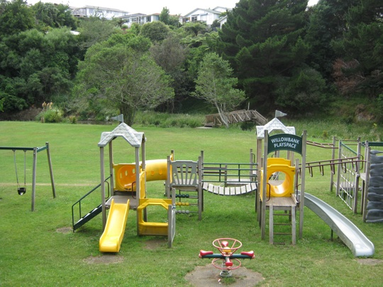

Willowbank Park, which has a play area for younger kids, large green spaces, a stream and a number of picnic spots. Not a bad place for a Christmas Day barbie!

This community newsletter is emailed to more than 900 Tawa households, businesses, schools, churches and clubs/groups (anyone who has an interest in the community of Tawa) every month or so. If there's anything you'd like to include in the next newsletter, please let us know. If you do not wish to receive the newsletter, please send us an email requesting that your name be deleted from our list.

