
3
COMMUNITY

NEWS

Tawa

January 2011

This community newsletter is compiled every month or so on behalf of tawalink.com, Tawa’s community website since 2002.

COMING EVENTS IN TAWA – TELL US WHAT’S HAPPENING (PLS)
If you know of an event coming up in Tawa, whether it be 7 days away or 7 months, please provide us with the details - an event being run by a school, church, club or organisation, or whatever else ..... We’re currently updating TawaLink’s “Coming Events” page for all of 2011. This is a comprehensive guide to what’s happening in our community. PLEASE LET US KNOW!
TAWA COMMUNITY GRANTS – CLOSING DATE EXTENDED
The Tawa Community Board has $15,000 to be made available to worthy local causes. If your club or group, school or church, is considering applying for a grant from the Tawa Community Board, you now have until Friday 18 February to forward your completed application to the Wellington City Council.
The Tawa Community Grants Fund is designed to assist voluntary projects in Tawa. Grants may be for charitable, educational, welfare, community development, cultural, recreational, sporting, activity development, equipment or training programmes. Grants may also be given to people representing New Zealand in a recognised sporting or cultural event.
To be eligible, applicants must:
- be based in Tawa
- show that their project will directly benefit the Tawa community
- not have excess reserve funds
- meet all criteria on the Tawa Community Grants application form
Call Phil Railton-Jacks at the WCC grants team on 803 8562 for further information, or see http://www.wellington.govt.nz/services/grants/index.html.
WANT TO HELP TAWA YOUNG PEOPLE IMPROVE THEIR CYCLING?
A training course in cyclist skills is being run 14-18 February for adult Tawa residents who would like to volunteer with local police to help deliver cyclist skills training in Tawa schools. The aim of this initiative is to increase the numbers of adults and children in our community who cycle with confidence on our roads.
Newly trained volunteers will have the opportunity to assist with cyclist skills training for school students at Tawa Intermediate 21-25 February and 21-25 March, and in Redwood School 7-18 March. Other Tawa schools may be involved later.
If you would like to get involved, contact Ian Browne on ian.browne@police.govt.nz or 439 0877.
TAWA WALKWAY PROJECT
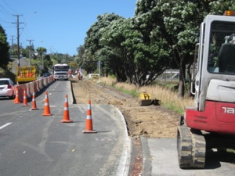
Construction started in December on Duncan Street between Tawa Station and the College. The path is being pulled up and replaced by a 3m-wide path/walkway. (See the Tawa Community Board snippets further down). Next will be a brand new footpath along Findlay Street. Wellington City Council has consultants doing topographical surveys from Willowbank to Duncan Street. From the surveys they will be able to lodge the resource consents they need. Council hopes to lodge the consent early this year for the Redwood Station to Duncan Street section. This will be the next piece of walkway constructed after Findlay Street.
The consultants are also doing some preliminary design work for the bridges.
After the community meeting held in November, and the meeting with the Tawa College Board of Trustees, Council submitted an application for a level crossing (between the College and Tawa Pool) to KiwiRail and this has just been approved. Council will now start designing how the level crossing will integrate with the land uses on either side.
- Brett Gillies, Chairperson of the Tawa Walkway Committee
TAWA COMMUNITY EDUCATION
Enrolments for Tawa Community Education Classes are now being taken for term one. New courses include Caring for the Carer, New NZ Sign Language, Ukulele, Beginner Gardening, Upholstery and Picture Framing. Enrol online at http://www.tawacomed.co.nz.

2 MINUTES WITH …..
Who are Will Warden, Barbara Adams, Robert Armstrong and Margaret McLeod? You might recognise 2 or 3 of those names, or maybe the faces! You might not know any. They are real Tawa people living in our midst, and they have their own stories to tell. Read all about them and a bunch of other Tawa people, almost 30 so far, at http://www.tawalink.com/tawa_people.html. There’s a new profile added each week.
NEW TRAIN TIMETABLE FOR TAWA
New timetables will be available on the MetLink website from Thursday of this week and at timetable outlets from early February. For example, the new times for Redwood to Wellington in the morning weekday peak between 6.30am and 8.00am will be 6.29am, 7.01, 7.18, 7.29, 7.36, 7.50 & 7.56. Definitely an improvement if you’re wanting to catch the train between 6.50 and 7.30am! Previously there weren’t any that stopped in Tawa in that particular time period.
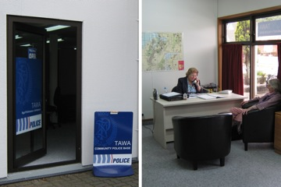
NEW COMMUNITY POLICE BASE
The local police base has moved to a different part of the Tawa Community Centre and it really does have a new and improved look, as shown at right. Last week’s Kapi-Mana News ran an article on the new base.
NEW COMMUNITY CONSTABLE
There has been a delay with the appointment of the new community constable. An appeal is taking place which means that there won’t be anyone officially starting in Tawa at the end of January as previously advised. At the earliest it’s likely to be the end of February.
NEW COORDINATOR AT THE COMMUNITY CENTRE
A new coordinator, Melanie Lapalme, will be starting at the WCC’s Tawa Community Centre this Friday. We can’t tell you anything more about her as we don’t know anything more about her except, to quote a Council officer, “She’s not from this area.”
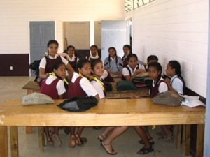
SPARE TOYS YOU CAN DONATE?
If you have quality used toys, children’s books and school stationery you’d like to donate to a good cause, Toys 4 Tonga is a Rotary project currently collecting such items for needy children in Tonga. A container of toys and books, etc will be on its way to Tonga in a couple of months’ time.
Toys, books and stationery can be left in the Toys 4 Tonga collection box at the Tawa Community Centre in Cambridge St or Toy World in Porirua.

These programmes for children aged from 4 to 12 are being offered by Hayley Balmer, a teacher, in Redwood, Tawa on 20 & 21 Dec and 26 - 28 January. Each session is different and is 3 hours long. Children can come for as many sessions as they like. All groups have limited places and a reservation is necessary. Cost $23 per session. Extra hours are possible. Email hayley.balmer@xtra.co.nz for further details.
TAWA COMMUNITY BOARD SNIPPETS
THE NEXT COMMUNITY BOARD MEETING IS THURSDAY 10.2.11
As there hasn’t been a Board meeting since the last community newsletter, there isn’t anything to report from a meeting that hasn’t taken place (if you get the drift).
However, the Board hasn’t been resting on its laurels. Here’s something of what members of the Board have been involved in:
- DUNCAN STREET
You may have noticed the recent roadworks in Duncan Street just south of Tawa College. This is to do with construction of the path for the Tawa Walkway project. The first stage
is to widen the footpath in Duncan St - from about Tawa Station to opposite the College driveway - to a 3m walkway. For some of that stretch there isn’t enough room off the roadway to make the walkway that wide. Consequently the new footpath/walkway is encroaching onto the road, which has resulted in the roadway being narrowed by 1.5m.
It seems that no-one locally knew that narrowing of Duncan St at this point was going to take place. And not everyone thinks it’s a good idea, bearing in mind the ‘diabolical’ traffic situation that regularly arises with traffic at the end of each school day, particularly when it’s wet and there are even more cars parked there than usual. Various bods including Tawa College representatives and Tawa Community Board members met with WCC traffic engineers on site last Wednesday (19 January) to review the situation. As a result, the Council did agree that narrowing of the road would stop well before the College, rather than the road being narrowed all the way up to the parking bay opposite the College.
As it is, there will be yellow lines in place to stop cars parking on the western side of the narrowed road (the side closest to the railway line). This will result in the loss of a number of parking spaces on that side of the road. However the Council contends that the narrowed road could actually improve the traffic situation at this point. Previously there was a gap of approx 4.5m for opposing traffic to get through if there were cars parked on both sides of the road. With the road having been narrowed and cars being able to park on only one side of the road, the gap for opposing traffic to get through will now become approx 5m. But that will still mean a schoolbus and the likes of an oncoming SUV (or even smaller) won’t be able to pass at the same time.
We’ll be watching with interest to see how things actually pan out when school starts again!
OTHER BITS & PIECES
- The Tawa Community Board has been trying for a number of weeks to get the street lights in Brasenose Place working again. They’ve already been fixed twice but only
seem to last a few days before bombing out again, leaving most of the street in darkness. We’re doing our best to get this finalised as soon as we possibly can.
- A sign between the new roundabouts at the southern entrance to Tawa will be in place one of these days indicating that both DressMart and the Tawa Village Shops are located up the road.
- Concerns about all-day parking in Rawson St (leading up to Linden Station) are being addressed by Community Board representatives and WCC traffic engineers.
- Other ‘mundane’ but necessary stuff like the state of various footpaths, removal of dead trees, water seepage, and parking restrictions have been dealt with in the past few weeks by the Board. You won’t want the details so we won’t give them.

HAPPY NEW YEAR FROM THE TAWA COMMUNITY BOARD
The Tawa Community Board wishes you a happy and prosperous new year.
Malcolm Sparrow • Cr Ngaire Best • Graeme Hansen • Cr Justin Lester • Margaret Lucas Chris Reading • Alistair Sutton • Robert Tredger

Adios

Malcolm Sparrow
On behalf of TawaLink.com
<info@tawalink.com>
<http://www.tawalink.com>
232 5030 A/H or 027 232 2320
COMING UP IN TAWA:
Thursday 27 January: Push Play in the Park
Duncan Park, Tawa 2-4pm. Take part in free outdoor activities suitable for all ages including T-Ball, badminton, volleyball. All equipment provided and no bookings necessary.
Saturday 19 February: Tawa Music Centre Enrolment
9.00-10.30am at Tawa Intermediate School Hall.
Sunday 20 February: Historic Walk from the Library to the Lookout
Organised by the Rotary Club of Tawa and the Tawa Historical Society. Bruce Murray and other long-term residents will explain the local history at several stops along the way.
No charge. Bring the whole family and learn many interesting facts about some of Tawa’s earlier people and places.
Starts Tawa Library at 2pm (or, if wet, Sunday 27 February).

Details of other upcoming events are available at http://www.tawalink.com/coming_events.html

Cheers

Malcolm Sparrow

On behalf of TawaLink.com
<info@tawalink.com>
<http://www.tawalink.com>
232 5030 A/H or 027 232 2320

“Could crop circles be the work of a cereal killer?”

“Both optimists and pessimists contribute to society. The optimist invents the airplane, the pessimist invents the parachute.”
- George Bernard Shaw

“Success is the ability to go from one failure
to another with no loss of enthusiasm.”
- Sir Winston Churchill

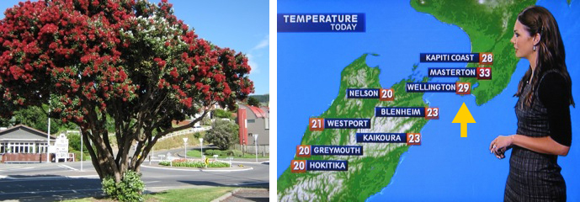

Wellington can be a great place in the summer. Pohutukawa in Tawa. Temperature recorded
on Wednesday 19 January 2011. When did you last see Auckland as warm as this?

This community newsletter is emailed to more than 900 Tawa households, businesses, schools, churches and clubs/groups (anyone who has an interest in the community of Tawa) every month or so. If there's anything you'd like to include in the next newsletter, please let us know. If you do not wish to receive the newsletter, please send us an email requesting that your name be deleted from our list.

