
3
COMMUNITY

NEWS

Tawa

February 2011

This community newsletter is compiled every month or so on behalf of tawalink.com, Tawa’s community website since 2002.

PLEASE SIGN THE EPETITION NOW !!!
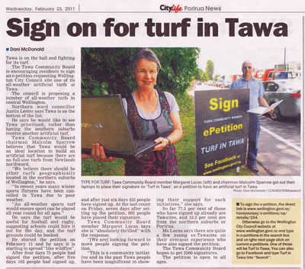
A big THANK YOU to each and every one of you who has signed the Tawa Community Board’s ePetition for a Turf in Tawa.
If you haven’t already signed, we would really appreciate your doing so!
If you have already signed, PLEASE get the rest of your family to do so. That action in itself could add several hundred names to the petition.
The vast majority of local people with whom we’ve been in contact think that the idea of an artificial turf in Tawa will be great for the community as a whole.
A couple of other responses have been:
• “Won’t it add to my already high rates bill?” We say no, it won’t. If the WCC has already allowed for funding for a small number of artificial turfs in Wellington, it makes sense for the community of Tawa to raise its collective hand and say, “Please

pick us for one of those turfs”. That’s precisely what we’re doing. Better here than 25kms away!
• “I’m not into sport. It doesn’t do anything for me.” The reality is that the majority of us who have signed the petition won’t directly benefit from it. However the community as a whole will. That’s what Tawa is all about – community! Working for the common good, that sort of thing (which on the whole we do pretty well – that’s what people like about this place!).
And for statistics freaks (like the writer):
At the end of Tuesday of last week, the petition had gained 165 signatures - after 4½ days.
As at 8pm today (Friday), the petition had 1092 signatures - after 14½ days. Halfway there!
79.0% of those are from Tawa (brilliant!), 6.4% from Porirua, 5.0% from other northern suburbs of Wellington, and 4.7% from other parts of Wellington city.
It would be great to exceed 2,000 signatures by 11 March. We can do that with at least 65 signatures a day. So please do get the rest of your family (and a few friends) to add their names. Go to http://www.wellington.govt.nz/haveyoursay/e-petitions/ep/details/154.
VARIOUS COMMUNITY NOTICES:
TAWA-LINDEN WALKERS
Tawa-Linden walkers meet outside the Tawa RSA hall, Oxford St, every Tuesday at 9.00am for a 9.15 start. Walks cover the greater Wellington area. A walk programme is on display in the Tawa Community Centre and will be updated before 1st March. For more details contact Maurice on 232 4407, or Claire 232 8764.
PLUNKET’S WALKING PROGRAMME
Join us on a walk around Tawa and Linden and be part of Plunket’s free walking programme. Doors open at 9.00am for a 9.15am start Wednesdays 2nd and 9th March. Doors open at 9.45am for a 10.00am start Sunday 27th February and Saturday 12th March. Pets, older children and partners welcome. Walk departs and finishes at the Tawa Linden Plunket Rooms in Linden Ave. Light refreshments will be available at the rooms.
TAWA JUNIOR HOCKEY CLUB – 2011 REGISTRATION NIGHTS
The Tawa Junior Hockey Club invites registrations from players in northern Wellington who wish to play turf hockey this winter. We welcome back players from previous years, and new players in years 5-8 are welcome. Registration nights are Tuesday 8th and Thursday 10th March, 6.00-7.00pm at the North City Cricket Clubrooms, Gee Street, Linden. Subs: $130 first child, $110 each additional child (covers uniform useage, affiliation, turf fees). For further information phone Rik Foote on 235 5031 or email rik459@hotmail.com.
MEN’S HEALTH EVENING
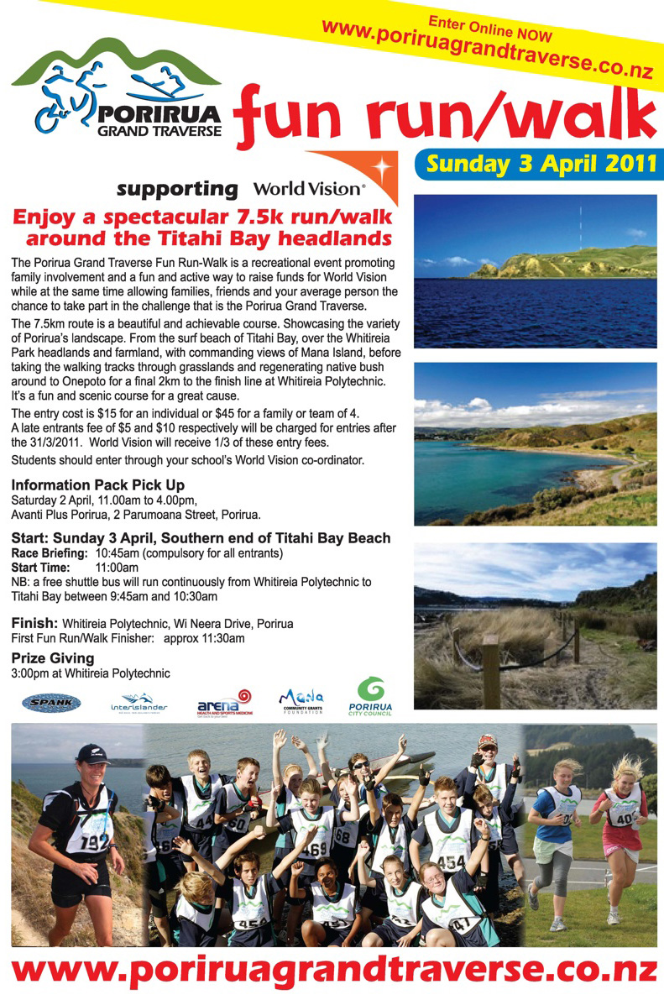
Following on from the very successful and well-attended men’s health evening held in July 2010, another evening is being held on Thursday 10th March at the Emmaus Centre, St Christopher’s Church. Light refreshments and free blood pressure tests will be available from 7pm. Dr Kevin Fitzsimons from the Tawa Medical Centre will open the discussion at 7.30pm. All Tawa men are invited to attend, and a koha of $5 would be appreciated.
PORIRUA GRAND
TRAVERSE FUN RUN & WALK
Porirua Grand Traverse Fun Run & Walk is a recent addition to the Porirua Grand Traverse and grew out of Tawa College’s relationship with World Vision. The event takes place on Sunday 3rd April. Details set out in the poster shown here.

NEW COMMUNITY CONSTABLE

As previously advised, there has been a delay with the appointment of the new community constable because an appeal is taking place. Unfortunately it’s still “going through the system” and it may be a few weeks yet before the new person is officially in place.
2 MINUTES WITH …..

Who are Murray Cameron, Marianne Peacocke and Wayne Devine? One has lived in Christchurch and Canada and has Dutch heritage. Another is an author whose working life was with the old Lands & Survey Department and the modern-day DoC. The other is Tawa-born and bred and currently Head of Music at Tawa College. Read all about these and other interesting “Tawa People” at www.tawalink.com/tawa_people.html. There’s a new profile added most weeks.
TAWA COMMUNITY BOARD SNIPPETS
- TAWA COMMUNITY PLAN
Tawa Community Board is finalising the draft of a “Community Plan” which sets out the role of the community board in Tawa and some specifics as to what the board wants to achieve in Tawa over the next three years. The plan will shortly be available for local residents to peruse (it’s actually reasonably interesting) and to provide feedback.
- THE PROPOSED NEW SUPERMARKET
At the very end of November New World will take over Woolworths’ supermarket complex. Total refurbishment will take place at that stage, with the new New World supermarket not re-opening until well into 2012. In the meantime a free bus service to New World Porirua is likely to be available and there may well be a temporary “convenience store” in the other part of the mall. The new highly-improved supermarket will be more than one-third larger.
- NEW TOILETS AT WILLOWBANK
The public toilets at the entrance to Willowbank will be getting a major revamp in another two or three months’ time. The intention is to retain the current concrete pad, keep the structure of the roof as a dual sheltered/viewing area, open up the structure into the reserve and enhance visibility of the stream (improved views?), and install Exeloo pre-built toilets.
- PROPOSED RESTORATION OF TAWA RAILWAY STATION
Tawa Community Board is discussing with the Tawa Historical Society the possibility of restoration of the Tawa Railway Station. If you’ve seen what has been done with Plimmerton Station, you’ll appreciate the possibilities with Tawa Station. We’ll keep you informed of developments.
THE NEXT COMMUNITY BOARD MEETING IS THURSDAY 10.3.11. ALL WELCOME!

Adios

Malcolm Sparrow
On behalf of TawaLink.com
<info@tawalink.com>
<http://www.tawalink.com>
232 5030 A/H or 027 232 2320
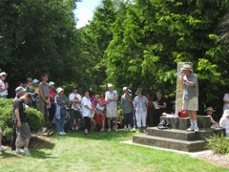
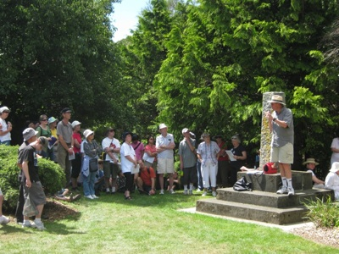
TAWA LOOKOUT HISTORICAL WALK
Around 180 hardy souls took part in the Rotary-organised walk on Sunday afternoon, 20th February 2011, starting at the Tawa Community Centre at 2pm.
Tawa’s own Aspire Band provided entertainment at the outset, then it was off in the direction of Oxford St and the first stop at Grasslees Reserve. At this point Bruce Murray (Tawa Historical Society) gave a talk on the significance in the history of Tawa of the Grasslees name and of Elsdon Best, the man. Along Davies St to McLellan St and Ranui Tce, and through the pedestrian walkway under the motorway to the next stop and another talk.
Then Allen Tce, Lupin & Spicer to the cul-de-sac in Woodman Drive. Being a very sunny and rather warm day (superb weather in actual fact), the water spray provided by the local fire brigade in the cul-de-sac was much appreciated. Some distance further along Woodman Drive a left-turn into Kilkelly Close was followed by the final track up to the Rotary lookout where one is rewarded with splendid views of the whole of the Tawa valley.
And so back to the community centre for well-deserved refreshments and a certificate to commemorate a successful excursion. Pics at http://www.tawalink.com/pic_week_2011-06.html

COMING EVENTS IN TAWA
Details of various events in Tawa are available at http://www.tawalink.com/coming_events.html.

Cheers

Malcolm Sparrow
On behalf of TawaLink.com
<info@tawalink.com>
<http://www.tawalink.com>
232 5030 A/H or 027 232 2320

“Every man has his follies - and often they are the most interesting thing he has got.”

“I know in my heart that man is good. That what is right will always eventually triumph.
And there’s purpose and worth to each and every life.” - Ronald Reagan

“For the people of Christchurch, this just isn’t fair.” - Kevin Rudd

This community newsletter is emailed to more than 900 Tawa households, businesses, schools, churches and clubs/groups (anyone who has an interest in the community of Tawa) every month or so. If there's anything you'd like to include in the next newsletter, please let us know. If you do not wish to receive the newsletter, please send us an email requesting that your name be deleted from our list.

