
COMMUNITY

NEWS

Early June 2011
This community newsletter is sent out on the first and third Wednesdays of each month (or thereabouts) on behalf of tawalink.com, Tawa’s community website since 2002.

TAWA COMMUNITY BOARD GRANTS
The Tawa Community Board’s Grants sub-committee has approved the following grants to local groups from a total pool of $15,000:
Beanstalk Kindergarten $675 to promote Beanstalk in the community and to nurture early childhood education
GirlGuiding NZ Tawa $1138 to purchase and install a whiteboard in the guide hall
Mana Tiaki Inc Society $250 towards a new pavement sign outside new offices
Sri Lankan Assn of NZ Inc $500 towards a workshop to train children in voice management and playing the guitar (at Tawa Community Centre)
Tawa College $1450 to purchase two full sets of hockey goalie gear
Tawa Community Light Party $750 towards annual children’s party held as alternative to Halloween
Tawa Community Patrol $1116 for two members to attend national training seminar in Dunedin
Tawa Progressive & Ratepayers Assn $1500 towards maintenance of TawaLink website
Tawa Squash Club $1000 for “Mums and Bubs in Squash” – a mid-week daytime initiative
Tawa Swimming Club $2453 to purchase new fins for Tawa Swimming Club members
Tawa-Linden Plunket Toy Library $1200 towards purchasing a bouncy castle to hire out to members
Vocal FX - Wellington Men’s Barbershop Inc $500 to enable assistant director (Tawa-based) to travel
to International Barbershop competition

TAWA HISTORY WEEK
The Tawa Historical Society will once again offer the community a Tawa History Week early this month. It will consist of four talks on topics related to Tawa’s history, and will be held each day at 10.00am till 11.00am from Tuesday 7 June to Friday 10 June 2011 (that’s next week). A cup of tea/coffee and a biscuit commences the proceedings (at 10am).
Topics for each day are listed on this page: http://www.tawalink.com/coming_events.html

GETTING HIS HEAD SHAVED FOR CHARITY
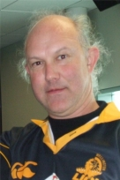
John Sherborne, a local man, has been persuaded to have his head shaved for charity - The Leukaemia & Blood Foundation of New Zealand. Seems like a few folks would like to see his ponytail go. Because it’s such a worthy cause he has agreed, subject to people donating a sum of $2,000 by 26 June.
See this link for more info:
http://www.shaveforacure.co.nz/view_event_profile/5351
One would have to say a complete head shave wouldn’t be a bad thing for John! So any contributions would be much appreciated!

SPRING INTO TAWA MARKET DAY
It’s only 101 days away – on Saturday 10th September. We’ll be sending out information later this month. Contact us if you haven’t previously been involved and want to be this time.

TAWA VOLUNTEER FIRE BRIGADE DEFIBRILLATOR
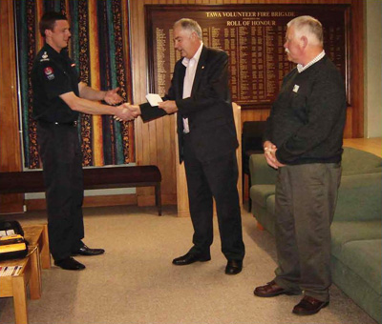
At a combined function at the Tawa Fire Brigade, cheques were presented by Tawa Rotary and Tawa Lions to Michael Farrand, Chief Fire Officer, to purchase a second defibrillator for the Brigade. Michael said “This recent acquisition will enable the Tawa Brigade to further assist the local community by providing lifesaving intervention to patients suffering from a cardiac arrest.” A defibrillator utilises electric charges to shock the heart and establish a normal heartbeat. This is a good example of how local service clubs can work together to provide funds to assist the Fire Brigade in its major role of supporting ambulance services throughout the Tawa community and wider region.
The photo shows Rotary’s past president Bruce Phillips presenting a cheque to Michael Farrand, Chief Fire Officer at the Tawa Volunteer Fire Brigade, while Tawa Lions president David King looks on.
- from this week’s Rotary Club of Tawa Tabloid newsletter

TAWA INTERMEDIATE TEACHER IN MUNICH
By Imogen Warren, recipient of a Ministry of Education Language Immersion Award to travel to Germany in April. She teaches German to her students at Tawa Intermediate.
Castles, mountains, legends and fairy tales. That is Bavaria (Bayern). Four weeks at a top language school in Munich was a dream come true. I spent my mornings in the school speaking only German (auf Deutsch bitte, was the tutor’s ongoing reminder) with people from all over the world. We all spoke broken German but with gestures and effort we laughed, learned about each other and slowly improved our German.
First thing every morning we would review the newspaper and learn about German politics and economics. Did you know that, for instance, BMW stands for Bayerische Motoren Werke and is a major reason why unemployment is so low in the area.

In the afternoons and weekends I visited museums, castles and strolled the streets of Munich. Prepared for winter weather (snow is still common in April) I was surprised to be in t-shirts getting a suntan in the warmest April in over 100 years! The beautiful weather also meant I was able to spend some afternoons in the Nymphenburg Palace, just behind my accommoda-tion, which was wonderfully calming and peaceful.

Further afield I visited Neuschwanstein Castle which is the man-made equivalent of the Grand Canyon, definitely a wonder of the world. I also felt it very important to visit Dachau Concentration Camp near Munich and travel to Krakow, Poland to visit Auschwitz Concentration Camp. Both were deeply moving and disturbing in equal measure. My students at Tawa Intermediate have been very interested in what we can learn from these places. It is vital that the causes and consequences of the Holocaust are not forgotten.
I have learned a huge amount about Germany, the German language, teaching languages and indeed myself during my trip. I have brought back new teaching techniques, resources, and most importantly a new idea of what it is like to be a student. Watching my tutor, other students, and thinking about my reactions as a student have given me fresh thoughts about what students need, want and are comfortable with. And what I can do better as a teacher.
GERMAN YOUTH CHOIR IN TAWA THIS MONTH
The renowned German Youth Choir “Christophorus Kantorei Altensteig” is touring New Zealand this month and will be giving a concert at Tawa College Hall on Monday 20th June at 7.30pm. The choir is being co-hosted by St Christopher’s Anglican Church and Tawa College.
The “Christophorus Kanteri Altensteig” is a well known school choir in Germany and carries the title “Best German Youth Choir” after winning the prestigious German choir olympics last year. Each year the choir undertakes a two week European tour and every four years an international tour with the goal of sharing their music in churches, schools and choirs and getting to know a country especially through its people. In that sense the choir seeks to be billeted with host families rather than overnighting in youth hostels!
The choir is touring New Zealand from 11th-29th June with 41 girls and 19 boys, grades 8-13, and 6 accompanying adults.
The concert programme (approx 1½ hours) is a mix of “spiritual and secular” music. Language-wise: 40% English, 40% German, 20% other.
For further info, see the official website: http://www.christophorus-kantorei.de/en/index_en.html
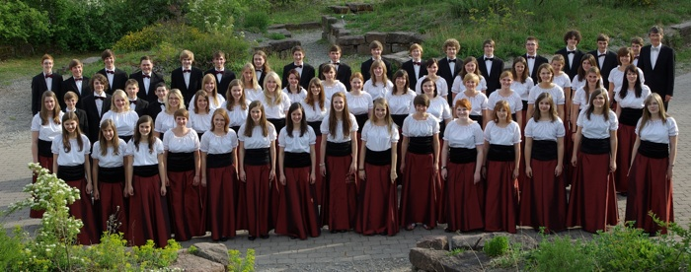
NOW FOR THE CRUNCH – BILLETS REQUIRED!
Following on from the above paragraph about the German Youth Choir, Neil Shanks (including his two eldest children), a former resident of Tawa and student at Tawa College, now residing with his family in Germany, is looking for billets (in pairs) for about 30 more members of their 68 strong team in Tawa for the nights of Monday 20th & Tuesday 21st June. If you can assist please contact Heather Becada (Neil’s sister) on 232 6955.

TAWA SWIMMING CLUB OPENINGS
Tawa Swimming Club currently has openings in its junior competitive swim squads. If your child is interested in swimming as a sport and has the basic skills of all 4 strokes please contact our head coach, Mat Woofe, on 027 316 2218 or email coach@swimtawa.org.nz to discuss options and arrange an assessment.
Tawa Swimming Club is a developing force in the world of competitive swimming, recently finishing 11th out of 78 clubs at the National Age Group Championships. Our current swimmers are representing Tawa regionally, nationally and internationally. They are very ably coached by Mat Woofe, himself an ex-NZ representative swimmer who has extensive experience in coaching including at an international level.
Take this opportunity now to be part of an exciting sport. Alternatively if you are not quite ready for squad training we do have spaces in our community club night programme. Contact our Club Captain on captain@swimtawa.org.nz for more information. Or visit our website at www.swimtawa.org.nz


TAWA COMMUNITY BOARD INFO
- PROFILE OF A COMMUNITY BOARD MEMBER
Graeme Hansen
Early life … Born in Hamilton (go the Mooloos - except
when playing Wellington).
Lived in Tawa since … 1984
Family … Married to Helen with three adult children and
one grandchild.
Work experience over the years …
Since leaving school I’ve always worked in the
insurance industry - in claims, commercial risk and underwriting.
In 2001 I started my own insurance agency, predominantly
working with businesses, and have been self-employed ever since.
Interests and hobbies … Justice of the Peace, Tawa Catholic Church Finance Committee
Chair, Coordinator and member of the Porirua Nominated Adult
Group (CYP&F Act); football referee, travel, photography,
armchair motorsport and football fan.
Which sports team(s)? Phoenix Football Club member, Hurricanes & Waikato/Chiefs supporter. English football club - Manchester United.
On the Tawa Community Board since … October 2007
Why the community board, and what do you do on it?
I wanted to work for my community. I was at a stage in life when
I had the time to work as an advocate. Personally I am keen to
see better public transport and roading.
Deputy Chair of Tawa Community Board since 2007.
Responsibilities: Roading, Tawa Grants, Spicer Landfill Community Liaison Group.

MY NAME IS SCAMPER AND I AM MISSING!!!
I am a 3-year-old neutered male tabby, short-haired cat. I am very independent and know what I require and when! I know my territory well, where I live and belong. I would not miss my food for anything. I can open my door to let myself in and out.
I usually hang out in the Redwood Village/Dress-Smart vicinity. If you come across me please contact Lynette on 232 8614.

TEEN ONLY NIGHT - GET LOUD @ THE LIBRARY
Tawa Library is opening 6.30-9pm on Friday 10th June for a teen only night (13-18 year olds only).
Lounge in the library – no kids, no adults, just you and your mates and music, gaming, free internet and free food. For ages 13-18 only (bring your library card or school ID to get in). Go to www.wcl.govt.nz/blogs/teens to find out about this event and other stuff going on for teens.

THANKS TO WELLINGTON CITY COUNCIL
Easyswim Swim School operates out of Tawa School’s pool. The school was recently granted money to replace four broken garage doors under the WCC School Pool Partnership Fund. The Swim School simply wishes to make it known that they’re grateful to the Council for the School Pool Partnership Fund.

HOT OFF THE PRESS – BARBERSHOP CHORUS SUCCESSES
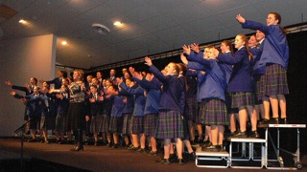

At the Wellington Regional finals at the Wellington Town Hall last night (Tuesday), Tawa College’s “Maiden Tawa” were placed 1st in the Young Women in Harmony competition. In the Young Men in Harmony competition, Tawa College’s “Acafellas” were 2nd. Congratulations to both choirs. They continue the tradition of excellence in music at the College. The National Finals are scheduled for Wellington in August.
[Okay, so we cheated with the pics. As we didn’t get hold of 2011 photos in time, these are the 2006 versions when, at the same event, Maiden Tawa were placed 1st and Acafellas 2nd.] Would you have known?

NEW COMMUNITY CONSTABLE FOR TAWA
It’s taken a few months but we’re almost there. At this very moment the Police are not able to make public the name of the new appointee. One or two details need to be finalised, like when she will actually be starting in Tawa. We should be in a position to reveal all (so to speak) in two weeks’ time.

WHAT DO YOU CALL SOMEONE WHO LIVES IN TAWA?
That question might invite unkind responses from the hoi polloi. But I’m intending it as a serious one.
If someone who lives in Wellington is a Wellingtonian, one living in Auckland is an Aucklander (aka a Jafa), someone in Dunedin a Dunedinite, and someone from Christchurch a Cantabrian (because they’re never known as Christchurchers or Christchurchites, but that’s another whole issue), what is someone from Tawa known as?
The three terms I’ve heard are these:
Tawaite (as in Tawa-ite), Tawinian, and Tawanese.
Admittedly it’s not a matter of great importance, but if are any other “names” you’d like to throw in the mix, feel free to do so. Personally I quite like the idea of saying “I’m Tawanese”, although there probably aren’t that many occasions when I’m likely to do so.

Adios

Malcolm Sparrow
On behalf of TawaLink.com
(loosely under the umbrella of the Tawa Progressive & Ratepayers’ Association)
info@tawalink.com www.tawalink.com
232 5030 A/H or 027 232 2320

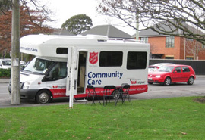
P.S. I was in Christchurch last week playing a small part in assisting the Salvation Army with the ongoing aftermath of the earthquake. We were assigned to camper vans (as pictured), three people per van, which we parked in either a shopping mall carpark or at the side of the road each day, any place where there were people. The aim was to provide both advice and financial assistance to those who had been affected by the earthquake.
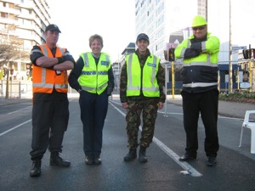
We came across people whose lives had been severely impacted by the earthquake. One “middle class man” in his early 60s had lost his house in the quake and was now in rented accommodation awaiting an insurance payout. He figured that he wouldn’t get enough to cover his losses and would need to take out a mortgage again, something he’d never expected to have to do. He had been in sales most of his working life but his place of work had been closed by the quake and he was out of a job. He was doing his best to find work but hadn’t yet been successful. He had never imagined he’d need financial assistance from the Salvation Army, but that was now the situation in which he found himself, hopefully only temporarily.
A certain number of those seeking assistance were doing so not just because of the earthquake. The Salvation Army is there to assist all who need it, but wisely treat each case on its merits. We saw a number of people in council flats who “exist” from one benefit day to the next, and sometimes don’t make it that far without assistance. My admiration for those like the Sallies who work with the “needy” on an ongoing basis has increased immensely. I will freely admit that it’s something I would struggle to cope with. They deserve a pat on the back … and maybe financial support from the rest of us!

We gave out chocolate bars to many of the personnel manning the checkpoints into the “red zone”. They were happy to talk – police, navy, air force, etc, as well as private security guards. Many are doing 12-hour shifts and are bored out of their skulls! One young military fellow admitted that the orange cones on the top of nearby 4m poles had been placed there by him. He’d also upped the price of a litre of petrol at the nearby service station (out of action, being in the red zone) to $4.00 – all to fill in the time!
As for Christchurch itself, it’s finally starting to sink in (for me anyway) that much of the inner city landscape has changed forever, and parts of suburbia as well. It won’t be the same again. I sincerely hope that the Cathedral will be resurrected to its former glory, but now I’m starting to wonder whether even that will happen. I think I’ll leave it at that.

“There are only two ways to live your life. One is as though nothing is a miracle. The other is as though everything is a miracle.” - Albert Einstein
“Life is either a daring adventure, or it is nothing.” - Helen Keller
“Many wise words are spoken in jest, but they don’t compare with the number of stupid words
spoken in earnest.”

This community newsletter is emailed to more than 1000 Tawa households, businesses, schools, churches and clubs/groups (anyone who has an interest in the community of Tawa) on the first and third Wednesdays of each month, or thereabouts. If there's anything you'd like to include in the next newsletter, please let us know. If you do not wish to receive the newsletter, please send us an email requesting that your name be deleted from our list.

