

COMMUNITY

NEWS

August 2011 - 2
This community newsletter is sent out on the first and third Wednesdays of each month (or thereabouts) on behalf of tawalink.com, Tawa’s community website since 2002. On this particular occasion it’s actually the fourth Thursday!

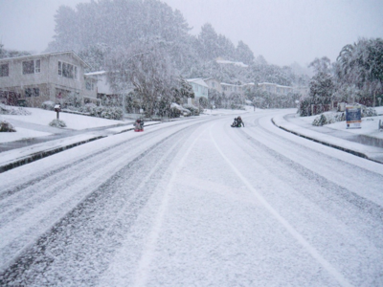
SNOW PICS
It already seems ages ago, the day(s) in mid-August 2011 when it snowed! And the snow is the reason this newsletter is later than it was meant to be. The day after the first snowfall I asked the Tawa community to send me through their pics for inclusion on a web page or two. However I don’t think I was expecting quite as many as 240 to come through!
It took me a considerable chunk of last week to get the resultant 163 photos onto the website. The occasion itself was magic – see my writeup online – and it was great to be able to feature around 35 Tawa streets’ worth of photos all on one site at http://www.tawalink.com/pic_week_2011-36.html. Thank you everyone for your contributions. They were much appreciated!
The above shot is of Oriel Ave, taken by Anna Heyward. It’s a road up which I travel frequently. I didn’t actually witness the snow on it, so it’s great to have the above record of the occasion.

SPRING INTO TAWA MARKET DAY FAST APPROACHING
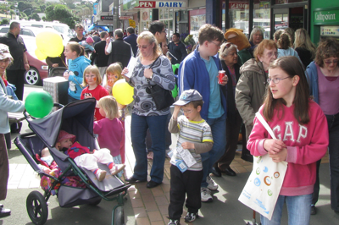
It’s just over two weeks until this year’s Spring into Tawa Market Day on Saturday 10th September.

This is when hundreds (if not thousands) of people head to the 50+ stalls operated by community groups and local businesses at the Main Road shops in central Tawa. And there’s always plenty of entertainment provided by students from the NZ Radio Training School. There will also be an item from a local dancing school, a few numbers from the Red Hackle Pipe Band, as well as Morris dancers and others in action.

Applications for stallholders are meant to be in by tomorrow, Friday 26th August. If you or your group are still interested in running a stall, send an email to info@tawalink.com or give Malcolm a call now on 232 5030.

THE OLD CALTEX SERVICE STATION PREMISES
We reported the following in May: “The former service station premises on the corner of the Main Road & Essex St was bought by Devon & Patterson Flooring Xtra who currently operate out of Rewa Tce. They were intending to use it for themselves but have had an approach from another retailer with whom they are currently in negotiations. Although it’s very likely that this deal will be going ahead, it won’t be finalised for another 2-3 weeks.”
We’ve been checking with Devon & Patterson every three weeks or so since then. Negotiations still haven’t been finalised, or it may be that they’ve moved on to negotiations with a different party. Whatever the case, it’s been suggested that I contact them again in another 2-3 weeks time and they may have something to report. We’ll keep you posted!

BBC COMES TO TAWA SCHOOL
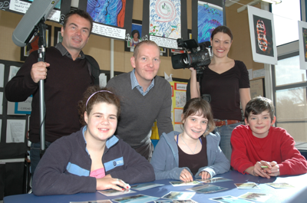
On 2nd August Tawa School hosted a BBC film crew filming for a UK TV series called “Wanted Down Under”, which focuses on Brits thinking about emigrating to New Zealand. The BBC bring the families over and film them looking into their employment, housing and general lifestyle issues as they consider the big move. This programme will feature a teacher, Rob Boraston from Devon, as he considers moving to Wellington to teach. After a day of filming Rob and his partner looking at housing in the area, the BBC crew filmed Rob being interviewed by the principal at Tawa School (Ian Dewar) and then teaching a class to find out what Kiwi kids and classes are like. The children took the opportunity to learn about the UK from Rob and to learn about the TV industry from the film crew. The programme will feature on BBC in a couple of months’ time and give Wellington/Tawa some great exposure to millions of Brits.

The photo shows Years 7 & 8 (intermediate aged) Tawa School students Chloe Johnston, Hannah Warden and Anders Holm, with emigrating British teacher Rob Boraston, and BBC film crew Jon Bowdon and Catherine Hoskin (producer).

TAWA INTERMEDIATE STUDENTS IN JAPAN

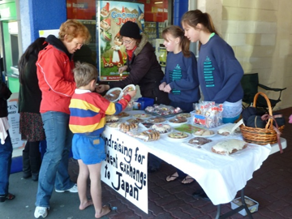
A party of 16 students led by deputy principal Keith Rickard and principal Carolyn Stuart are currently in Japan. They left on Tuesday and return on Sunday 4th September, spending a day or two in Tokyo but most of their time based in Fujiyoshida at the foot of Mt Fuji.

The exchange always takes place with the 26th August in mind as this is the date of the Fire Festival - a huge cultural event in Fujiyoshida and an unforgettable experience for the students.

Tawa Intermediate has been partnered with Fujigoko Jaycees since 1995 and visits Japan every second year. The school played host to 20 Japanese students and three adults back in March.

The photo shows a fundraising stall held at the Main Road shops in Tawa at the end of July. See www.tawalink.com/pic_week_2011-35.html.

WORK UNDER WAY AT TAWA MALL
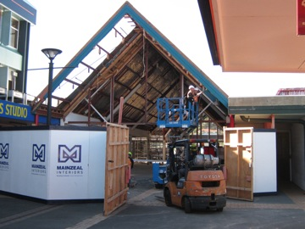
Foodstuffs have previously advised that: “A temporary ‘mini’ foodstore will be set up in Tawa Mall for residents to buy groceries locally while the New World supermarket is being developed nearby. Vacant space in the mall will be used for the temporary store so residents are not left without a convenient place to shop.”
You may have noticed that work has already started on the former furniture store in the mall, the area in which the temporary foodstore will be located. Foodstuffs’ intention is to have the temporary store open prior to closure of the current supermarket at the end of November.
Mainzeal has been appointed as contractor for the Stage One works and these are on programme for a November completion.
Stage 2 works will then commence.

TAWA COMMUNITY BOARD INFO
UPDATE ON TAWA SHARED WALKWAY

The walkway between Redwood Station and Tawa Station alongside the railway line has now pretty much been completed, apart from one or two finishing touches. Wellington City Council is making great progress with the walkway as a whole and it’s very pleasing to see it taking shape in the way that it is. See the photos below.

Stephen Carruthers, WCC Transport Planner, advises that the next stage of the walkway will be Luckie St. Construction will start there in the next couple of weeks. That will be followed by Beauchamp St where work is likely to begin about October.

Plans for a strictly-controlled crossing across the railway line between the Tawa College carpark on the west side of Duncan St and Tawa Pool have already been finalised as part of the walkway. Stephen is addressing the Tawa College Board of Trustees today on the question of where exactly a new pedestrian crossing in Duncan St near the college driveway should be sited.

LETTER TO THE EDITOR
You may have seen the article about Tawa on the front page of the Property Market section in last Saturday’s Dominion Post. It was good positive stuff but unfortunately had a small number of facts wrong.
Graeme Hansen and I (Malcolm) took it upon ourselves to send a letter to the Editor on Tuesday (two days ago) endeavouring to “set the record straight”. The letter hasn’t yet been published. It may not be. Here it is in its entirety:

Tawa is indeed a family-friendly and facility-filled suburb (Property Market writeup, August 20th). The article about Wellington's top suburb (geographically, at least) read well and accurately summed up the benefits enjoyed by the 14,000 residents who live here, not 8,000 as mentioned. However one or two aspects need clarifying. As we understand it the suburb as a whole is Tawa and it contains localities such as Linden, Redwood and Greenacres. Tawa became a borough in 1953, not 1959.
In terms of expansion, there has been more on the eastern hills than that resultant from infill housing. Tawa is a popular place in which to bring up a family because it has so much going for it including an excellent range of schools. Although Brandon Intermediate was mentioned, it is in Cannons Creek and has no connection with these parts. There are six primary schools in Tawa plus Tawa Intermediate, He Huarahi Tamariki (School for Teenage Parents) and a highly-regarded secondary school, Tawa College. At the other end of the scale, Tawa has an abundance of groups catering for the senior population. Those who live here are privileged to do so.
Malcolm Sparrow
Chair, Tawa Community Board
Graeme Hansen
Deputy Chair, Tawa Community Board

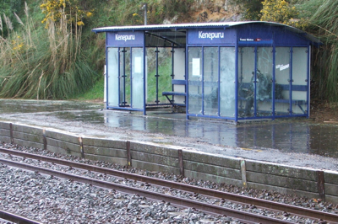
TAWA HISTORICAL SOCIETY NOTICE
MORE FROM THE TAWA COMMUNITY BOARD
POSSIBLE CLOSURE OF KENEPURU STATION

Around 12 individuals from the Wellington Regional Council, both officers and councillors, and the chair of the Tawa Community Board met at Kenepuru Railway Station last week to survey the station and to ascertain why there is talk of its possible closure.

The problem seems to be that the eastern platform needs repairing. To bring it up to scratch will cost more than $1m, or so they tell us. Because the number of people using the station is not great, the powers-that-be feel they can’t justify that amount of money being spent. The investment is too high considering a rather low patronage. In a nutshell we have been told that the two options are to spend a lot of money on the station or to close it.

The matter will be discussed at the next meeting of the

the Tawa Community Board at 7pm on Thursday 8th September. If you wish to hear more about this, you are welcome along. To actually have your say at the meeting – i.e. speak for up to three minutes during “public participation” – you need to book your slot with Fiona at the Wellington City Council on 803 8205.

MEETING WITH THE MAYOR
The chair of the Tawa Community Board has the opportunity to meet with the Mayor of Wellington once or twice a year to bring her up‐to‐date on where the board is at, and to convey any concerns we have on behalf of the Tawa community. The most recent meeting (and the first one so far) took place earlier this month and was very worthwhile.
Topics covered included:
- Tawa Community Plan, a copy of which was handed to the Mayor
- communication with the community via this eNewsletter, a copy also being handed over
- building up Neighbourhood Support in Tawa
- Tawa Primary Schools’ Citizenship Awards and the Mayor’s role in those
- the board’s relationship with Wellington Emergency Management (Civil Defence)

The AGM of the Tawa Historical Society will be held at 7.30pm on Monday 5th September 2011 in the Tawa Community Centre – all are welcome. 2011 marks the 10th anniversary of the Society.
The first edition of our newly published book Arthur Carman’s Suitcase has sold out, but a second edition has been published and can be purchased from the Tawa Library for $30.

CHILDREN’S CLOTHING & TOY SALE
You’re welcome along this coming Saturday, 27th August, at Tawa-Linden Plunket’s quality pre-loved children’s clothing and toy sale at the Tawa Community Centre, 5 Cambridge St, Tawa, 1pm to 3pm. Gold coin entry.

CHATTING TO YOUR NEIGHBOURS
I know of more than one example of how the snow brought people together. Neighbours were out on the street taking photos, throwing snowballs and chatting to people they hadn’t seen for some time or perhaps had never actually met before. It’s interesting how it seems to be an “event” that brings people together, like an earthquake or a snowstorm or whatever.
We’re hoping that more people in more Tawa neighbourhoods take the initiative and get to know their neighbours without needing a major event to do it for them.

Even a neighbourhood barbecue once or twice a year can be a worthwhile exercise and a lot of fun. It’s simply a matter of rolling out two or three barbecues to the end of the cul-de-sac or onto the grass verge out the front or maybe into someone’s front yard. With spring and summer just around the corner, what about taking the initiative and instead of cranking up the barbie out the back of your place, roll it out onto the street and invite your 8 or 10 nearest households to do the same. Speak to one or two in person and maybe contact the others with a letterbox drop.
If you don’t get around to doing that between now and March 2012, you’ll have no excuse at that stage. We’ll be actively promoting Neighbours’ Day Aotearoa which is an initiative encouraging street barbecues throughout the whole country on a particular weekend in late March. Our aim will be to see 50 or more taking place in Tawa. But of course you don’t have to wait till then! Start practising before the real thing!
ANOTHER EXAMPLE of “NEIGHBOURHOOD SUPPORT” IN TAWA:
“Yes, we agree that knowing your neighbours is very important. We have irregular get-togethers with our surrounding neighbours [in our street in Redwood], instigated in fact by our next door neighbours who have since moved out-of-town. These are anything from a backyard BBQ in summer to afternoon tea on a winter’s afternoon - about 10 houses. It’s very reassuring, especially for the parents of little ones, to know there is someone nearby to lend a hand if needed.”

Adios

Malcolm Sparrow

On behalf of TawaLink.com
(loosely under the umbrella of the Tawa Progressive & Ratepayers’ Association)
info@tawalink.com www.tawalink.com
232 5030 A/H or 027 232 2320

“A lot of people like snow. I find it to be an unnecessary freezing of water.” - Carl Reiner

“The reason there is so little crime in Germany is that it’s against the law.” - Alex Levin

“A society grows great when old men plant trees whose shade they know they shall never
sit in.”

This community newsletter is emailed to more than 1000 Tawa households, businesses, schools, churches and clubs/groups (anyone who has an interest in the community of Tawa) on the first and third Wednesdays of each month, or thereabouts. If there's anything you'd like to include in the next newsletter, please let us know. If you do not wish to receive the newsletter, please send us an email requesting that your name be deleted from our list.



Come along and support your favourite
Rugby World Cup team and your local RSA.
The opening of the RWC 11 will be on
Friday 9th September 2011 and will be
broadcast live on the Tawa RSA’s 2 big screens.

Come along in your favourite team’s colours for
a night of good cheer, good food, good company,
and good rugby as the ABs kick off the highlight
of the 2011 sporting year.
Let’s see you there supporting your team
and your local RSA.



All games will be televised during the Club’s operating hours.
Food will also be available on Friday and Saturday nights
during the tournament.

