


NEWS

COMMUNITY
Christmas 2011
This community newsletter is sent out in the first and the third weeks of each month on behalf of tawalink.com, Tawa’s community website since 2002. The newsletter is supported by the Tawa Progressive & Ratepayers’ Association.

TAWA LIONS CHRISTMAS PARADE
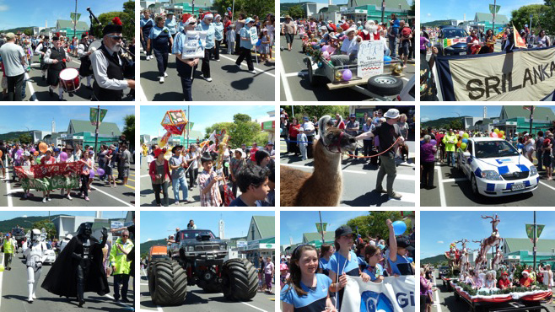
This year’s Tawa Christmas Parade took place on the first Saturday afternoon this month. It was a great afternoon weatherwise and the parade was well-supported. I don’t know how the crowd number compared with previous years (it’s very difficult to tell), but it looked to me like the number of actual participants was up. There was certainly a wide range of groups involved, including both the local Filipino and Sri Lankan communities, as well as the “old faithfuls” like the scouts, guides, playcentre, music centre, MG car club, pipe band, etc. Here are a few photos:
THEY TOOTED FOR TUCKER
As reported in the early December eNewsletter, a food collection for the Tawa Food Bank took place over a couple of evenings earlier this month. “Toot for Tucker” it was called. Members of Tawa Rotary, Tawa Lions and Tawa Volunteer Fire Brigade were out in the streets of Tawa collecting donated non-perishable food items to build up Christmas stocks for the food bank.
Over the two nights a total of 2190 items of food was collected, and $1140 in cash. This was an outstanding effort considering it was the first time “Toot for Tucker” had been trialled in Tawa. Thank you so much to all those who contributed to the food bank project.

TAWA PRIMARY SCHOOLS’ CITIZENSHIP AWARDS
Individual photos of the winning students from each of the seven Tawa schools can be found on this web page: http://www.tawalink.com/tpsca_2011.html. In case you missed the article in Porirua CityLife News the week after the awards ceremony, it is also available on that web page.
The last lot of awards were presented by the chair of the Tawa Community Board to Erin Lockhart at the Tawa Intermediate School prizegiving ceremony at the school last Monday.

CHRISTMAS IN THE CUL-DE-SAC
“Surrounded by the wonderful backdrop of the Woodman Drive Christmas lights, come and support the Salvation Army and give back to the community in this time of giving.
Members of the Tawa College Dawn Chorus will be performing an arrangement of Christmas carols from 8.30pm. There will be a sausage sizzle, food and drink for sale. Thanks to kind donations from local businesses, there will be a Christmas gift basket raffled.
So come along to 46-54 Woodman Drive from 8.30pm on Thursday 22 December, bring the family and celebrate the festive season. All proceeds go to the Salvation Army. Postponement date 23 December.”
Christmas in the Cul-de-sac is the initiative of a group of senior Tawa College students including the 2010 head boy, Mitchell Bernard (see http://www.tawalink.com/mitchell_bernard.html) who ran it for the first time last year. See pics at http://www.tawalink.com/pic_week_2010-46.html.
It wasn’t a warm evening then but a large number of people turned up for the event. Many of the Christmas lights in this impressively-decorated cul-de-sac come on long before darkness sets in around 9pm. On that first occasion Murray Cameron, HOD Music at Tawa College, played numerous Christmas carols on the keyboard before members of the “Dawn Chorus” started singing. All in all it was an inspiring time which is being repeated for Christmas 2011.

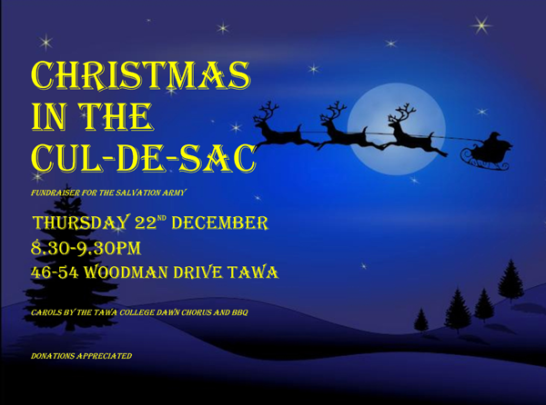
SATURDAY MARKET STAYING OPEN
The Lions Club of Tawa would like to remind everyone that their Saturday Market is open all through the holiday season, including both Christmas and New Year’s eves, at Dress-Smart, south Tawa. The market is held every Saturday (wet or fine) from approximately 8.00am to 2.30pm for fruit and vegetables and from 9.00am to 2.00pm for the sale of eggs, honey, liquorice and second hand goods (including books). And if you have goods that you wish to sell, the cost is only $10 for any car boot sales.
For further information contact Ross Pedder on 232 7147.

COMMISSIONING OF COMMUNITY PATROL CAR
Having been operating in Tawa since May 2008, the Tawa Community Patrol now has its own vehicle. Up until recently patrol members (numbering around 20) have been using their own vehicles (one per night) to drive around the streets of Tawa on Friday and Saturday evenings, acting as “eyes and ears” for the Police.
A goal of $9000 had been set to get the car on the road. By the time of the recent “commissioning ceremony” at the Tawa Community Centre attended by both sponsors and community representatives, $7500 had been raised. The total was reached, as in the photo, with Rotary President Richard Hutchinson (left) handing over a cheque for $1500 to Peter Lockery, chair of the Tawa Community Patrol Charitable Trust.
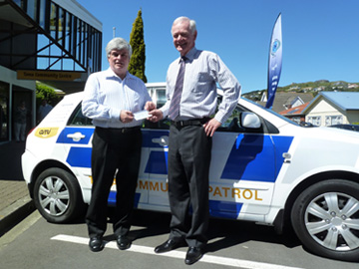
The patrol car has been sponsored by:
ToTal Harbour City Guard Services Ltd
North City Motors Tawa Ltd
Just Rust Ltd
BP Tawa
Nichecom Ltd
AMI Insurance Ltd
Deneefe Signing Systems
Rotary Club of Tawa
Lions Club of Tawa
Tawa Community Board
Wellington City Council

UPGRADE WORK AT KENEPURU STATION
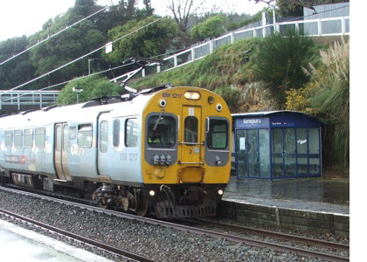
Greater Wellington Regional Council and KiwiRail are carrying out essential repairs and reconstructions at Kenepuru Station over the holiday break to ensure passengers’ safety and improve access. The work will take place between Monday 26 December 2011 and Tuesday 24 January 2012, during which time the station will be closed.
The construction work will include resurfacing of both platforms, the replacement of the southbound platform frontage and upgrading the main access path on the southbound side to prevent any further erosion.
Where do passengers go for train or buses replacing train services during the upgrade work?
See http://www.tranzmetro.co.nz/Detail.aspx?ID=bcb46592-be6c-424d-8271-5759c9ed0ffc for the answer to this question.

STOPPING AT PEDESTRIAN CROSSINGS
The following has been sent through by a concerned member of the community.
“A wee suggestion. Can we have some ‘etiquette’ for both pedestrians and motorists at our pedestrian crossings please [particularly at the Main Road shops].
Pedestrians feel they have the right of way and just step out with no consideration for the motorists - and yes, the cars stop, they’re very good at that!
Motorists often stop when a pedestrian’s stepping out from the footpath on the opposite side when I understand with the waiting area that we have (the island in the middle), it’s okay for the traffic to continue through in such cases. If cars stop when they don’t need to, this adds to the build-up of traffic we often experience.
Actually, I’m usually a pedestrian and don’t like holding up the traffic and wish they wouldn’t stop unnecessarily!!!”

TAWA COMMUNITY BOARD INFO
ACHIEVEMENTS IN THE PAST 12 MONTHS
The chair of the Tawa Community Board was recently asked to supply details to a local newspaper of what the board has accomplished this year. The following is a list of the board’s major achievements.
The Tawa Community Board:
• has made major efforts to liaise closely with the local community, including running a “Meet the community board” meeting earlier in the year and having a stand at various school galas and Spring into Tawa Market Day. Board information is regularly included in this community eNewsletter which goes out twice monthly to around 1100 Tawa residents. Two printed TCB newsletters have been delivered during the course of the year to every household in Tawa.
• actively campaigned for a “Turf in Tawa” which, with more than 2200 individuals backing the board’s petition, resulted in the Wellington City Council agreeing to an artificial turf in Tawa/Grenada North in the 2014/15 year.
• Grants subcommittee approved grants to 12 local community groups from a pool of $15,000, the largest of $2453 going to the Tawa Swimming Club.
• financed a further defibrillator in Tawa, and was instrumental in the installation of a bench seat on the Main Road opposite St Francis Xavier School.
• made a major submission to the Wellington City Council on its Draft Annual Plan, supporting certain aspects and opposing others like a proposed residential rates increase of 6.2%.
• advocated on behalf of residents on numerous roading and parking issues, and other matters such as the proposed closure of Kenepuru Station and the removal of the post box outside Woolworths.
• has had a good working relationship with Foodstuffs, thus were able to stress to them how important it was for some form of supermarket to continue in Tawa once Woolworths closed its doors. We have since seen the opening of the Tawa Temporary Supermarket to tide people over until the new New World Supermarket opens in mid-2012.
• instigated the Tawa Primary Schools’ Citizenship Awards this year, recognising “true leader- ship, citizenship, contribution to school life, etc” in each of Tawa’s six primary schools, plus the intermediate school. This culminated in an awards ceremony where the Mayor of Wellington presented awards to one senior student (or in some cases, two students) from each of the schools in a short but well-received ceremony. The awards will continue as an annual event.

OVER THE NEXT 12 MONTHS
The Tawa Community Board will:
• give its full support to “Neighbours’ Day Aotearoa” in late March 2012. The aim is to have at least 50 streets in Tawa getting together with their neighbours in some way or another, like sharing a barbecue, over the weekend in question.
• work towards installing hanging baskets in the Main Road shopping centre.
• support the proposed restoration of Tawa railway station, and support ongoing progress with construction of the Tawa Shared Walkway.
• organise once again the Tawa Community Civic Awards which recognise the immense contribution volunteers make to our community.
• continue to advocate on behalf of residents on matters of concern to the community.
• continue with the Tawa Primary Schools’ Citizenship Awards.

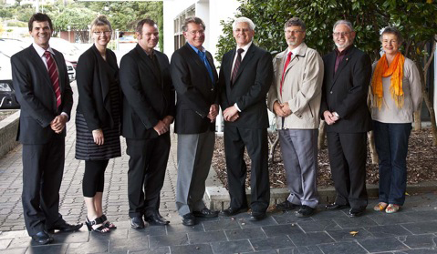

COMPLIMENTS OF THE SEASON FROM THE TAWA COMMUNITY BOARD

From left:
Cr Justin Lester
Cr Ngaire Best
Alistair Sutton
Robert Tredger
Malcolm Sparrow (Chair)
Chris Reading
Graeme Hansen (Deputy)
Margaret Lucas

ON CHRISTMAS DAY …..
Malcolm Sparrow will be in Christchurch with his wife’s sister’s family.
“In the morning we’ll get to a Christmas service and have a big midday Christmas dinner. Unwrapping the presents will feature in there somewhere. In the afternoon we’ll head out to rellies at Tuahiwi (near Woodend) and play cricket on the back lawn. That’ll be followed by an outdoor barbecue with more eating, and back into town later in the evening.”

Ngaire Best will be at home in Tawa.
“I’ll be up bright and early, and off to Christmas carols at the College, a family tradition. Then we’ll have the Christmas presents under the tree with my parents, followed by Christmas lunch at home. In the afternoon we’ll take the dogs to the beach at Queen Elizabeth Park and have a casual picnic tea.”

Graeme Hansen will be at home in Tawa.
“This will be the first Christmas with none of our children living in Wellington. The day will commence with church, then maybe lunch in a park (weather permitting) and end with a light dinner with family.”

Justin Lester will be at home in Johnsonville.
“My wife’s family is staying with us so we’ll have a Christmas brekkie and unwrap presents under the Christmas tree. It’s our daughter Madeleine’s first proper Christmas, she’s 16 months old, so I imagine mum, dad, and her grandparents will be watching her every expression. Hopefully we’ll get a bit of sunshine after that so we can enjoy a bbq and run around outside.”

Robert Tredger will be visiting his in-laws!
“Christmas is about family, and as mine is spread around the world, we will be visiting my
in-laws. It should be a good day as there will be four generations there, and possibly a new addition to the household as well. I have no doubts that the food will be magnificent and we will eat too much. In the evening I will ring my family in the UK to wish them all Merry Christmas and a Happy New Year.”
From Margaret Lucas, an Advent Thought by Joy Cowley.
Star maker, earth shaker, power of the hurricane, voice of the dove, comes to earth in a blaze of angels, called by compassion, formed by love.

WE WOULD ALSO LIKE TO TAKE THIS OPPORTUNITY to thank all

those who work on an ongoing voluntary basis in our community, with

particular thanks to the following groups:

Tawa Volunteer Fire Brigade

Tawa Community Patrol

Tawa Community Police Base Volunteers

A safe and happy Christmas to you all!

CHRISTMAS SERVICE
If you’re in Tawa over Christmas, remember the Combined Christmas Day Service which has been held in the College hall every Christmas Day for almost 50 years.
It’s an opportunity to get together with several hundred other locals to focus on what Christmas is really all about.

Wishing you a very Merry Christmas and a Happy New Year.



All the best .....

Malcolm Sparrow

On behalf of TawaLink.com
(loosely under the umbrella of the Tawa Progressive & Ratepayers’ Association)
info@tawalink.com www.tawalink.com
232 5030 A/H or 027 232 2320

“He who has not Christmas in his heart will never find it under a tree.” - Roy L Smith

“Santa Claus has the right idea. Visit people once a year.”

“It is the one season of the year when we can lay aside all gnawing worry, indulge in sentiment without censure, assume the carefree faith of childhood, and just plain “have fun”. Whether they call it Yuletide, Noel, Weinachten, or Christmas, people around the earth thirst for its refresh- ment as the desert traveller for the oasis.” - D D Monroe

A PERSONAL NOTE …..
We’ve had a family tradition for the past decade or more of spending Christmas in Tauranga every second year with my side of the family, and in Christchurch every other year with my wife’s side of the family. This year we’ll be driving to Christchurch on Christmas Eve for a little break.
It’s been pretty special over the years to have virtually “everyone” together on these occasions – 20 all up in Tauranga last Christmas, including my parents, siblings, own kids and most of their cuzzies. Now that the youngsters are in their late teens and twenties and starting to head off in different directions, there are usually some “missing” and that will increasingly be the case. But in the meantime we’ll make the most of these fun get-togethers.
Brings to mind the old Maori saying which I think is rather meaningful, especially at Christmastime:
He aha te mea nui o tenei Ao?
He tangata!
He tangata!
He tangata!
What is the greatest thing of this world?
It is people!
It is people!
It is people!

This community newsletter is emailed to around 1100 Tawa households, businesses, schools, churches and clubs/groups (anyone who has an interest in the community of Tawa) in the first and the third weeks of each month. If there’s anything you'd like to include in the next newsletter, please let us know. If you do not wish to receive the newsletter, please send us an email requesting that your name be deleted from our list.

