
COMMUNITY

NEWS

April
2012 - 1
This community newsletter is sent out usually in the first and the third weeks of each month on behalf of tawalink.com, Tawa’s community website since 2002. The newsletter is supported by the Tawa Progressive & Ratepayers’ Association.

NEIGHBOURS’ WEEKEND IN TAWA A GREAT SUCCESS!
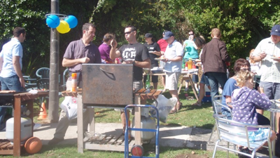
Neighbours’ Weekend in Tawa has been a great success with 45 neighbourhood gatherings taking place on 24-25 March and the previous weekend, and six more lined up for this past weekend.
From what I can gather, that’s more than the rest of Wellington put together. As stated by the Mayor, Celia Wade-Brown, herself, “… hats-off to Tawa in particular. Their enthusiasm is really impressive.”
More than 1100 Tawa people took part in all those street gatherings, mostly barbecues but with the occasional afternoon tea or pot luck meal thrown in.
The concept was driven locally by the Tawa Community Board with support from the Lions Club of Tawa and the local Ratepayers’ Association. It’s about building a community before you need one.
The feedback has been incredibly encouraging with a big number already talking about repeating the exercise further down the track. And other comments like “Some who have been living around here for decades met for the first time ...” and “We are all keen to keep the neighbourly spirit alive ...” are what made it all worthwhile.
A number of reports on “Neighbours’ Weekend” in Tawa are now online. We tried to get them into printed editions of various newspapers but they weren’t particularly interested. No doubt if someone had badly burned themselves at one of the barbecues it would have been on or near the front page, but we weren’t prepared to make that sacrifice! CityLife Porirua News is probably the only paper running a printed article for us. See page 11 of this week’s edition.
Have a look online at:
“Tawa Goes All Out for Neighbours Day” on the Wellington City Council site:
http://www.wellington.govt.nz/news/display-item.php?id=4868
“Wellington suburbs get behind Neighbours Day” (The Dominion Post): http://www.stuff.co.nz/
dominion-post/news/6629512/Wellington-suburbs-get-behind-Neighbours-Day
“Tawa residents right neighbourly” (The Wellingtonian): http://www.stuff.co.nz/dominion-
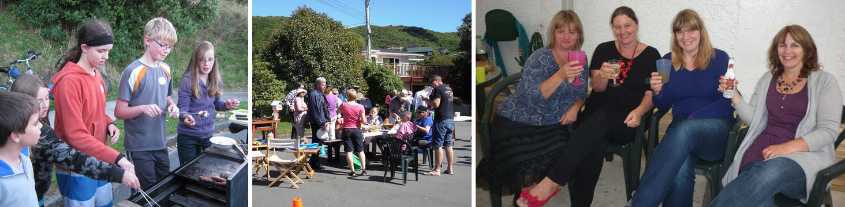
post/news/local-papers/the-wellingtonian/6645071/Tawa-residents-right-neighbourly

FEEDBACK FROM NEIGHBOURS’ WEEKEND IN TAWA
There’s a heap of feedback (reports/summaries/reviews – call them what you like) and photos at http://www.tawalink.com/neighbours_street_list.html. It all makes good reading.
WINNERS OF THE BBQ PACKS
As we’ve previously said, the Tawa Temporary Supermarket was kind enough to offer the Tawa community three BBQ packs comprising the likes of sausages, bread, tomato sauce and a few other BBQ goodies. The names of all the streets “registered” at a particular point were put into a hat and three were drawn out to win the BBQ packs.
The three winning streets were McKeefry Grove and mid Sunrise Boulevard with BBQ packs, and Anthony St who opted for an “afternoon tea” pack because their event, instead of being a barbecue, was (well, it’s kind of obvious really) an afternoon tea.
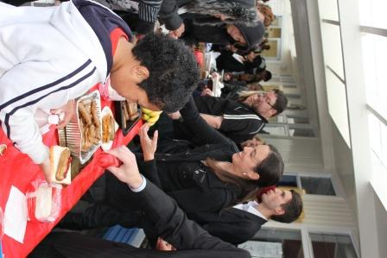
REPORT FROM HAMPTON HILL SCHOOL

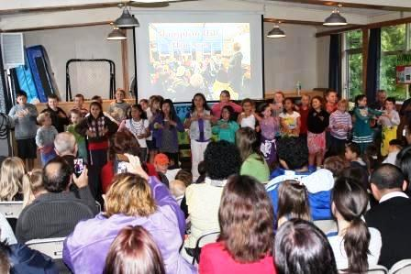
What an amazing Community Hui Hampton Hill had on Monday 7 March. The BOT (Board of Trustees) and staff were overwhelmed by the terrific turnout of families who attended. The evening centred around the children who kicked the evening off by doing a short performance highlighting one of the cultures in the school. Everyone then shared a BBQ dinner, followed by time for the adults to share together whilst the children were involved with activities with Kelly Sports.
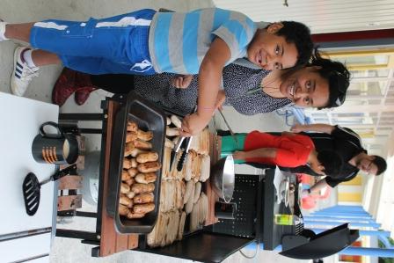
The BOT and staff cooked and served the food for the families and the BOT made sweet treats for dessert. Staff worked with their classes prior to the hui, looking at different cultures and preparing the children to show their learning to the community.
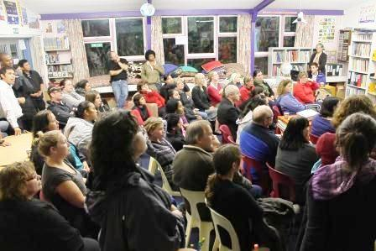
The evening concluded with parents volunteering their time to assist with school-based activities. These include the Glee club, Green Thumbs Enviro group, Kapa Haka, Sports groups, GATE (gifted and talented) groups, and classroom help.
Despite the weather being really dismal, the mood was buoyant and families had the opportunity to meet others and spend time talking and looking at ways to support the school. A second hui will be held on 29 September for the community to again meet and share time / ideas together.

TAWA JUNIOR SQUASH
Tawa Squash Junior Club Night is back, bigger and better than ever. Junior club night Fridays 4pm-6pm (except school holidays). Members free, visitors $2. All that is needed is a pair of non-marking shoes - all other gear is provided.
Squash is a great family sport that can be played at any time, in any weather, to keep fit and have fun.
Tawa Juniors last year supplied three girls and one boy in the Wellington Junior Reps. That’s four from one club out of the 12 selected! And one of our recent juniors, Evan Williams, represented NZ at the senior world champs in Germany last year. What a great club to be involved in!
See you at Tawa Squash Club, 67 Main Road (next to St Francis Xavier School), phone 232 8200.

MANA TIAKI KAPAHAKA AND WORKSHOPS
Mana Tiaki is a community-based whanau group in Tawa providing services and support to help the local community engage in Maori cultural activities. Every Thursday afternoon during school terms we run kapahaka sessions and workshops for all school-aged children that introduces them to all aspects of Maori culture.
On Thursday 5 April we are running:
3.30-4.00pm Nga Mokopuna Kapahaka for preschoolers.
4.30-5.30pm T-shirt kowhaiwhai screen printing for Tamariki and Rangatahi. Please bring a plain white shirt to screen print. We will need plenty of hands on board to help with this session and to help with the cleanup at the end.
Any queries to Stacy Goldsmith at Mana Tiaki on 232 5731.
TAWA CRAFT MARKET
The inaugural Craft Market which took place in the Tawa Community Centre hall a couple of Saturdays ago was a great success and will now be run monthly. The next occasion will be Saturday 21 April 9.30am to 1.30pm, with free entry and parking.
Crafters will be selling their wares and there will be something for everyone.
If you are interesting in having a stall or running the fundraising BBQ please contact Toni Stoker on 232 4370 or email inot_ynotstoker@xtra.co.nz.
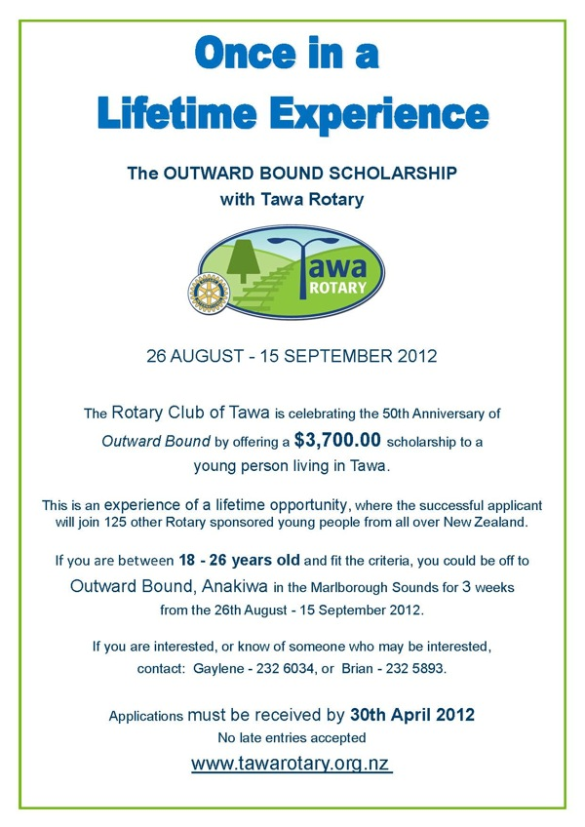
ROTARY CLUB OF
TAWA OFFERING
OUTWARD BOUND
SCHOLARSHIP
See the poster at right.

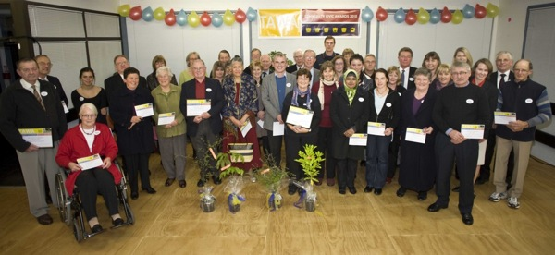


RUGBY WORLD CUP IN TAWA
TAWA COMMUNITY BOARD INFO

NEIGHBOURS’ WEEKEND IN 2012
Little more needs to be said that hasn’t already been said on the first page (and more) of this newsletter, except that this was a project well received by the wider community and it was driven by the community board. And a big thank you to the person(s) in each street who organised their street’s get-together. It wouldn’t have happened without them!

TAWA COMMUNITY CIVIC AWARDS

This year the Tawa Community Board is again organising the Tawa Community Civic Awards which recognise the immense contribution volunteers make to our community. Publicity will begin shortly and the awards ceremony will take place on Friday 22 June.
In the meantime please do start thinking of people you know who could be worthy of an award. It’s one way of showing appreciation for what they do.
PHOTO: Starting to erect signage at Takpu Island.

be worthy of an award. It’s one way of showing appreciation for what they do.

TAWA PROJECTS NOT DEFERRED
Fortunately there has been no deferral/delay with proposed funding for either the artificial turf scheduled for Tawa or Grenada North in 2014, or to Tawa’s Shared Walkway which is an ongoing project. However in regards to the turf the Council will be hoping for more financial input from the local community than they would have been previously.
A special word of thanks to Councillors Ngaire Best & Justin Lester (both community board representatives) who “fought hard” to ensure that both of these projects remain on track, i.e. weren’t put on the backburner which could have easily happened as part of the Council’s need to save dollars.

TAWA RAILWAY STATION
Where are we currently at with “refurbishment” of Tawa Railway Station? An investigation into replacing the roof at the station has revealed there are more significant issues other than just roof replacement. Greater Wellington Council will be presenting their findings at the next meeting of the Tawa Community Board and “opening a line of communication for suggestions for a way forward for the future of Tawa Station”. There are probably simpler ways of saying that!
If you wish to hear more about the future of the station, you’re welcome at this meeting starting at 7pm on Thursday 12 April in the boardroom at the Tawa Community Centre.

The Rugby World Cup (aka the Webb Ellis cup) was at Redwood School recently as part of the “Great Rugby Road Trip” where it is being taken all around New Zealand to thank people “… for the wonderful support which was given during Rugby World Cup 2011”.
Redwood School is one of just 100 schools nationwide lucky enough to see the cup close up as shown here – Grace Thompson (left) and Keshawa Jayasinghe. The Hurricanes player is Reggie Goodes.

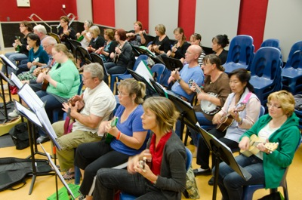
COMMUNITY EDUCATION CLASSES
Tawa College Community Education Classes for Term 2 are now on the website www.tawacomed.co.nz, or collect a brochure from outside Take Note Tawa or at the Mervyn Kemp Library, or phone 232 7163.
Of special interest to Tawa residents will be the Emergency Preparation class being taught by Graham Nel from Disaster Prepare Ltd on 1 May from 7-9pm. A free first aid kit will be given to all participants. You can check out Graham’s website by going to www.disaster-prepare.co.nz.
Cooking classes this term will include Indian on Monday, Chinese on Tuesday, Italian on Wednesday and Portuguese on Thursday.
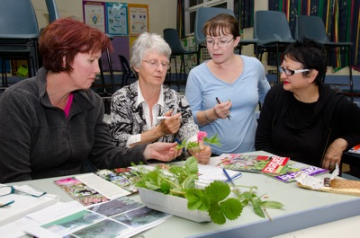
For those who wish to keep fit there are Pilates, Bollywood Fitness and Belly Dancing in the evening, as well as Pilates at the Tawa Community Centre on Wednesday mornings from 10-11am.

If you are nervous about speaking in public or have presentations to make at work or at your club, then why not come along to the Speaking Publically with Confidence course on a Thursday evening. Peter creates a very supportive environment where you are given guidance and practice to gain confidence whether it is for a job interview, a public presentation or just to get your point of view across at a meeting.
If you have friends or neighbours for whom English is a second language please encourage them to come to the conversational classes that are held on Tuesday and Wednesday evenings at the college.
The photos featured here are of the ever-popular Ukulele class, the Gardening class and the new Astronomy class on Friday nights.

Adios

Malcolm Sparrow

On behalf of TawaLink.com
(loosely under the umbrella of the Tawa Progressive & Ratepayers’ Association)
info@tawalink.com www.tawalink.com
232 5030 A/H or 027 232 2320

“If you want to feel rich, just count all the things you have that money can’t buy.”
“We cannot live only for ourselves. A thousand fibres connect us with our fellow men.”
- Herman Melville

“What greater sense of fulfilment can there be but to make a difference to the community in which you live? That’s the real opportunity New Zealand offers. It’s hard to make a difference living in New York. Here everything you contribute makes a visible difference.”
- Sir Paul Callaghan

This newsletter is emailed to around 1100 Tawa households, businesses, schools, churches and clubs/groups (anyone who has an interest in the community of Tawa) usually in the first and the third weeks of each month. If there’s anything you'd like to include in the next newsletter, please let us know. If you do not wish to receive the newsletter, please send us an email requesting that your name be deleted from our list.

More from me on Neighbours’ Weekend …..
A lot of my time over the past couple of months has gone into ensuring a successful Neighbours’ Weekend in Tawa. So it was incredibly pleasing to achieve our target of 50 neighbourhood gatherings in our one suburb – but it wouldn’t have happened without the 50+ individuals who took the time to organise something in their own streets. A bouquet to all of you who made the effort!
When you ask local people what they like about Tawa, one word that invariably forms part of their reply is “community”. It’s all about the “village feel” and connections with other people, those who live nearby. Neighbours’ Weekend is a great opportunity to enhance that sense of community, getting to know better those who live in the houses within cooee of where we live.
One thing that came through to me in the five weeks buildup to Neighbours’ Weekend was that many people like the idea of a street barbecue (or similar) as a means of “mixing and mingling” with their neighbours – as long as someone else organises it! Once or twice people commented (almost “complained”) that there wasn’t going to be anything in their street. And my response was along the lines of “Well, it just takes someone with a bit of initiative to make it happen!” (hint, hint).
“A very easy to run event” was part of the feedback we received. For most people it wasn’t too much of a burden if everyone brought along their own food. And as it turned out, there was a lot of variety in the way people did things, and that was great. One street even had a fire engine and the community patrol car present at their event!
In the end, many people got to meet neighbours they’d never met before, and they got to know other ones better than they’d known them before. Many streets now have lists of neighbours which will enable them to “better look out” for each other. When a car was stolen in my own street a few weeks back, we heard about it via a street email. That encouraged us to take extra care in regard to our own property.
Roger Sutton, CERA chief in Christchurch, has said: “We need people talking to each other ….. we’re much healthier and stronger when we do that.” Neighbours’ Weekend in Tawa has given us a boost in doing that. The amount of feedback from various streets indicating that they’ll be getting together again for a pot luck meal or coffee and cake or whatever in the months ahead (or some time down the track) is very encouraging! All it takes is someone actually using their initiative to make it happen!

And on a different note …..
I mentioned a couple of newsletters ago that we’ve had a German exchange student with us this term, a very pleasant girl who’s in Year 12 at Tawa College. She’s enjoyed making the most of her short time here in seeing the sights of Wellington, the Central Plateau area (with a neighbouring family), the West Coast (on a 5-day school history trip), and parts of the lower North Island.
Early in the piece we took her to see the gannets at Cape Kidnappers, the tractor ride along the coastline being as much a part of the experience as getting up close to thousands of noisy birds at the actual destination. More recently she enjoyed going with us on the train to a Hurricanes match at the Stadium.
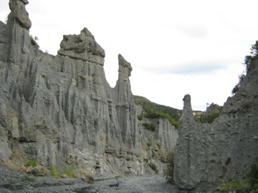
A few weeks back it was a day trip to Cape Palliser. Karen and I have been there once before, just on two years ago. It’s about an hour south of Featherston.
My family isn’t known for early starts. We reached the carpark at the start of the walk in to the Putangirua Pinnacles in time for lunch. After picnicking at the picnic spot we started our trek which more-or-less follows the stream.
At a certain point you have a choice of the high road or the low road. I took the high road for a view down onto the pinnacles. The others took the low road which saw them looking up at the pinnacles once they’d got in amongst them. After I’d enjoyed the view from the top – it was quite good – I got to see the view from the bottom as well. That was a whole lot better, in my opinion, and well worth the 40-45 minute walk (one way). Unique formations, a bit like the “Badlands” of the American West, only on a slightly smaller scale.
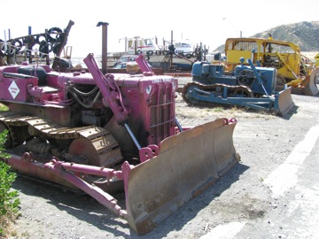
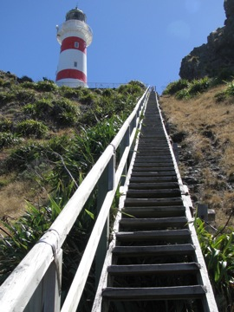
And so it was on to the sleepy fishing village of Ngawi with its multi-coloured bulldozers and, a little further on, Cape Palliser at the end of the road. I like lighthouses. I don’t know why, but they’re few and far between, and often worth making the effort to visit. To get to this particular one requires a major haul up 250 steps. That’s how many we’re told there are and that’s correct. I’m one of those suckers who has to count something like that.
We stopped for a few photos of the seals a short distance back along the coastline, and then it was homeward bound. A good day’s outing and one I’d recommend.

