
COMMUNITY

NEWS

April
2012 - 2
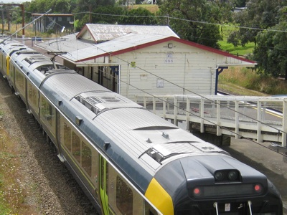
This community newsletter is sent out usually in the first and the third weeks of each month on behalf of tawalink.com, Tawa’s community website since 2002. The newsletter is supported by the Tawa Progressive & Ratepayers’ Association.

TAWA COMMUNITY BOARD INFO

THE FUTURE OF TAWA STATION
The fate of the current Tawa Railway Station building was outlined by Greater Wellington Regional Council officers and a regional councillor at the recent Tawa Community Board meeting. The building is apparently in such a state of disrepair, including leaning on rotten pilings, that drastic action is required.
There are seemingly two alternatives:
- to restore the current building which would be a major undertaking and, we’re told, could mean the closure of the station for between one and two years! The cost

The cost of restoration would be in the region of $1-1.5 million.
- to knock down the current building and replace it with a modern structure. The station would be closed for around 3 months, and the cost of this option would be around $600,000.
The Regional Council - who will make the final decision - have indicated they have funding for the second option only.
The station was built in 1937 and is an important part of the history of Tawa. How strongly do you feel it should be restored?

NOTE: The community board is calling a public meeting at 4.30pm on Sunday 6 May at the Tawa Community Centre (for no more than an hour) to ascertain the views of the community on this. If you’re not able to be there and wish to convey your thoughts to us, please email malcolm@tawalink.com or phone Ngaire Best on 232 9000.

TAWA COMMUNITY CIVIC AWARDS

Within the next few days you should receive a flyer in your letterbox like that shown at right, giving you the chance to nominate someone for the Tawa Community Civic Awards.
The purpose of the civic awards is to thank the many in this community who contribute (voluntarily) to improving the quality of life for those of us who live here - whether it be in a sports club, in schools, church life, amongst seniors, youngsters, service clubs, or helping out in whatever other way. We would be a whole lot poorer without that army of kindhearted individuals.
These awards have been run by the community board in Tawa every two years since 2006. Most of us know someone who volunteers in some way in the community. All we need to do is to put their name forward for an “award” which is merely

basically a certificate of appreciation to be presented to them by the Mayor of Wellington.

TAWA COMMUNITY CIVIC AWARDS (contd)
Nominations close on Friday 25 May, and the awards ceremony will take place on Friday 22 June at the Tawa Community Centre.
There are seven categories in all:
• Arts & Culture • Education and/or Child/Youth Development • Health & Wellbeing
• Heritage & Environment • Sport & Leisure • Youth • Rotary Young Employee
The Youth category (15-24 years) which recognises “... young people who provide outstanding service within the community of Tawa” was new in 2010.
This year we have a further new category, the “Rotary Young Employee Award” for those 17-24 years who display “... energy and enthusiasm in undertaking workforce responsibilities”. A nomination form for that particular award is available online at http://www.tawalink.com/tcca_rotaryaward.html.

SUBMISSION TO THE LONG TERM PLAN(S)
The Tawa Community Board is currently working on submissions to the Long Term Plans of both the Wellington City Council and the Greater Wellington Regional Council.
Particular topics of interest to Tawa are the “Turf in Tawa” and the “Tawa Shared Walkway” - ensuring that previously-promised funding is not deferred. The shared walkway will head through Grasslees Reserve which has been allocated $650,000 by the Wellington City Council for an upgrade, and we need to ensure that too is enacted.
The community board will be forwarding a submission to the city council emphasising that these projects are all important to Tawa and that we would very much like to see them completed within the time frames already agreed to.
If you wish to see these projects completed as proposed, you too can forward a submission stating precisely that! Every submission helps the cause! Go to the online form and state that you are in favour of each of those mentioned above: http://www.wellington.govt.nz/haveyoursay/publicinput/2012-05-longterm.php

WHAT DOES THE TAWA COMMUNITY BOARD ACTUALLY DO?
In a nutshell, the community board (comprising 6 elected members and 2 city councillors)

Cr Justin
Lester

1. considers issues referred to us by the Wellington City Council, and brings matters of community concern to the council
2. promotes community spirit in Tawa by supporting initiatives that

Cr Ngaire Best

Alistair Sutton

Robert Tredger

Graeme
Hansen

Margaret
Lucas

Malcolm Sparrow

Chris Reading

initiatives that build up community connectedness
3. administers the Tawa Community Grants scheme which has $15,000 available each year for allocation to worthy community groups.
In practical terms the board liaises with the city council on basic issues like roading, lighting, overgrown grass, playgrounds, parks and parking, etc.
We also advocate to council on behalf of the community on projects such as “Turf in Tawa” – the installation of an artificial sports pitch in Tawa, and we discuss proposed changes to the likes of Kenepuru and Tawa Railway Stations (recent examples) with the Greater Wellington Regional Council. We meet with commercial operators such as Foodstuffs and Progressive Enterprises to ensure that community concerns are taken into account with the new supermarkets that are being constructed.
In recent weeks the chair of the community board has met with Katrina Shanks (National list MP for Ohariu), John Price (Kapiti Mana Area Police Commander), and Celia Wade-Brown (Mayor of Wellington) to discuss various Tawa community issues with them.

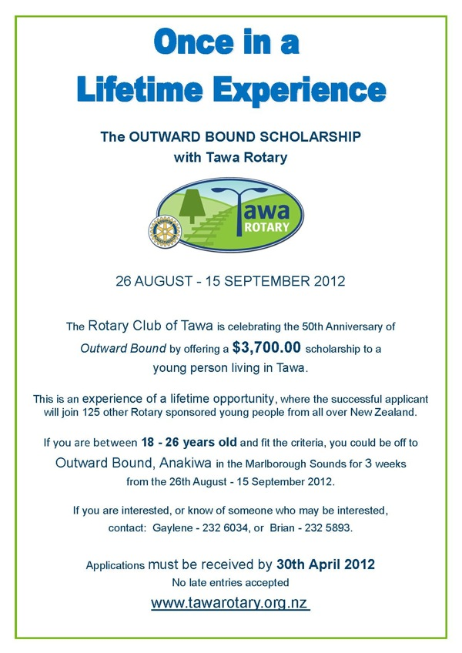

WHAT DOES THE COMMUNITY BOARD ACTUALLY DO? (contd)
Our participation in the community includes:
- operating a stand at various school galas and the annual Spring into Tawa Market Day
- running the Tawa Community Civic Awards every two years (recognising the immense
contribution volunteers make to our community)
- running the yearly Tawa Primary Schools’ Citizenship Awards which first started in 2011
- organising Neighbours’ Weekend in Tawa with an end result of neighbourhood gatherings
in more than 50 local streets
- working towards installing hanging baskets in the Main Road shopping centre
- producing a twice-yearly printed newsletter which is distributed to all 4600 households
in the Tawa community

A STUDENT IN YOUR HOME?
How would you like to bring another culture into your home? AFS is currently looking for families to host students from around the world for two months. During the time of their stay the students will attend school, immerse themselves in New Zealand life and become part of your family. There are students from countries such as Spain, Italy, France and Belgium who are eager to make New Zealand their home for a couple of months. For more information or a copy of the chapter newsletter please email hyoung@greenacres.school.nz

TAWA CRAFT MARKET
The next Tawa Craft Market will be held at the Tawa Community Centre on Saturday May 19th from 9.30-1.30pm. Opportunities are available to operate a stall or to run the fundraising BBQ. All community groups, schools, kindies, etc, are welcome. Contact Toni Stoker on 232 4370 or email inot_ynotstoker@xtra.co.nz

Adios

Malcolm Sparrow

On behalf of TawaLink.com
(loosely under the umbrella of the Tawa Progressive & Ratepayers’ Association)
info@tawalink.com www.tawalink.com
232 5030 A/H or 027 232 2320

“Raising a kid is part joy and part guerrilla warfare.” - Ed Asner

“It is important to possess short term pessimism and long term optimism.”
“While the spirit of neighbourliness was important on the frontier because neighbours were so few, it is even more important now because our neighbours are so many.” - Lady Bird Johnson

This newsletter is emailed to around 1100 Tawa households, businesses, schools, churches and clubs/groups (anyone who has an interest in the community of Tawa) usually in the first and the third weeks of each month. If there’s anything you'd like to include in the next newsletter, please let us know. If you do not wish to receive the newsletter, please send us an email requesting that your name be deleted from our list.

On a personal note …..
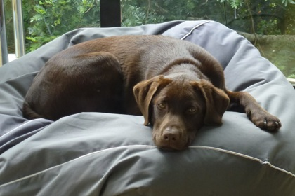
My chocolate labrador pup whose name is Abby is now more than five months old and starting to mature – very slowly! She’s pretty much “house trained” (if you know what I mean), but we still have to remember to let her outside after two or three hours in the evening to ensure the carpet inside stays dry.
Unfortunately socks seem irresistible to her. Fortunately not ones being worn at the time! But if one is neglectful enough to leave socks and shoes within her reach, she doesn’t seem able to help herself. Actually I didn’t word that very well because the problem is she does help herself, all too readily! Off she goes with one or both socks in her mouth. And she’s not very obliging about letting me take them back off her. More than one sock now has holes in it – and I don’t mean around the toe area – because retrieving them is a less than delicate operation.
She’s now going for regular walks, part of the exercise regime for both dog and handler, with Karen taking her out somewhat more often than I do at this stage. As with most dogs, the prospect of a walk creates great excitement. The obvious thrill is part of the pleasure of owning a dog. There’s still a lot of learning to be done in terms of getting her to “heel”, but I think we’re making progress.
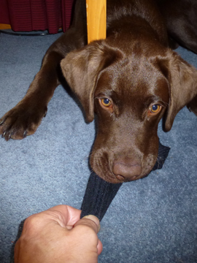
Further obedience classes are going to be needed. She now knows the basic commands but doesn’t always oblige. When she’s told to come, for example, she usually does – but when it doesn’t suit, she chooses not to! So there’s a certain amount of knocking into shape yet to be done!
I registered her with the city council yesterday and phoned the vet to book her in for “de-sexing”, aka speying. I don’t think I’ll bother adding up all that she’s cost us so far. Best not to know! The reality is that it’s not a cheap exercise owning a dog, especially a “bigger” model. Is it worth it? Occasionally I have my doubts, but on the whole the answer has to be yes. Most dog owners would presumably share the same sentiments.
She was snoozing at my feet earlier as I started typing this, enjoying the close contact on which many dogs thrive. It’s that kind of companionship that helps explain the phrase “man’s best friend”.
And so I wish good luck to the family member looking after her when Karen and I head to the Southern Lakes district for five days later this week!

