
COMMUNITY

NEWS

May 2012
extra
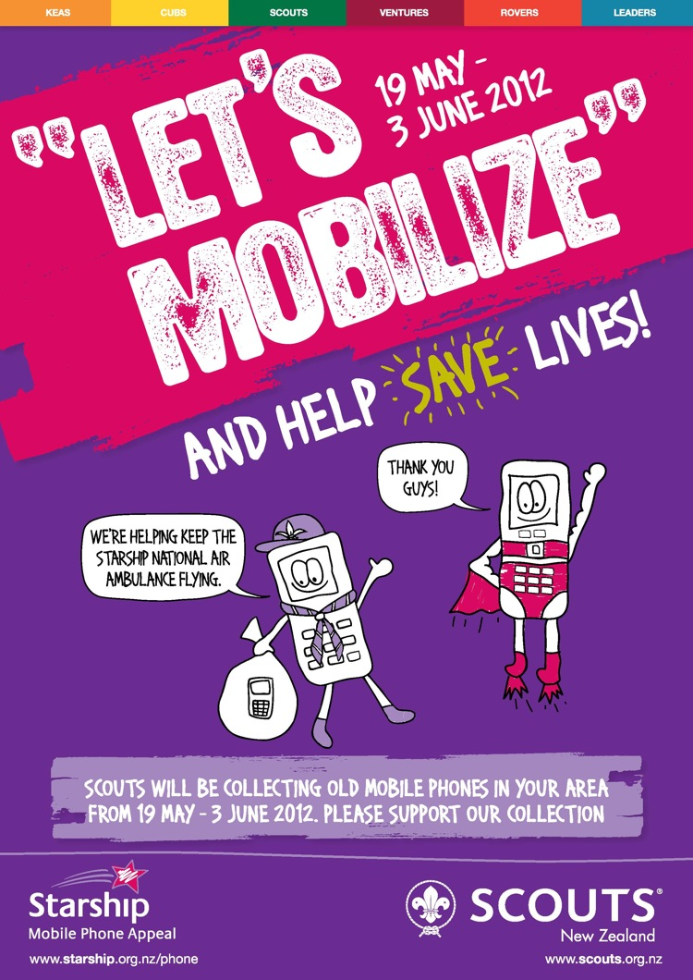
The actual community newsletter is sent out usually twice each month on behalf of tawalink.com, Tawa’s community website since 2002. The newsletter is supported by the Tawa Progressive & Ratepayers’ Association.

THANKS FOR ALL THOSE NOMINATIONS
At the beginning of last week we had received a total of nine nominations for this year’s Tawa Community Civic Awards – five for the new Rotary Young Employee award and four for the other six categories combined. No wonder some of us were starting to feel a little perturbed! We’re aware that there’s usually a “last minute rush”, but on this occasion it needed to be a “deluge” if we were going to end up anywhere near the usual 40 or so. Even on the Thursday, one day before closeoff, we had received only 24 all up. And then the deluge materialised …..
A lot have come through online. Others have been deposited in the “Nominations box” at the Library. At the end of Friday we cleared a further 15 from that box. We now have nominations for some 60 different individuals or groups, more than any previous year, although we do have have more categories these days.
A big thank you to all those who made the effort to complete a nomination form.

more categories these days.
One interesting fact is that there were seven nominations for one particular individual. Most others received just one, which was all they needed.
So a big thank you to all those who made the effort to complete a nomination form. It’s all about showing appreciation to those who provide a voluntary service in the Tawa community. We’re thankful that you’re appreciative! See you at the awards ceremony on Friday 22 June.
GOT AN UNWANTED
CELL PHONE?
This is your chance to dispose of any unwanted mobile phones between now and 3 June. It’s part of the “Starship Mobilize Appeal” – see the poster at right. The project is being run by Keas, Cubs, Scouts & Venturers.
There is a collection box at Mac’s Photo & Lotto Shop on the Main Road, Tawa, southeast of the pedestrian crossing in the central shopping area. Drop off all your surplus cell phones there.

