
COMMUNITY

NEWS

June
2012 - 1
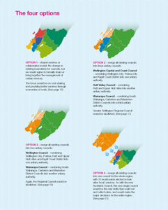
This community newsletter is sent out usually twice each month on behalf of tawalink.com, Tawa’s community website since 2002. The newsletter is supported by the Tawa Progressive & Ratepayers’ Association.

TAWA COMMUNITY BOARD INFO

WHAT FORM OF ‘AMALGAMATION’?
There is likely to be, at the minimum level, a closer working together in the future of the various city councils that make up the Wellington region. That makes sense in many respects.
At the other extreme the various local bodies in the Wellington region, including Wairarapa, could all be combined (forced?) into one ‘super city’, similar to the Auckland model.
Change is bound to happen in the not-too-distant future. At this stage the Wellington City Council is interested in knowing what we as residents think about the matter. They are putting forward four different options as shown in the diagram at right.

The full-size version of this graphic is enclosed as a pdf. It is also available at http://www.wellington.govt.nz/haveyoursay/publicinput/2012-05-reform.html along with a lot more detail.
Please let the community board know your views, even if it’s simply an email to info@tawalink.com which states nothing more than “I prefer option …”. The ideal of course is to send your feedback to the WCC as well as sending us an email. That is what they’re wanting after all!

A COMMUNITY CONSTABLE IN TAWA

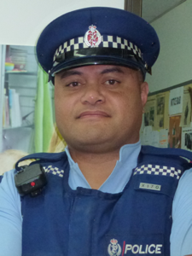
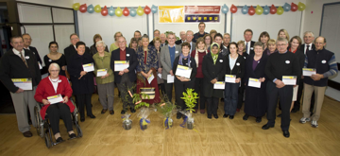
We’ve recently been informed by the Kapiti-Mana Police District (under which Tawa comes) that a community constable has been appointed to ‘relieve’ in Tawa through to the end of the year. His name is Tango Pakome. He has 10 years’ police experience behind him and he has recently been involved in community policing in Cannons Creek and Waitangirua. So a big welcome to Tango (for at least six months!).
Constable Sarah Riddering is aiming to be back on deck again at the end of this year or early next year.

TAWA COMMUNITY CIVIC AWARDS
In case you missed it earlier, we are very pleased to advise that for this year’s Tawa Community Civic Awards we received nominations for a total of 63 different individuals or groups. 11 of those are for the new Tawa Rotary Young Employee Award.

A big thank you to all those who made the effort to complete a nomination form. It’s all about showing appreciation to those who provide a voluntary service in the Tawa community. The awards ceremony will take place on Friday 22 June when the Mayor of Wellington will present a certificate to all those who were nominated (as long as they met the eligibility criteria).

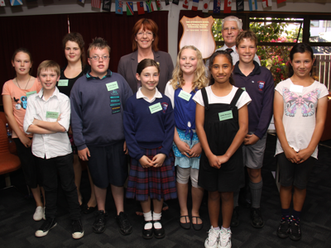

TAWA COMMUNITY BOARD INFO (contd)

SUBMISSION TO THE WCC
The Tawa Community Board sent in a written submission to the Wellington City Council’s Long Term Plan last month (and to the Regional Council’s LTP a few weeks earlier). Board members Malcolm Sparrow and Robert Tredger subsequently spoke at the oral hearings.
At the WCC hearing the main points we covered were:
- support for greater co-operation between the various councils in the Wellington region and looking at what benefits might be obtained from some form of ‘amalgamation’.
- the need to bear in mind that although certain central city buildings require earthquake strengthening, Tawa also has some including the Council-owned Pool and Library. There may be others which need to be identified and dealt with accordingly.
- ensuring that the artificial turf proposed for Tawa or Grenada North is not delayed and that further investigation should take place in regard to joint sponsorship/funding with the likes of Tawa College with a view to possibly bringing this forward from 2014/15.
- ensuring that the shared walk/cycleway is not delayed as this could put supporting funding from the NZTA at risk.
- support for the redevelopment of Grasslees Reserve, and the possibility of an area within this space suitable for a community garden in association with Tawa College and local food banks.
- keeping a check on rates increases over the next 10 years.
SUPERMARKET PROGRESS
We’ve had concerned residents contact us about the ending of both the shuttle service to Countdown in Johnsonville and the shoppers’ bus to New World in Porirua and Churton Park. Very low patronage is the simple reason for the cessation of these services. However New World have advised they will continue with a one-day-a-week service to New World Porirua, on a Thursday.
Regarding progress with the Countdown supermarket at Takapu Island, they have advised they are “… starting ground work on the store as we speak [early June] and aim to be open early in the New Year.”
ECOBULBS
At this stage ecobulbs shouldn’t be going into your recycling bin. However they can be dropped off for recycling at the southern landfill, although that’s hardly worth a special trip from this neck of the woods. We’re working on a solution!
TAWA PRIMARY SCHOOLS’ CITIZENSHIP AWARDS
The chair of the community board has recently spoken to the senior students in all seven of Tawa’s primary schools, including the Intermediate, telling them about the primary schools’ citizenship awards

citizenship awards and encouraging the Year 6 (or Year 8) students in each school to strive to be the winner of the award.
Each session was 7-10 minutes long and was “visually enhanced” with a billboard of last year’s winners (as in the pic at right), along with the wooden shield now resident in each school’s office block. The shields list the names of successive years’ winners - just one in each school to date. The awards ceremony itself will take place at the end of November with either the Mayor or Deputy Mayor of Wellington presenting the awards.

LOCK IT OR LOSE IT!
Tawa seems to have its fair share of thefts from parked cars. The Police figures indicate that as many of 50% of these occurrences result from either unlocked vehicles or items of value being on display in a locked car. The point they’re making is to ensure that we lock our cars whenever they’re parked, even in a driveway, and don’t leave valuables (cameras, laptops, etc) inside the car, or certainly not in sight.
TAWA HISTORY DISPLAY
The Tawa Historical Society’s photographic exhibition at the Library continues through to Friday 15 June. It includes panoramic views, photographs and topographical pictures of the whole Tawa area. For further information contact Bruce Murray, Tawa Historical Society chairman, 232 5374.
TAWA CRAFT MARKET
The next one is being held on Saturday 16 June at the Tawa Community Centre, Cambridge Street, Tawa from 9.30-1.30pm. Come and support this local event and see some amazing local crafters! We are growing in popularity and it is a chance for local people to support local fundraisers. New stallholders are always welcome. Contact Toni Stoker on 232 4370 or email inot_ynotstoker@xtra.co.nz.
FAREWELL TO CHRIS STONE
After 23 years as head teacher at Brian Webb Kindergarten, Chris Stone is being farewelled with a community afternoon tea from 2pm on Saturday 16 June at Hampton Hill School. BYO plate of nibbles to share. Coffee and kids’ drinks provided. Call Barbara Scott-Hill on 232 4406 with any queries. A donation towards a gift can be made directly to Brian Webb kindy.

TAWA GOES TO TOWN
The first rehearsal for this year’s show, for the adult choir, will be this coming Sunday 17 June and every Sunday until 18 September – show-time.
Rehearsal times will be 3.30–5pm in the Tawa College Music Department. Registrations will start at 3pm this week only. The cost of music and the CD is $15.00.

TAWA COMMUNITY CENTRE

MEETING
The Tawa Community Centre is holding a Community Meeting on Wednesday 20 June from 7-8.30pm. Come along and share your ideas about what you would like to see happening at the Centre. For more details call Melanie or Hinetai on 232 1682.
MATARIKI DISCO
Saturday 23 June at the Tawa Community Centre. 5.30-7.15pm up to Year 5. 7.30-10pm for Year 6 and over. See the flyer at right.
ROCKING AND ROLLING IN
REDWOOD
On Saturday 23 June at 7.30pm Harbour City Rock n Roll will be presenting an evening of Rock n Roll at Redwood School Hall. This will be a fun evening of learning RnR dancing with professional dancers in an enjoyable, friendly and supportive environment. It is a fundraising event for the club, a ’50s & ’60s themed fancy dress dance.

STILL GOT AN UNWANTED CELL PHONE?
You can still dispose of any unwanted mobile phones between now and the end of this month. Redwood School is collecting them. So drop off all your surplus cell phones there.

Adios

Malcolm Sparrow

On behalf of TawaLink.com
(loosely under the umbrella of the Tawa Progressive & Ratepayers’ Association)
info@tawalink.com www.tawalink.com
232 5030 A/H or 027 232 2320

“You don’t need a parachute to skydive. You only need a parachute to skydive twice.”
“Courage isn’t the absence of fear, it is the presence of fear yet the will to continue.”
“He who asks a question is a fool for five minutes; he who does not remains a fool forever.”
- Chinese proverb

This newsletter is emailed to around 1100 Tawa households, businesses, schools, churches and clubs/groups (anyone who has an interest in the community of Tawa) usually in the first and the third weeks of each month. If there’s anything you'd like to include in the next newsletter, please let us know. If you do not wish to receive the newsletter, please send us an email requesting that your name be deleted from our list.

My point-of-view …..
I don’t have a problem with knighthoods and similar recognition at the highest level. However one has to question whether some of the recipients really deserve the honours bestowed upon them. Just because someone in business is doing his or her job well, or someone in the sporting field is excelling in his or her chosen field – does that make them worthy of such honours? I’m more inclined to think it does if they’re performing a role which is more than just furthering their own ends. However I’m not sure that’s the case with the likes of certain beer barons or property magnates. It might be hard to argue that their “contribution to society” is really worthy of recognition by the Queen.
Undoubtedly there are many who do deserve the recognition they get. And there will always be those who probably don’t. Nothing’s likely to change in that regard.
We’re also not likely to see widespread recognition given to the many unsung heroes at the local level, many of whom put in far more hours in “serving others” than some of those upon whom glory is thrust at the national level.
That’s why most Sunday evenings I enjoy watching “Good Sorts” on TV1. Recognition is given to ordinary people at the local level. And that’s why we run the community civic awards in Tawa. We’re showing appreciation to the many people who put in many hours of their own time to serve/assist others in so many different ways.
I have the privilege of reading detailed writeups of the roles played by those nominated for our local awards. In my opinion a number of these people are more worthy of high honours than some of the rich and famous who do get acknowledged! It’ll be our chance at the end of next week to recognise them in our own way, with our Mayor presenting them each with a certificate of appreciation. We have many really “good sorts” in our own community, and they deserve all of the thanks we’ll be giving them.

