
COMMUNITY

NEWS

July
2012 - 1
This community newsletter is sent out usually twice each month on behalf of tawalink.com, Tawa’s community website since 2002. The newsletter is supported by the Tawa Progressive & Ratepayers’ Association.

HOST FAMILY URGENTLY NEEDED
A Malaysian girl, Liwen, is due to arrive in NZ on 12 July – that’s next week. A family to host her for two months is urgently needed. AFS will offer $50 per week for the privilege of doing so. It is a wonderful opportunity to have an intercultural experience the whole family can enjoy. During her exchange local support will be provided for Liwen and the host family.
AFS Pasifika is a vibrant chapter that holds fun events for the whole family, no matter what their age. If you opt to host Liwen you will be welcomed into the chapter with open arms. If you’re interested in hosting Liwen, please contact Howard Young on afspasifikaporirua@hotmail.com
Liwen
Age: 15
Native Language: Chinese
Length of stay: 8 weeks (July to Sept 2012)
Liwen is a friendly, sociable and adventurous individual. She enjoys reading books and watching movies. She loves to swim and loves music and going to concerts. Once a week she also attends a cooking class. In the future she would like to get into the hospitality industry with the aim of becoming an air stewardess so she can get to see the world.

“SITTING EASILY” WORKSHOP
Sat 7 July at the Tawa Community Centre. The theme is “Sitting Easily”. It is for people who sit at computers a lot. See the flyer at right.

GRANTS INFORMATION
A Grants information evening will be held at the Tawa Community Centre on Wednesday 25 July 6.30-8.00pm.
You or your organisation could reach your goals with a Wellington City Council Grant. Advisors will be on hand to discuss Council grants and the new online application process. All welcome. Tea and coffee will be provided.

SPRING INTO TAWA MARKET DAY
This year “Spring into Tawa” will be taking place on Saturday 8 September. Information is being sent out this week. Contact us if you haven’t previously been involved and want to be this time.

MAYORS OF TAWA
Who was Mayor of Tawa from 1955-1983? For the answer to this question along with a few media articles on former mayors of Tawa, see www.tawalink.com/tawaboroughcouncil.html

MORE PHOTOS

FROM THE

TAWA

COMMUNITY
CIVIC AWARDS
The first shot shows the ‘presenters’ on the night:
Robert Tredger (left), and Malcolm Sparrow holding a bag of carrot sticks in one hand and a chocolate bar in the other - choice of prize for answering a quiz question correctly.
The other shots are of the Mayor with the prize winners:

ARTS & CULTURE

– Mike Harmon

EDUCATION AND/OR

CHILD/DEVELOPMENT

– Marie Prescott

HEALTH & WELLBEING

– Barbara Russell

(individual winner)

HERITAGE

& ENVIRONMENT

– Peter Turney

SPORT & LEISURE

– Graham Phillips

YOUTH (15-24 YEARS)

– Michael Johnson

TAWA ROTARY YOUNG

EMPLOYEE AWARD

– Mathew Gillett

ROTARY BOOK FAIR
It’s time again for the Rotary Club of Tawa’s annual Book Fair. As previously it will be held at Tawa Junction at the end of Surrey Street on two weekends: 21/22 and 28/29 July from 9.00am until 4.00pm each day. Tens of thousands of books are expected to be available with a wide range of authors and subjects.
This “supersize recycling project” means everyone wins. Those with surplus books taking up needed space can clear their shelves by donating their books; those who want some more books get a chance to buy them at cheap prices; and all the profits go to support various charities. The main one is Life Education Trust, which is given half of the total Book Fair profit. This organisation takes its big caravan to local primary and intermediate schools to teach children to be proud of themselves and be aware of the pitfalls of drugs and alcohol.
The Book Fair last year allowed the Tawa Rotary Club to present the Trust with a cheque for $9000, so local children also “win”. Rotary would like to beat this total for the 2012 Fair.
Anyone wishing to donate well-cared for books, CDs or DVDs (but not magazines) may drop them off at Mexted Motors, Drummonds Pharmacy or Harcourts Real Estate. If there are too many to deliver yourself, ring Ann at 232 8827, Brian at 232 5893 or Doug on 232 7894.

NEW PATH LIGHTING AT HAMPTON HILL SCHOOL
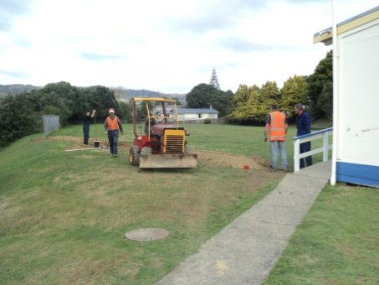
Thanks to a generous grant from the Wellington City Council and the Hampton Hill After School Care, Hampton Hill School has now got a well-lit path for those dark evenings.
The school’s Board of Trustees applied for the grant as they were concerned that it was just too dark at night for the After School Care and staff working late to be walking up and down the path. The lighting was put in quickly after the grant approval came through and was ready for the three way conferences that the school had at the end of term 2.
Parents have commented on how good it was to have a safe path to walk up and down and that it was great to be able to see where they were going.
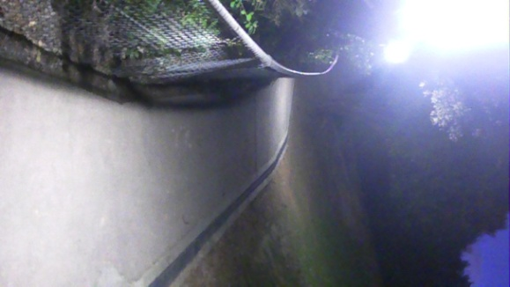
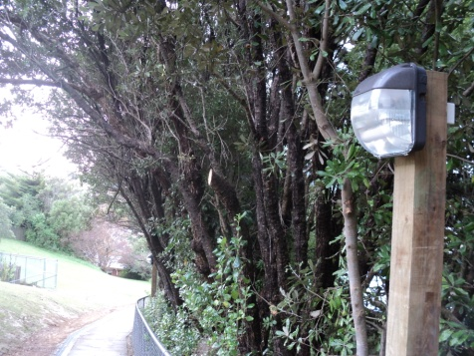
One of the conditions for the grant for the lights was that Hampton Hill School Hall be available for hire. The hall is now ready for this and any parties interested in hiring out can contact Sara McLay the Office Manager to get the forms for hire.
Staff, students and families will also benefit from the lighting when the school has their second Hui for the year in term 3 and the disco in term 4. A great many thanks needs to go to the Wellington City Council and the Hampton Hill School After School Care for making this possible and ensuring the safety of the members of the Hampton Hill community.

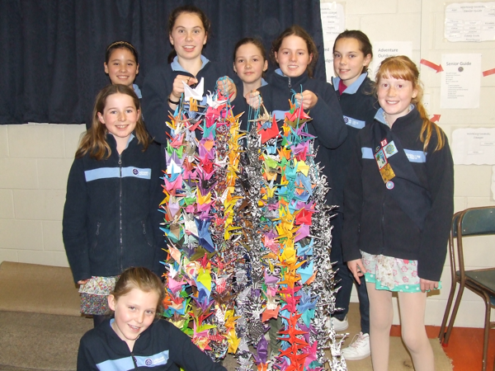
PEACE CRANES FOR JAPAN
Tawa Wednesday Guides have been folding 1000 origami peace cranes and have recently finished them off. The Japanese believe that the receiver of 1000 peace cranes has good fortune. The local Guides will be sending theirs to Girl Guiding Japan as a message of good hope for all the guides whose lives were severely disrupted by the earthquake and tsunami. The photo shows some of the girls holding the 1000 cranes before they were boxed up.
CAN YOU HELP WITH POSTAGE?
It will cost around $60 to post this to Japan. If, say, six local people each donate $10, this would cover the cost of postage for the Guides. Please contact the editor of this newsletter if you can assist in this way: info@tawalink.com. (This is the Editor’s suggestion, not the Guides’. He will put up the first $10.)

TWO MORE LOTS OF COMMUNITY AWARDS ON THE GO
Nominations for two more lots of community awards need to be in as follows:
North Wellington Volunteer Service Awards – Friday 20 July 2012
For more information contact ray.good@paradise.net.nz
Wellington International Airport Community Awards – Friday 27 July 2012
More details at www.wellingtonairport.co.nz/at-the-airport/our-community/community-awards

PROPOSED AFTER-SCHOOL PROGRAMME FOR INTERMEDIATE AGE
Do you need an after-school care programme for your Year 7/8 Intermediate aged child? A new programme is being developed for this age group, in the Tawa area. In order to gather data for the viability of such a programme, please take 5 minutes to complete this short online survey.

Survey link: http://www.surveymonkey.com/s/RVRD3NR

(The survey is completely anonymous and places you under no obligation to sign up for the proposed programme). Survey closes: Sunday 29 July. Thanks for taking part.

PHOTOS OF OUR CIVIC AWARDS’ NOMINEES
Photos of each of those who were presented a certificate by the Mayor at our recent Tawa Community Civic Awards ceremony are available online for a short time. Go to this address:

https://rcpt.yousendit.com/1585196467/4a53216ffe02fe7a947d98a16ceeadea&rcpt=malcolm@tawalink.com

You might have to download the whole lot to find the one(s) you’re looking for.

If you subsequently want a higher resolution copy emailed to you, please email Malcolm at info@tawalink.com with the number of the actual photo.


Adios

Malcolm Sparrow

On behalf of TawaLink.com
(loosely under the umbrella of the
Tawa Progressive & Ratepayers’ Association)
info@tawalink.com www.tawalink.com
232 5030 A/H or 027 232 2320

“The person who starts out going nowhere, generally gets there.”
“Earn as much as you can. Save as much as you can. Invest as much as you can. Give as much as you can.” – John Wesley
“I am of the opinion that my life belongs to the whole community and as long as I live, it is my privilege to do for it whatever I can. I want to be thoroughly used up when I die, for the harder I work the more I live.”
– George Bernard Shaw

This newsletter is emailed to around 1100 Tawa households, businesses, schools, churches and clubs/groups (anyone who has an interest in the community of Tawa) usually in the first and the third weeks of each month. If there’s anything you'd like to include in the next newsletter, please let us know. If you do not wish to receive the newsletter, please send us an email requesting that your name be deleted from our list.

From the Editor of this newsletter …..
It’s great to see writeups on the Tawa Community Civic Awards in the local newspapers this week. See page 25 of Kapi-Mana News and page 11 of CityLife Porirua News. And page 6 of the Northern Courier has an article on Peter Turney, winner of the Heritage & Environment category at the awards.
From time to time I send information to the various papers about events coming up in Tawa or those which have already occurred. The community newspapers are generally quite good at publishing these, particularly the latter two papers mentioned above. This is appreciated, because there is lots of “good stuff” happening in this community and people like to read about local events. The civic awards in June and Neighbours’ Weekend in March are good examples.
However it’s a different story when it comes to The DominionPost. I’m firmly of the opinion that unless it’s something “controversial” about Tawa, plainly negative, or exceptionally “quirky”, they’re simply not interested. I do send them Tawa news from time to time including a couple of photos of our recent civic awards recipients. One day they might surprise me by publishing something, but it hasn’t happened yet.
Occasionally I write a Letter to the Editor and, yes, I have had one or two published. However that’s much more restrictive in terms of how much can be said, and it doesn’t include a photo!
I was disappointed that no mention was made of the big occasion that was Neighbours’ Weekend in Tawa last March, on the Capital Day page or anywhere else in The Dominion Post. After all, how many other suburbs in Wellington (or anywhere else in the country for that matter) went to the effort of hosting 50 “street parties” for a very positive event designed to promote neighbourhood connect- edness?
Tawa College held a very successful Formal (ball) last month. I realise that the expression “good news” is regarded by some as an oxymoron. However I think it’s sad when you think that our daily newspaper would have jumped at the opportunity to mention the Formal only if something untoward had happened – in the way that unpleasant incidents sometimes occur in connection with certain school balls.
Someone suggested that if I had no luck in getting The DominionPost to feature an item on any of Tawa’s “good news” stories, I could cover them in a Letter to the Editor. So that’s what I’ve done. It was emailed to the newspaper in question last Friday morning. You can read it here because chances are you won’t be reading it in The DominionPost!
Bear in mind that condensing what I ideally wanted to say to just 200 words means that many of the interesting details have had to be omitted:
“Although good news doesn't sell newspapers and success stories coming out of Tawa receive scant attention, there are many examples of positive happenings in Tawa.
At the recently-held Tawa Community Civic Awards ceremony attended by around 150 people, the Mayor of Wellington presented certificates of appreciation to more than 50 individuals and groups who serve the Tawa community in a voluntary capacity.
In mid-June hundreds of young people took part in the annual Tawa College Formal (ball). The students looked great in their formal dress and had a fantastic time at the five-hour event. Their behaviour was a credit to themselves, the college and the community.
Earlier in the year 50 Tawa streets took part in Neighbours' Weekend barbecues, afternoon teas and similar. More than 1100 people were involved, getting to better know their neighbours and enhancing community spirit.
Hundreds of locals have recently started rehearsals for "Tawa Goes to Town", Tawa's biennial Schools' and Community Festival. What other single suburb in New Zealand runs such an event with around 80 adult participants and eight local schools providing some 600 singers and dancers? Another example of why Tawa is Wellington's top suburb more than just geographically!”

Malcolm Sparrow
Tawa Community Board

