
COMMUNITY

NEWS

July
2012 - 2
This community newsletter is sent out usually twice each month on behalf of tawalink.com, Tawa’s community website since 2002. The newsletter is supported by the Tawa Progressive & Ratepayers’ Association.

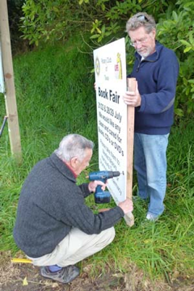
ROTARY BOOK FAIR
Tawa Rotary’s annual book fair is taking place at Tawa Junction (at the end of Surrey Street) this weekend and next, 21/22 & 28/29 July, from 9.00am until 4.00pm each day. Many thousands of books will be available with a wide range of authors and subjects.
All the profits go to support various charities. The main one is Life Education Trust which is given half of the total book fair profit. This organisation takes its big caravan to local primary and intermediate schools to teach children to be proud of themselves and to be aware of the pitfalls of drugs and alcohol. Local organisations also benefit from the profits.
You can still drop off surplus books at Mexted Motors, Drummonds Pharmacy or Harcourts Real Estate. Too many to deliver yourself? Phone Ann on 232 8827, Brian on 232 5893 or Doug on 232 7894.

SPRING INTO TAWA MARKET DAY
This year “Spring into Tawa” Market Day will be taking place on Saturday 8 September. Information has been sent out to last year’s stallholders. If you’re interested in running a stall this time around, see www.tawalink.com/springintotawa2012.html for all the details and an application form.
A number of stalls have already been reserved, especially in the central plaza area. Make sure you don’t miss out - send in your application form in the near future!


MAYORS OF TAWA
Who was Mayor of Tawa from 1955-1983? For the answer to this question along with a few newspaper articles over the years about former mayors of Tawa, see www.tawalink.com/tawaboroughcouncil.html.

PEACE CRANES FOR JAPAN
We mentioned in our last newsletter that Tawa Wednesday Guides had made 1000 origami peace cranes to send to Girl Guiding Japan as a message of good hope for all the guides whose lives were severely disrupted by the earthquake and tsunami.
We’re very pleased to report that the $60 needed for postage to Japan was met by a small number of donors in this community. You know who you are. Again, many thanks for your generous assistance.

CLOSING DATES FOR VARIOUS COMMUNITY AWARDS
Nominations for two more lots of community awards need to be in as follows:
North Wellington Volunteer Service Awards – Friday 20 July 2012. That’s today!
For more information contact ray.good@paradise.net.nz
Wellington International Airport Community Awards – Friday 27 July 2012
More details at www.wellingtonairport.co.nz/at-the-airport/our-community/community-awards.


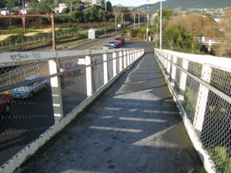

TAWA COMMUNITY BOARD INFO

DETAILS OF TAWA COMMUNITY CIVIC AWARDS

Information about each of the 63 nominees for the Tawa Community Civic Awards was read out as the Mayor of Wellington presented their certificates at the recent awards ceremony. Those details and photographs of the awards recipients are now available on the community website at www.tawalink.com/civic_awards_2012.html.

TAWA STATION AND THE OVERBRIDGE
A concerned resident recently asked what could be done to improve the state of the pedestrian overbridge at Tawa Station on frosty mornings when ice is often a hazard.
Greater Wellington Regional Council who are responsible for both the railway station and the overbridge have responded:
“The long term plan is to demolish and rebuilt Tawa Station during the 2012/13 [Christmas/January] holiday period. At the same time we are proposing to carry out some essential bridge repairs to extend the current life cycle of the bridge. During this work we intend to apply an antislip surface to help prevent a repetition of the slippery surface currently experienced during frosty conditions. As an interim measure we have instructed our contractor to carry out gritting of the Tawa footbridge ramps and walkways in line with local weather reports (low temps, ice and frost.) This practice will continue until such time as repairs to the bridge are carried out later this year.”

Greater Wellington Regional Council who are responsible for both the railway station and the overbridge have responded:
“The long term plan is to demolish and rebuilt Tawa Station during the 2012/13 [Christmas/January] holiday period. At the same time we are proposing to carry out some essential bridge repairs to extend the current life cycle of the bridge. During this work we intend to apply an anti-slip surface to help prevent a repetition of the slippery surface currently experienced during frosty conditions. As an interim measure we

We have instructed our contractor to carry out gritting of the Tawa footbridge ramps and walkways in line with local weather reports (low temps, ice and frost.) This practice will continue until such time as repairs to the bridge are carried out later this year.”

YOUR THOUGHTS ABOUT THE RE-BUILD OF TAWA STATION
In case you missed it in the above paragraph, it is likely to be December/January when Tawa Railway Station is pulled down. The intention of the Regional Council is to liaise with both the Tawa Historical Society and the Tawa Community Board in regard to what kind of “Tawa flavour” they’d like to see incorporated in the new structure.
When we asked for feedback earlier on about the future of the current building, some of the suggestions we received (in terms of the new structure) are listed here:
- a safe, dry, draught-free, ‘vandal proof’ building where people can wait, not open-sided sheds as at Takapu Road Station
- some kind of tagger-proof display preserving the memories/heritage etc of railway in Tawa
- a glazed shelter which offers protection from the weather and through which you can view the train approaching
- not metal walls with holes in them which allow the prevailing wind to drive rain in, as at the new Redwood Station
- big enough to hold a lot of people with seats
- a new comfortable shelter/waiting room that can be made to earthquake- and weather-protection standards and easier to maintain than the old one
- investment in smart-technology to give us real-time updates about train arrivals and departures and related information. Editor’s comment: apparently this will be happening at Tawa Station and most other stations within a matter of months.
- some basic public toilet facilities
- some solid rubbish bins
Editor’s comment about bins and toilets: we’re told that these are more trouble than they’re worth and are not going to happen.

The community board would like any further suggestions from you, as local residents, about the new setup. This is your chance to have your say. Please email your ideas to info@tawalink.com over the next week or so.

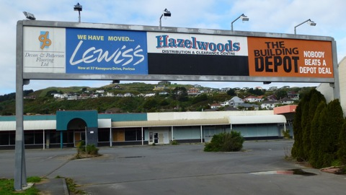
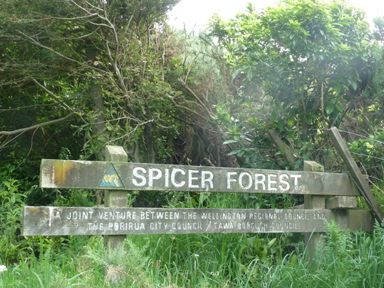

TAWA COMMUNITY BOARD INFO (contd)

MERIDIAN ENERGY’S MILL CREEK WIND FARM
Ohariu Valley, “over the hill” (westwards) from Tawa, is the site of Meridian Energy’s latest wind farm, Mill Creek, a 26-turbine $169m project. Meridian estimates the project will inject $45m into the Wellington economy, providing about 100 fulltime jobs during construction. The 59 megawatt wind farm, due for completion in mid-2014, could generate enough electricity for 30,000 homes.
The first part of the project will be taken up by improving access roads to transport the 67-metre turbine shafts to the site. Public access to Spicer Forest, on the western hills of Tawa, will be off-limits during the construction period. Signs will be put up at access points one

around the forest.
The impact on the Tawa side may not be as great as was first feared. The proposed Meridian access route is not along Tawa roads. After leaving the motorway at Porirua, it heads along Kenepuru Drive and Raiha St, then up Broken Hill Road and the existing landfill access road. It appears that the number of trees needing to be removed between the landfill and Tawa will be minimal. These trees do provide a lot of protection to Tawa from the landfill in terms of noise, smell, dust, and plastic bags being blown by the wind.

Over most of the remainder of the ridgeline section the route is largely through existing pasture or bulldozed track area where there are few trees, although some earthworks will be required to smooth some of the gradients. The area where most of the trees will need to be removed will not be visible from the Tawa side.
The Te Aroha national walkway will be re-routed so that it can remain open as much as possible during the Meridian construction period.
Meridian Energy representatives will be speaking to the Tawa Community Board about their project at the board’s next meeting on Thursday 9 August. For more about the wind farm see www.stuff.co.nz/dominion-post/business/7113313/Ohariu-wind-farm-ready-to-roll.

NO PROGRESS WITH TAWA JUNCTION

will need to survive on local activity, e.g. a retirement village or perhaps a plant employing mostly locals.

In the meantime New Zealand’s foremost imaging bureau for cultural heritage institutions, NZ Micrographic Services and its sister company, business records scanning bureau Desktop Imaging, are operating substantial businesses employing more than 80 people in part of the current Tawa Junction complex.

These businesses have now all gone from Tawa Junction

Last October we reported that Tawa Junction (the site at the end of Surrey St) was to be developed into a very attractive, landscaped office park. That was true at the time.
Having made further enquiries into progress with this project, we’ve been advised that the contract has now lapsed, and “the property is being taken back to the market for another attempt at a sale.”
The feeling of some is that “retail on this site is out of the question”, and it onon

NEW WORLD SHOPPERS’ SHUTTLE

TAWA COMMUNITY BOARD INFO (contd)

PROPOSED PARKING RESTRICTIONS IN TAWA

The proposed restrictions have been forwarded to the Tawa Community Board. These will be advertised on the “Our Wellington” page of The DominionPost on Tuesday 24 July 2012:
• OXFORD STREET (southern end)
Council officers have received a request from the Toy Library located in Oxford Street opposite Tawa School, to provide time limited parking on Saturday mornings. Currently parking spaces are fully occupied due to swimming, rugby lessons and other activities in the area. Accordingly it is difficult for parents with kids to find nearby parking to drop off or pick up toys.
It is proposed to have two P30 time-limited parking spaces in front of the Toy Library to reduce the parking difficulties experienced in this location.
• PARKING AT WILLOWBANK RESERVE
Members of the Tawa Community Board requested clarification of parking signs erected within the off-street parking area adjacent to the Bucket Tree Motel. We have been unable to confirm the existing 2 hour parking was resoluted (by the former Tawa Borough) and it is being used by commuters to park all day. The purpose of this marked area is to provide parking for visitors to the adjacent reserve.
The intention of this report is to formalise the parking restrictions so they can be enforced as required.
It should be noted that just six of thirteen car parks are recommended for a time term restriction. The balance will remain unrestricted for commuters and those wishing to stay for longer periods.

PROGRESS WITH TAWA POOL
Steady progress is being made with refurbishment and earthquake strengthening of the Tawa Pool building. It is hoped that the pool will be open again by mid-November. However that’s not set in concrete (so to speak). We’ll bring you more details when there’s something more specific to report.

The New World shoppers’ bus to Porirua now runs as a shuttle one day a week. It leaves from outside the BNZ at the back of Tawa Mall at 10am each Thursday, with a pick-up at the corner of Linden Ave and Findlay St. It leaves Porirua New World at 12 noon to return to Tawa (presumably with a drop-off at the corner of Linden Ave and Findlay St).

Whether you are required to be carrying groceries in New World bags to qualify for the return ride free-of-charge isn’t known, well not to the writer anyway.

NEW WORLD SUPERMARKET OPENING

Talking about New World, the latest information is that the scheduled opening date for the new supermarket is Monday 24 September – barring unforeseen circumstances. If that date changes, and that’s always a possibility, we’ll let you know.

TAWA COLLEGE 40-HOUR FAMINE RESULT
The 40-hour Famine Committee and I would like to thank all those students, parents, family and friends who in some way supported Tawa College students [for World Vision’s 40-hour Famine fundraiser]. With your help we raised $15,030.00!! It was also great to see students get behind the event through participating in Survivor, Art-a-thon, famine booklets, etc. Thanks for your support!
- Eric Clarke, Teacher in Charge

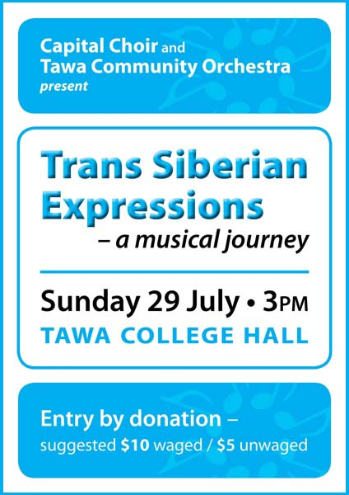
COMING UP:

Saturday 21 July

TAWA CRAFT MARKET

At the Tawa Community Centre from 9.30-1.30pm.

Saturday 21 & Sunday 22 July

ROTARY BOOK FAIR

See first page of this newsletter.

Monday 23 July

BEANSTALK KINDERGARTEN OPEN DAY

At 39a Duncan St, Tawa, 9.30 to 11.30am. For further details call 232 4261 or see www.beanstalk.org.nz

Wednesday 25 July

WCC GRANTS INFORMATION EVENING

At the Tawa Community Centre 6.30-8.00pm.

Saturday 28 & Sunday 29 July

ROTARY BOOK FAIR

See first page of this newsletter.

Sunday 29 July

TAWA ORCHESTRA CONCERT

See poster above right.

Thursday 2 August

MID-WINTER CRAFT FAIR
Tawa Central Kindergarten presents its Mid-Winter Craft Fair, 7-9pm Thursday
2 August 2012. At the kindy premises
@ 21 Oxford Street, Tawa. Gold coin entry, no eftpos available.
We have a great range of hand crafted and artisan products available, as well
as children’s books, stationery, food, clothing and accessories.
Come and enjoy an excellent night out!! Contact person: Vanessa 021 289 3226.

Saturday 4 August

REDWOOD SCHOOL GARAGE

SALE / MINI-FAIR
See poster at right.
A shipping container was delivered to the school during the recent holidays and will be onsite for three weeks for storage of all the goods for the garage sale.
The photo shows the container under the watchful eye of young Redwood pupils (from left) Amy Wiltshire, Grace Thompson and Abby Robinson.

TAWA COLLEGE’S 2012 MAJOR PRODUCTION
A first for Tawa in many years, two hilarious New Zealand comedies are on show in 2012!
From Wednesday 15th through to Saturday 18th August in the Tawa College School Hall commencing at 7pm:
“Desperate Antics” by Kevin Keys
&
“The End of the World as We Know It”
by Bernard Beckett

Two short blisteringly funny takes on where we are going as an economy and where we might be headed to as a society. The plays explore themes of family, market forces, teenage and international relations and whether or not we are all going out in a giant Mayan calendar explosion.
A must-see night of fun and laughter that will pleasantly make you think.

PROMOTE YOUR BUSINESS TO A CAPTIVE AUDIENCE!
At the Super Bowl each January, fans will sit and watch a commercial that’s cost the advertiser millions of dollars.
At the Tawa Music Festival, “Tawa Goes to Town”, you can promote your business to an audience of 2000 mostly Tawa residents for only $100 + GST. Your business will feature on the big screens at the Michael Fowler Centre before the show starts. Don’t let a chance like this go by! Email info@tawalink.com for more details.

Adios

Malcolm Sparrow

On behalf of TawaLink.com
(loosely under the umbrella of the
Tawa Progressive & Ratepayers’ Association)
info@tawalink.com www.tawalink.com
232 5030 A/H or 027 232 2320

“The real measure of our wealth is how much we’d be worth if we lost all our money.”
“I told the doctor I broke my leg in two places. He told me to quit going to those places.”
- Henny Youngman
“You may not realise it when it happens, but a kick in the teeth may be the best thing in the world for you.”
- Walt Disney

This newsletter is emailed to around 1100 Tawa households, businesses, schools, churches and clubs/groups (anyone who has an interest in the community of Tawa) usually in the first and the third weeks of each month. If there’s anything you'd like to include in the next newsletter, please let us know. If you do not wish to receive the newsletter, please send us an email requesting that your name be deleted from our list.


On a personal note …..
We have an 8-month-old chocolate Labrador whose name is Abby, which may indicate that she is female. I’m not sure if any surveys have been carried out on the canine species to determine if their IQs have increased over time and whether the female version is smarter than the male.
What do New Zealand, Argentina and Estonia have in common? It has been determined that women in those countries are, on average, slightly more intelligent than men. That’s according to recent media reports. What about the other 200 or so countries in the world? Is the reverse the case? Perhaps it’s only a matter of time before the previously-mentioned list of three increases in number. Who knows? Do we really care?
It is known that certain breeds of dogs are more intelligent than others. Poodles are allegedly one of the most intelligent. However debate continues as to whether poodles are actually “real dogs”.
Overriding intelligence isn’t known to be one of the Labrador’s strong points. It has its share, but it’s really more interested in food, people, fetching the ball (although not always), going for walks (always), sleeping (lots), and generally getting the most out of life.
Abby enjoys her walks – immensely. Whenever I put on my jacket, she assumes we’re going for a walk and gets very excited. When I meet her outside with leash in hand, she goes absolutely bananas. The thrill is unbelievable. It’s the same every time. It is quite nice to see such pleasure (although it’s a little over the top), but the leash doesn’t go on until she’s settled down. Neither of us would need to be in a rush!
The new routine is to walk from Brasenose Place to Oriel Ave, into Balliol and then Peterhouse. That’s the controlled walk when the leash is “loose”. The ideal is for her to walk alongside me but we’ve a way to go on that one. The continuous supply of little bikkies is still necessary to keep her close to me. As soon as she gets far enough ahead so that the leash is taut, we stop and start over again. I think she’s learning. The leash is mostly reasonably “loose”.
We then head into Redwood Bush. That’s phase two of our outing. There’s no signage indicating I shouldn’t let her off the leash, so I do. I hope I’m not putting my foot in it by saying so. We start off with her sitting obediently. I move up the track 20 metres or so with my constantly reminding her to “stay”. On the word “come” she tears towards me at such a speed she always overshoots, and has to come back for a couple of bikkies’ reward. She then hurtles up and down the track having a whale of a time. I’m keeping a constant eye out for anyone coming the other way. It would be slightly awkward to have her bowl them over. I’m assuming that anyone not kindly disposed toward dogs won’t have read this far, otherwise I might be criticised for not having her under control. In reality I think she is pretty much “under control”, depending on your interpretation of that phrase.

She’s really never too far away from me. From time to time I call her back to practise her response should I see other walkers. The reality is we’d been on seven weekday outings before we encountered another person. I’m aware that more people use this track at the weekends.
So it’s good exercise for both of us, a 27 to 30 minute round trip, and my four-legged friend covers considerably more territory than I do. It’s rounded off with a circuit of Brasenose Park, less than 200 metres from where I live. We’re very fortunate to have such recreational facilities so handy.

