
COMMUNITY

NEWS

August
2012 - 1
This community newsletter is sent out usually twice each month on behalf of tawalink.com, Tawa’s community website since 2002. The newsletter is supported by the Tawa Progressive & Ratepayers’ Association.

WANT A STALL AT SPRING INTO TAWA MARKET DAY?
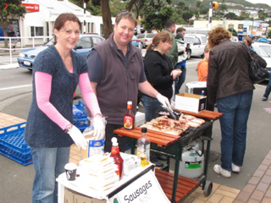
This year’s “Spring into Tawa” Market Day will take place on Saturday 8 September.

At this stage 40 spaces have been booked. There are a number of good ones left if you as an individual or your club or school or church wishes to be involved in this year’s event. Applications should be in by Friday 24 August. Check out the webpage at www.tawalink.com/springintotawa2012.html or email Malcolm on info@tawalink.com.

In addition to all the stalls, the event will feature various musical items, singers and dancers, plus entertainment provided by NZ Radio Training School students.

ROTARY BOOK FAIR – ONE MORE DAY TO GO!

The recent Tawa Rotary Book Fair was a great success, largely due to the vast number of books donated by the community. The club received more than ever, with a substantial number of books being donated on the four actual sale days.
Not surprisingly there are thousands of books left over. Most will be passed on to other Rotary Clubs for their own book fairs. Others are expected to be sent to Tonga, the Cook Islands and Zimbabwe. Firstly though, the Tawa Rotary Club invites members of the local community to have the chance to buy books at even cheaper prices.
A fifth and final “clear-up” day will be held at Tawa Junction on Saturday 18 August from 9.00am till 4.00pm.
This will be your chance to buy at reduced prices. Ordinary paperbacks and similar sized hard cover books are reduced from $2 to $1 each. Larger books are reduced from $3 to $2.

TAWA COLLEGE’S 2012 MAJOR PRODUCTION
A first for Tawa in many years, two hilarious New Zealand comedies are on show in 2012! From Wednesday 15 to Saturday 18 August in the Tawa College School Hall commencing at 7pm:
“Desperate Antics” by Kevin Keys
&
“The End of the World as We Know It”
by Bernard Beckett

Two short blisteringly funny takes on where we are going as an economy and where we might be headed to as a society. The plays explore themes of family, market forces, teenage and international relations and whether or not we are all going out in a giant Mayan calendar explosion. A must-see night of fun and laughter that will pleasantly make you think.

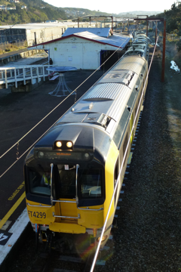
TAWA INTERMEDIATE OPEN NIGHT AND OPEN MORNING

TAWA COMMUNITY BOARD INFO

THE RE-BUILD OF TAWA STATION

A few locals, including members of the Tawa Community Board and some from the Tawa Historical Society, will be getting their heads together in the near future to come up with ideas as to how we would like the “replacement structure” at Tawa Station to look. The Regional Council (GWRC), the funders of the project, will have the final say.

Our intention is to put to the GWRC a few specific proposals as to what we would like to see incorporated in the new complex, including some Tawa-specific ideas. Of course these will be in addition to ensuring it is as safe, weather-proof and vandal-proof as possible.

Thanks to those of you who have forwarded us suggestions.

PROGRESS WITH TAWA JUNCTION
In the last newsletter we reported that there had been no progress with Tawa Junction. Since then there does appear to have been some progress. The site is being bought by an Auckland gentleman who has previously owned it. He was prepared to say that his intention is to refurbish the existing complex for commercial use, a mixture of perhaps office space or retail or whatever else. We’ll await developments.

BEAUCHAMP ST / LINDEN AVE CORNER
Graeme Hansen (“Minister of Roading” within the community board) and I (Malcolm Sparrow) met with WCC officers recently to discuss what’s happening at this particular location. The corner where one turns left from Beauchamp St into Linden Ave has been altered and bollards are in place at the edge of the footpath. We have received comments from members of the community concerned that the quality of the re-surfaced road is poor and that pools of water accumulate when it rains.
The widened footpath at this point is part of the Tawa Shared Walkway which takes in Beauchamp St and heads across to Findlay St. Council officers agreed that the work carried out by the contractor on the road itself is not up to scratch. The asphalt will be re-laid and improvements made to reduce water accumulation. One of the bollards will be re-positioned by 300mm to ensure an easier left turn into Linden Ave. A white line will also be painted to remind pedestrians to stop and look before crossing Linden Ave. We’re counting on all that making a noticeable difference.


Tawa Intermediate’s annual Open Night is being held on Thursday 9 August between 6.30pm and 8.15pm. It is an opportunity for families with Year 6 students and anyone else interested in what the Intermediate is doing to come and have a look. There will be two identical assemblies during the evening - one at 6.30pm and the other at 7.30pm. As well as coming to an assembly, attendees are invited to have a look around the school and see the amazing opportunities available to students.
If you would like to see the Intermediate in action, come and visit on Tuesday 14 August between 9.00am and 11.00am. This is an opportunity to see a regular day at the Intermediate.

If you have not received a Prospectus for 2013 through your child’s primary school, you can call the school office on 232 5201 to request one or collect one at Open Night or at the Open Morning. Please note there is no parking available in the school grounds.

AFS PASIFIKA STUDENTS IN TAWA
Mid July saw the AFS Pasifika chapter bring four more students to Tawa College and the Tawa area. AFS Pasifika would like to thank the people of Tawa for the support they have shown these students in welcoming them to the area.
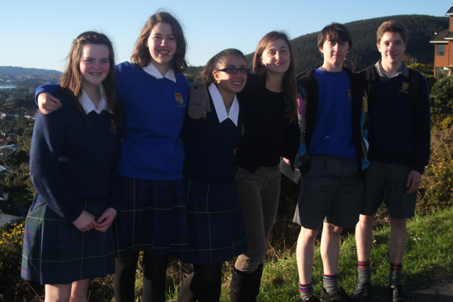
Whether your contact with them is as a host family, a school peer or staff member, or simply as a local resident who has crossed paths with them, every person has helped make their exchange a wonderful experience to date. Gloria Foresi, Valentina Carta, Malo Couaran, and Charlotte Ehret are living in Tawa until early September, whilst Till Weber is now six months into his year exchange. They all hope to meet as many people as possible during their exchange.
From L to R : Maddy Arnold (Valentina’s host sister), Charlotte Ehret (France), Valentina Carta (Italy), Gloria Foresi (Italy), Malo Couaran (France), Till Weber (Germany), all hosted by families in Tawa.

YOU CHANCE TO HELP PLANT SOME TREES!
There will be a tree planting project at the Tawa Lookout (off Kilkelly Close) this coming Sunday 12 August, 1-4pm, to carry on the work of earlier years.
You’re welcome to join with others from the Tawa community, as well as those from Tawa Rotary and Friends of Tawa Bush Reserves, in providing assistance with planting at this site. Any queries should be directed to Richard Herbert on 232 6828 or 027 445 5942.

BIG SING NATIONAL FINALE
Tawa College’s Twilight Tones Chamber Choir has been selected to attend the Big Sing National Finale, making them one of the top 18 choirs in the country at secondary level. Huge congratulations to the students involved and especially to their director Mr Isaac Stone. The students involved will be attending this event from Wednesday 15 August to Saturday 18 August. We are lucky that this event is in Wellington this year so family and friends can go to the Wellington Town Hall and support our students.
The students will have three public performances during the festival. Their first one is during session 2 of the festival, which begins at 4.30pm on Thursday August 16. The second is on the Friday evening during session 7 beginning at 6.30pm.
Along with all the other choirs they will also present one item at the gala concert on the Saturday evening. This concert will commence at 6.30pm and includes a prizegiving and a massed item performed by all the singers taking part.
The Secondary Students’ Choir will also present a concert at 12.30pm on the Saturday. This will be the last chance to hear the current choir members sing together before a new choir is selected at the end of the year. There are two Tawa College students in this choir.
During the day, entry to sessions is $5, in the evening $15 adults and $10 for children. The gala concert is ticketed through Ticketek ($25/$15 before Ticketek fees are added on).
Anyone wanting to follow the Big Sing can do so on Facebook. There will also be live internet streaming of the sessions at R2.co.nz. Those wishing to make a donation towards the costs of organising the Big Sing Finale can do so by visiting the following site: http://www.fundraiseonline.co.nz/NZCFTheBigSingWellington/

CAN YOU HELP WITH STORAGE?
Tawa Music Centre are looking for a place to store their musical instruments. Do you have a spare room or garage, or know of somewhere suitable? If so, please contact Martin MacLean (chairperson) on 232 9897 or Marianne Peacocke (supervisor) on 232 7541.
TAWA CRAFT MARKET
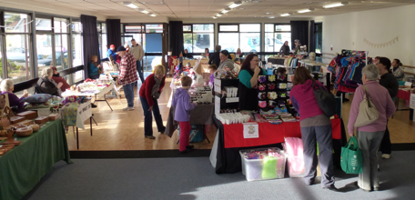
The next market is being held on Saturday 18 August at the Tawa Community Centre, Cambridge St, from 9.30am to 1.30pm. It is again fully booked but if anyone would like to run a fundraising BBQ, please contact Toni on 232 4370 or email inot_ynotstoker@xtra.co.nz.

Foot traffic is starting to pick up, so come along and support this local event. Donation bucket for the Wellington Free Ambulance this month.

PROMOTE YOUR BUSINESS TO A CAPTIVE AUDIENCE!
In case you missed it last time, the fantastic offer below is still available:
At the Tawa Music Festival, “Tawa Goes to Town”, you have the opportunity to promote your business to an audience of 2000 mostly Tawa residents for only $100 + GST. Your business will feature on the big screens at the Michael Fowler Centre before the show starts. Don’t let a chance like this go by! Email info@tawalink.com for more details.

NEIGHBOURHOOD FISH & CHIPS
Neighbours’ Weekend back in March saw more than 50 street gatherings in Tawa – barbecues, afternoon teas, etc. It was a great opportunity for people to meet others in their street whom they’d never met before.
Some of the feedback included the intention to get together again further down the track:
“Everyone had a great time and it is certainly something that we would like to repeat.”
“We heard repeatedly ‘Let’s do this again!’”
“We agreed to have a mid-winter progressive dinner …”
It’d be interesting to know how many of those groups have actually done something again. Some are perhaps waiting for better weather!
Apparently the Mayor of Wellington, Celia Wade-Brown, is involved in fish & chips evenings in her street in Island Bay every few months. Taking a cue from that, part of my street had its own get-together over fish & chips on a recent Saturday evening. We couldn’t invite the whole street because of space limitations. As it was, we had 29 people turn up!
It’s a good low-key way of mixing with the neighbours (always a good thing) and doesn’t take much organising. I’d recommend it. Perhaps you could take the initiative in your street!

Adios

Malcolm Sparrow

On behalf of TawaLink.com
(loosely under the umbrella of the Tawa Progressive & Ratepayers’ Association)
info@tawalink.com www.tawalink.com
232 5030 or 027 232 2320
“Time’s fun when you’re having flies.” – Kermit the Frog
“Knowledge is power, if you know it about the right person.” – Ethel Watts
“Action may not always bring happiness, but there is no happiness without action.” – Benjamin Disraeli

This newsletter is emailed to around 1100 Tawa households, businesses, schools, churches and clubs/groups (anyone who has an interest in the community of Tawa) usually in the first and the third weeks of each month. If there’s anything you'd like to include in the next newsletter, please let us know. If you do not wish to receive the newsletter, please send us an email requesting that your name be deleted from our list.

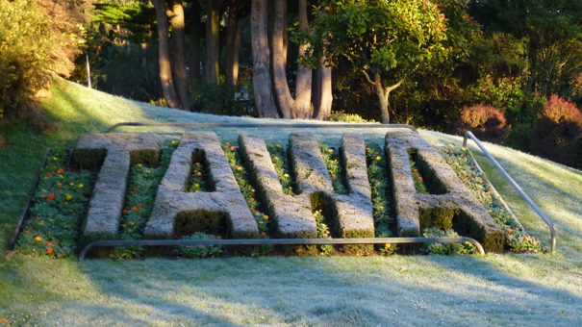

After a decent frost on

Friday 27 July 2012

On a personal note …..
Once a year, usually around early August, my wife allows me to go on a 3 to 4 day pilgrimage to the South Island. Canterbury is where my roots are and that’s where I like to head. That’s not to say we don’t get to Christchurch together other times of the year, but on this occasion it’s just me.
I hire a car for a couple days or so and head off in the direction I’ve already decided upon, generally south or southwest. Where I end up is not pre-determined.
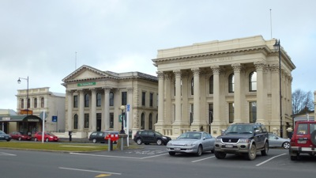
Two years ago I drove to the Mackenzie Country and landed up following my nose south as far as Alexandra for the night. After “exploring” Central Otago over a few hours the next day (not that real exploration gets done in such a short time frame), I landed up in Ranfurly making enquiries about Dansey’s Pass, a crossing between Naseby, Central Otago, and Duntroon in North Otago. It was an isolated gravel route which I’d previously never heard of, and it had only just re-opened after being closed mid-winter. So it was fun to travel that and, along the way, to pass by snow at the side of the road. I do recall at one point driving downhill at a mere 3 to 4 kms per hour because the muddy road surface was such that, if I started to slide, my car was likely to leave the road on the upcoming bend and the chances of surviving the fall over the bluff were probably not great.
But back to August 2012. I returned earlier this week from a four-day stint - nothing quite as hazardous this time other than the usual risks involved with driving almost 1200 kms on mostly dry South Island roads in winter time. The initial plan was to drive from Christchurch to Oamaru and have a look at some of the recently-renovated historical buildings made of local stone (called Oamaru stone, interestingly enough). And that’s precisely what I did. Quite distinctive and attractive, they were.
What I particularly enjoy about travelling through the Canterbury countryside at this time of the year are the views of the snow-covered mountains. I really do like them, which is a bit of a problem in that I keep stopping to take photos. That’s the benefit of travelling on my own and the reason my wife is happy for me to go by myself. Anyone travelling with me would soon tire of the constant stops. On this particular day the cloud was low and my views of the mountains were virtually non-existent. Thus not many photo stops at all.
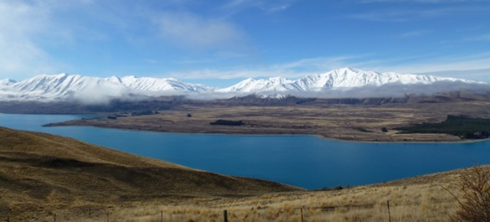
Where to from Oamaru? Early in the piece I didn’t know, but by mid-afternoon I found myself heading up the Waitaki Valley and subsequently spending the night at Twizel. Not a lot happens there on a Friday night, well not that particular Friday night! Fortunately the Olympics were on the TV.
My intention the next day was to meander my way back to Christchurch. The views of the mountains initially were no better than the previous day, but the cloud started to lift as I approached Tekapo. I had passed the roadsign pointing to Mt John before deciding on the spur of the moment to head up there. So I turned around and did just that. The views were superb.
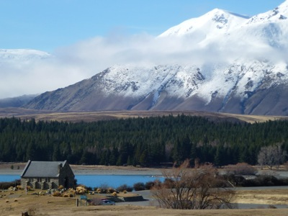
Lake Tekapo is often a picturesque aqua colour, and this time was no different. The snow on the surrounding hills (or mountains if you prefer) wasn’t especially low, but still made for a beautiful setting. It was nice to have time up my sleeve to spend the best part of 90 minutes enjoying it all.
Back on the flat, I popped in to the Church of the Good Shepherd in Tekapo, took a quick couple of shots of the sheepdog statue, and carried on my merry way with a brief diversion to Peel Forest (of which I have fond memories from decades long gone) before calling in to see relatives in Ashburton.
I’m one of those people (mostly men, it seems) who enjoys observing and listening to steam trains. Enjoys them to the extent of “following” them all the way up to Arthur’s Pass, which is how I spent my Sunday. It’s a combination of the steam train, the snowclad mountains and, to a lesser degree, getting a kick out of watching those rather mischievous keas that draws me up that way every year or two. I did the same thing last year, and will probably go back again either next year or the following one.
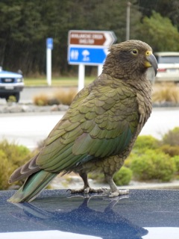
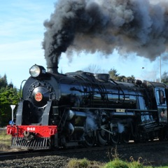
I bumped into a chap I had met up there this time last year. He was on the same mission I was. It’s a “disease”, he confessed as his video camera zoomed in on the approaching steam train, hissing and puffing its way up the slope. But magic to some of us. He’ll give it up some day soon, he reckoned, but I’m not sure that he really meant it.
It was a fun time away and, as I’ve said it before, we’re indeed very fortunate to have so much scenic beauty packed into these two small islands that make up NZ. It’s great to take time to get out and enjoy them.
