
COMMUNITY

NEWS

October
2012 - 3
This community newsletter is sent out usually twice each month on behalf of tawalink.com, Tawa’s community website since 2002. The newsletter is supported by the Tawa Progressive & Ratepayers’ Association.
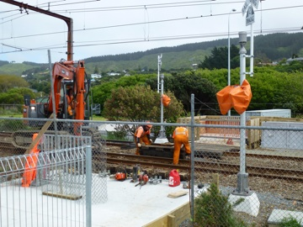

TAWA COMMUNITY BOARD INFO

SHARED PATHWAY OPENING
As advised in our previous newsletter, the Mayor of Wellington will officially open the now-completed portion of the Tawa Shared Pathway this coming Saturday, 27 October. The winning name for the walkway will be announced then, and the Rotary Club of Tawa will present the winner of the naming competition with their $200 voucher.
The photo at right shows the pedestrian route across the railway tracks being laid in place over Labour Weekend. The crossing will be “activated” at the ceremony itself, scheduled to take place between

between 12.45-1.30pm. Meet in the carpark opposite Tawa College in Duncan St.

ROUNDABOUT ADJOINING TAKAPU ROAD STATION CARPARK
You may have noticed that work has begun on a new roundabout on the Main Road between Takapu Road Station carpark and the start of Willowbank Road. This was required by the city council as part of the approval given to Progressive Enterprises in building their new Countdown supermarket up at Takapu Island.
The Tawa Community Board was advised at its meeting on Thursday 11 October that construction

construction of the roundabout would begin approximately six weeks before the supermarket was due to open. Last we heard, opening is scheduled for February 2013 at the earliest. We were therefore surprised to see work on the roundabout having commenced already.
The community board has ensured that the project will be undertaken without the loss of any carparks at the station. However we do not know when it will be completed – possibly even before it was originally scheduled to be started.

THE RE-BUILD OF TAWA STATION

Tawa Station will be closed as from Wednesday 26 December. Demolition of the existing building will start four days later. A replacement structure will be built in time for the station to re-open on 2 April 2013.

Work will also be carried out to the pedestrian overbridge. This may be closed for a couple of hours at a time on certain days, hopefully not when kids are heading to or from school.

Meanwhile community board members and historical society members have continued discussions regarding the art designs that will appear on 16 panels at the re-built station.

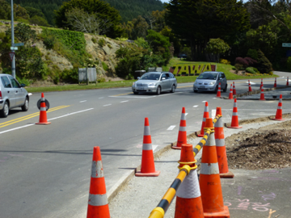

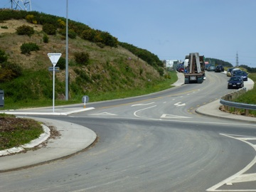
GO TAKE A HIKE IN THE WELLINGTON RAIN FOREST!

TAWA COMMUNITY BOARD INFO (contd)

YOUR COMMENTS ON A NEW STREET NAME …..
As part of the redevelopment of Takapu Island there is an access road (cul-de-sac) which is

yet to be named. This is the short road heading up from the roundabout towards the yet unfinished Countdown supermarket. Local people are invited to provide input into naming this road.
We don’t know whether it will be a “Place” or a “Street” or a “Way” or whatever. That aspect isn’t important.
What is important is the actual name given to it. The following are four suggestions currently in the mix, mostly based on Tawa’s “civic history”. In alphabetical order they are:

• Elsdon Best Place or Street, etc
Elsdon Best was born at Grasslees Farm (Tawa) in 1856 and was the foremost Maori ethnologist of his day. The book “Tawa Flat and the Old Porirua Road” by Arthur H Carman is dedicated to his memory, and reveres him as “Tawa Flat’s greatest son”. There is a memorial to him at Grasslees Reserve today.
• Graeme Sutton Place or Street, etc (or Sutton Place or Street, etc)
Graeme Sutton served on the Tawa Borough Council from 1974 to 1989, and continued on the Tawa Community Board from 1989 until his death in 2009 (with a break of six years at one point). As a Rotarian and a Justice of the Peace he was an integral part of the fabric of Tawa.
• Mitchell Place or Street, etc
Roy Mitchell served on the Tawa Borough Council 1958 to 1959 and from 1962 to 1967, as Deputy Mayor from 1967 to 1983, before serving as Mayor of Tawa from 1983 to 1986, a total of 25 years’ service to the Tawa community. He retired on a high note with the completion of the Tawa civic building (Cambridge St), shopping mall and pensioner flats.
• Patukawenga Place or Street, etc

Iwi advise that land north of the cul-de-sac, adjacent to the Takapu Stream, was a cultivation area for a chief called Te Patu-Kawenga. It is understood that it was possibly Patukawenga who said “Ko taku takapu tenei”, meaning this is my belly, i.e. place of food supply.
Your comments are welcomed. Do you like any of those above, or do you have a further suggestion? Please email your comments to info@tawalink.com by Friday 2 November.

The Friends of Tawa Bush Reserves in conjunction with Greater Wellington Regional Council have arranged a tour of the Wainuiomata Water Collection area and walk through the beautiful pristine forest which is some of the best pre-European lowland rain forest in the lower North Island.
The tour starts at 9.00am at 10 Whitcher Grove, Wainuiomata on Sunday 11 November, and participants will be guided by a Greater Wellington Park Ranger. As you will walk up to 11 kms, anyone taking part should be moderately fit and be prepared for bush environment. The walk may take up to 3 hours. No dogs are allowed.
This is a beautiful walk that will be of interest to people who appreciate the importance of our native forest and the efforts of our forefathers to protect such an important resource.
The tour is limited to 50 people, so the first bookings are all that can be accepted. People interested in joining the walk should email paice@wave.co.nz by 4 November and provide name(s) and contact home number. Enquiries to Brett Gillies on 232 5078 or Chris on 232 2407.

INSPIRING YOUTH IN OUR COMMUNITY
Under the leadership of Dale Williams, the Mayor of Otorohanga, business and community leaders in that town have banded together to provide opportunities for their youth. As a result, youth unemployment in Otorohanga is virtually non-existent and graffiti is minimal.
Tawa College along with Tawa Rotary and Tawa Lions are bringing the Mayor of Otorohanga to Tawa to share with us how we can inspire youth in Tawa and see them “more involved”. If you’re interested in the wellbeing of youth in our community, come along and find out more.
In the Tawa College hall on Tuesday 6 November at 7pm. See the notice below left.
TAWA LIONS 2012 COMMUNITY CHRISTMAS PARADE
The Lions Club of Tawa reports that planning is well under way for this year’s Tawa Community Christmas Parade, to be held on Saturday 1 December. Tawa Lions has organised this parade each year since 1999 when it was taken over from the then business association.
Past parades have generally been well supported by various community groups, says parade convener Alastair Campbell, and this year should be no exception. Any business, organisation or community group that wishes to participate but has not already been approached should contact Ken Coad. This is a great opportunity for local organisations to showcase themselves to the community, and many community groups welcome the annual event to display their membership and activities to the public of Tawa and immediate areas.
Entrants for the parade assemble at Tawa School in Oxford Street at 1.00pm, with the parade commencing at 2.00pm. The parade route is from Oxford Street on to the Main Road (by Mexted Motors) through the town shopping centre and on to Surrey Street. Road traffic will be diverted through Tawa, Duncan and McLellan Streets for the duration of the parade, until approximately 2.45pm.
This community activity is funded by Tawa Lions Saturday Market, with assistance from Wellington City Council and Mana Community Grants Foundation. Anyone requiring further information should contact Ken on 232 2475.

ART & CRAFT EXPO
9am to 3pm, Saturday 27 October, at the Tawa Community Centre, 5 Cambridge St - free entry. Pottery, cards, crochet, paintings, jewellery, and much more. Hosted by Tawa Art and Craft Society (Inc). Enquiries to Aileen at aileenwood@hotmail.com.

TE KOHANGA REO O NGAHAURANGA MARKET FUN DAY
Te Kohanga Reo o Ngahauranga are having a Market Fun Day on Saturday 27 October from 9.30am onwards at Linden School. Plenty of goodies, fun and entertainment to be had.
Enquiries to Frankie on 232 8424 or email Whanau@k09c043.kohanga.ac.nz

BRIAN WEBB SHOPPING EVENING
Brian Webb Kindergarten is hosting a shopping evening on Thursday 15 November from 7-9pm at Tawa Baptist Church hall, 229 Main Road. $2 entry includes coffee and supper. There will be a variety of stalls selling crafts, cosmetics, children’s clothing, confectionery and much more.

TAWA COMMUNITY LIGHT PARTY
A safe alternative to Halloween. This is a fun night of entertainment, food, face painting and talent quest for children aged 5-12. On Wednesday 31 October 6pm–8pm (starting with a sausage sizzle for tea) at Tawa New Life Church, 236 Main Road.
This is a free event but tickets are essential to gain entry. Available from Baptist Church Office (corner Main Road and Victory Cres) 9-12 Tues-Friday, New Life Church Office (next to Pink Pineapple) 12-5 Tues–Friday or 10-1pm on Sat 27 October or contact Michele McDonald, Light Party coordinator, on 232 4924.

RE-OPENING OF TAWA POOL

Tawa Pool is re-opening Saturday 17 November. Join us and The Breeze from 1.30-5.30pm. Free entry, fun activities, bring the whole family. Dress up in 70s disco outfits, there will be prizes for best costumes.
Competitions, inflatables, sausage sizzle, face painting, roller blading, paint the mural on the skate ramp fence and more!

TAWA SCHOOL FAIR
Check out the fun of the fair at Tawa School on Saturday 24 November. Real coffee, great food and entertainment. Entry is free – rain or shine.

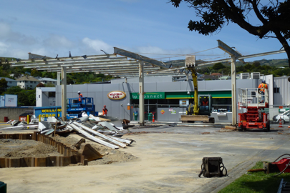
BP STATION BEING UPGRADED
If you drive along the Main Road with your eyes open, you’ll have seen major work currently being carried out at the BP station. The fuel side of the operation has been closed since this past Tuesday, and it won’t re-open until 15 December.
The store selling coffee and groceries, etc, remains open. The carwash facility has already gone and won’t be replaced.
As a matter of interest, when the writer came to Tawa to live in October 1996, there were five petrol stations here. Actually he thought it was six, but he can only “account” for five. There was a Mobil station in Linden at the corner of Linden Ave & Beauchamp St – now trading as Linden Motors (1984) Ltd, and there was another Mobil station as part of the Mexted Motors complex on the Main Road. They’ve both long since gone. In more recent times, the Caltex station has disappeared from the corner of Main Road & Essex St – the site where Simon’s Amcal Pharmacy now operates.
That leaves us with only two, in fact just one selling petrol at this present point in time – the Z station (formerly Shell) on the Main Road south, with the BP station currently being renovated. Yes, things certainly change over time!

Adios

Malcolm Sparrow

On behalf of TawaLink.com
(loosely under the umbrella of the Tawa Progressive & Ratepayers’ Association)
info@tawalink.com www.tawalink.com
232 5030 or 027 232 2320

“One reason I don't drink is that I want to know when I am having a good time.” – Lady Astor

“Honk if you love Jesus. Text while driving if you want to meet him.” – As seen on a church sign

“Giving money and power to government is like giving whisky and car keys to teenage boys.”
– P J O’Rourke

This newsletter is emailed to around 1200 Tawa households, businesses, schools, churches and clubs/groups (anyone who has an interest in the community of Tawa), usually in the first and the third weeks of each month. If there’s anything you'd like to include in the next newsletter, please let us know. If you do not wish to receive the newsletter, please send us an email requesting that your name be deleted from our list.

On a personal note …..
I enjoy taking part in community life and have done so for a number of years, long before taking on my present “community role”.
I recall being present for the re-opening of the Mervyn Kemp Library back in November 2002 (www.tawalink.com/library.html), the unveiling of the Tawa Intermediate-produced tiles on the outside of the library in February 2005 (www.tawalink.com/library_tiles.html), taking photographs at almost all our Spring into Tawa Market Days over the past 10 years (see www.tawalink.com), doing the same at our local Christmas Parade year after year (also online), going to various school galas, music festivals every two years, etc, etc.
I was honoured recently to be asked to give a short speech at the opening of the new supermarket. In addition to that, there are two more official openings coming up which I would very much like to attend. They are the opening this Saturday of the new pedestrian crossing across the railway tracks, as part of the Tawa Shared Walkway. However, many months ago Karen and I arranged to go to the Mary Poppins production in Auckland this weekend, and one can’t be in two places at the same time! So I’m very disappointed not to be in Tawa for the occasion. The show had better be good!
In mid-November the re-opening of Tawa Pool will take place. That will be quite an event and I would very much enjoy being at that too. As luck would have it, we’ve booked to go to a show in Christchurch that weekend, the Canterbury A & P Show, a somewhat different kind of show. That one involves mostly farm animals and machinery. And it’s usually warm, even hot, norwest weather on the day. Hopefully it will be again.
Talking about animals, community board members Graeme Hansen, Robert Tredger and I went to the monthly meeting of the Makara-Ohariu Community Board last week. I’ll get to the animals bit shortly. There was a particular item on the agenda in which we were interested, and it was also a good opportunity to see how another community board conducts its meetings. It was a little less formal than a meeting of the Tawa Community Board, but what intrigued me was the fact that they met in a little country hall immediately across the road from a paddock of sheep.
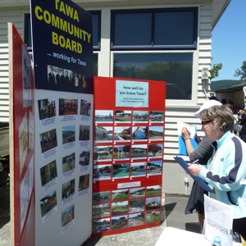
After setting up trestle tables for the meeting and getting proceedings under way, those present were bemused by the ongoing rumblings of what we took to be a bull nearby. Eventually it settled down, but the fact that business had been interrupted by a four-legged neighbour, albeit briefly, reinforced the fact that we were in a totally different setting to our usual Cambridge Street, Tawa, venue. An interesting experience indeed and almost the highlight of a meeting that finished within an hour.
As a matter of interest, the Tawa Community Board will have a stand at the Tawa School fair on the last Saturday next month. Come and have a look at the photos showing what the community board does, and feel free to chat to any of the board members present at the time.

