
3
TAWA’S CONTRIBUTION
TO EARTHQUAKE RELIEF
March 2011

This is a supplement to the community newsletter compiled every month or so on behalf of tawalink.com, Tawa’s community website.

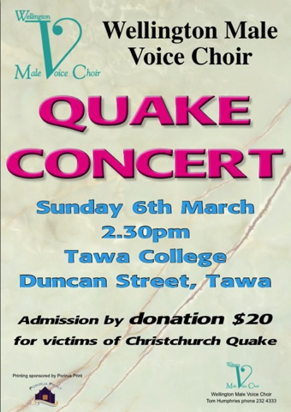
QUAKE CONCERT THIS SUNDAY
The Tawa-based Wellington Male Voice Choir is organising and featuring in the Tawa “Quake Concert” at 2.30pm on Sunday 6th March in the Tawa College Hall. Guest artists include the Tawa Orchestra, the Vocal FX barbershop choir, and the Tawa Filipino choir. Admission is by $20 donation, with all proceeds going to support those affected by the Christchurch Earthquake.
LOCAL SCHOOLS PLAYING THEIR PART
Tawa College held a red and black mufti day yesterday (Thursday) and raised $2700 towards the Red Cross Earthquake Appeal.
One student from Christchurch is now attending the College, and a Christchurch-trained teacher is relieving.
St Francis Xavier pupils and staff dressed in red and black mufti today (Friday) and raised $382 for Christchurch. They usually get less than $200 when they have a mufti day. This money will be passed on to Caritas NZ. Two parents will be selling cupcakes after school in the school grounds on Thursday 10th March with all proceeds going to Red Cross.
Tawa School has a number of smaller things happening - mostly organised class by class. They had a red & black day along with the two minutes’ silence on Tuesday. An ice cream sale after school raised $204. A cup cakes sale made by the middle school children raised $321. The intermediate-age children have a sausage sizzle luncheon next Tuesday.
Tawa School is hosting a couple of families of children who have come up from Christchurch for a break from all the shaking.
Redwood School held a red & black mufti day today (Friday) to show their support for those affected by the earthquake in Christchurch, raising $810 in the process. It went against the grain for at least one of the teachers, very much a Hurricanes’ supporter, to adorn Canterbury colours, but like all those taking part he appreciated the reason for doing so.
THE COMMUNITY BANDING TOGETHER
It’s all about the community banding together in a time of major loss. Nothing more needs to be said in that regard as it certainly has been well covered in the media – with just cause.
There are other schools and various groups in the Tawa community doing what they can to assist. We’ve simply included the reports that have been sent to us. (Greenacres School featured last week).
This photo shows candles lit last Sunday at Tawa Baptist Church in memory of those who were lost in the earthquake.
Sent out by Malcolm Sparrow on behalf of tawalink.com • info@tawalink.com • 232 5030 A/H • 027 232 2320

