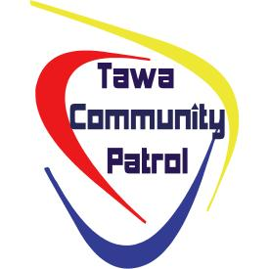

Want to help make Tawa a safer community?
The Tawa Community Patrol is a voluntary organisation helping to make Tawa an even safer community.
Acting as the eyes and ears of the New Zealand Police, the Patrol operates both day and night operations.
The Patrol is made up of Tawa citizens wanting to make a real difference.

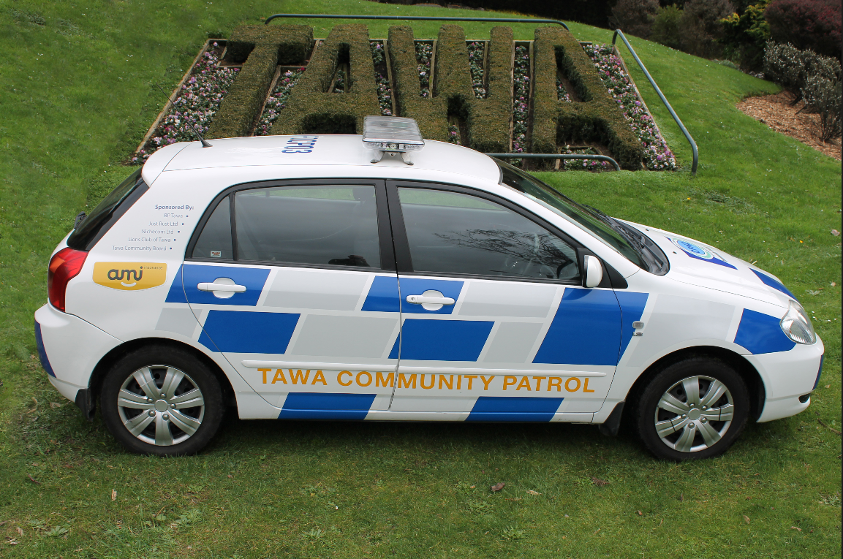

New DAY and NIGHT members are always welcome
For more information about joining the Tawa Community Patrol, email tawacp@hotmail.co.nz
Visit the Tawa Community Patrol on Facebook



